Fluid Mechanics Lab
Experiment # 1
HydroStatic Pressure Apparatus

Equipment Diagram:
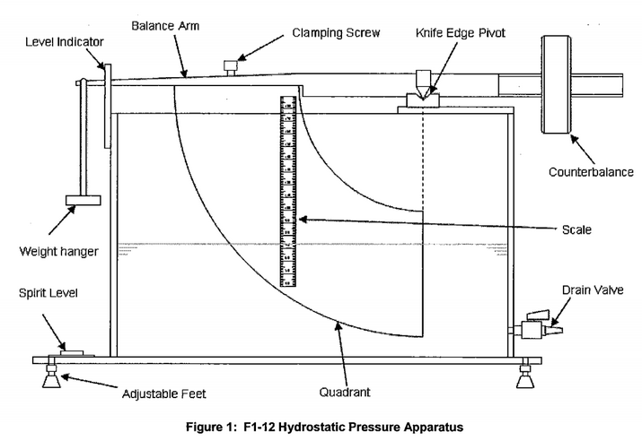

Objective:
To determine the hydrostatic thrust acting on a plane surface immersed in water when the surface is partially submerged or fully submerged.
To determine the position of the line of action of the trust and to compare the position determined by experiment with the theoretical positon.
Method:
By achieving an equilibrium condition between the moments acting on the balance arm of the test appartaus. The forces acting are the weight applied to the balance and the hydrostatic pressure on the end face of the quadrant.
Equipment Required:
In order to complete the demonstration we need a number of pieces of equipment.
- The F1-12 Hydrostatic Preussure Apparatus (including set of weight and weight hanger)
- Source of clean water (typically F1-10 Hydraulics Bench)
- A jug
- Calipers or ruler, for meauring the actual dimensions of the quadrant, if desired

For siphoning water:
- A beaker, measuring cylinder, or similar container of water of similar height to the flotation tank
- A length of small bore flexible tubing
Theory:
When the quadrant is immersed in water it is possible to analyse the forces acting on the surfaces of the quadrant as follows:
The hydrostatic force at any point on the curved surfaces is normal to the surface and therefore resolves through the pivot point because this is located at the origin of the radii. Hydrostatic forces on the upper and lower curved surfaces therefore have no effect – no torque to affect the equilibrium of the assembly because all of these forces pass through the pivot.
The forces on the sides of the quadrant are horizontal and cancel out (equal and opposite).
The hydrostatic force on the vertical submerged face is counteracted by the balance weight. The resultant hydrostatic force on the face can therefore be calculated from the value of the balance weight and the depth of the water as follows:
When the system is in equilibrium, the moments about the pivot point are equal:
mgL = Fh
where:
m is the mass of the weight hanger,
g is the acceleration due to gravity,
L is the length of the balance arm,
F is the hydrostatic thrust, and
h is the distance between the pivot and the centre of pressure.
Hence by calculating the hydrostatic thrust and centre of pressure on the end face of the quadrant, we can compare theoretical and experimental results.
Partially Submerged Vertical Plane:
For the case where the vertical face of the quadrant is partially submerged:

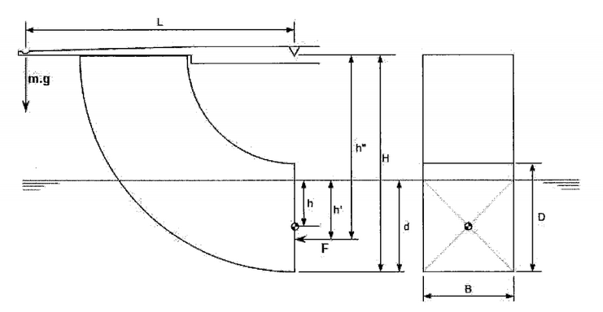
where:
L is the horizontal distance between the pivot point and the weight hanger,
H is the vertical distance between the pivot and the base of the quadrant,
D is the height of the quadrant face,
B is the width of the quadrant face,
d is the depth of water from the base of the quadrant, and
h’ is the vertical distance between the surface and the centre of pressure.
The forces shown are F, the hydrostatic thrust, and m.g, the weight.

Hydrostatic Thrust:
The hydrostatic thrust can be defined as:
F = ρgAh (Newtons)
where:
A is the area = = A = Bd
h is the mean depth of immersion = h = $\frac{d}{2}$
therefore:
F = $\frac{1}{2}$ρgB$d^{2}$ …………..(1)
Experimental Depth of Pressure:
The moment, M, can be defined as
M = FH’’ (Newtons)
A balancing moment is produced by the weight, W, applied to the hanger at the end of the balance arm. The moment is proportional to the length of the blance arm, L.
For static equilibrium the two moments are equal, i.e.
h’’ = $\frac{mgl}{F}$ = $\frac{2mL}{ρBd^{2}}$ _{(metres)}
Theoretical Depth of Pressure:
The theoretical result for depth of pressure P below the free surface is
h’ = $\frac{I_{x}}{Ah}$ …………..(2)
where I_{x} is the 2nd moment of area of immersed section about an axis in the free-surface. By use of the parallel axes theorem:
I_{x} = I_{c} + A$h^{2}$
= $\frac{{Bd}^{3}}{12}+Bd{\left(\frac{d}{2}\right)}^{2}= \frac{Bd^{3}}{3}$ …………..(3)
The depth of the centre of pressure below the pivot point is therefore given by:
h’’ = h’’ + H – d (m) …………..(4)

hence:
h’’ = H - $\frac{d}{3}$

The turning moment can then be calculated.

Fully Submerged Vertical Plane:
For the case where the vertical face of the quadrant is fully submerged:

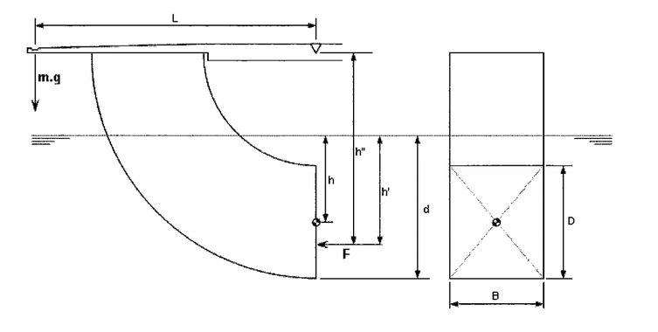

Where:
d is the depth of submersion,
F is the hydrostatic thrust exerted on the quadrant,
h’ is the depth of the centre of pressure,
h’’ is the distance of centre of pressure below the pivot,
B is the width of the surface, and
D is the depth of the surface
W is the weight on the hanger (W = mg)

Hydrostatic Thrust:
The hydrostatic thrust F can be defined as
$F= ρgAh=pgBD(d-\frac{D}{2}$) …………..(5)

Experimental Depth of Pressure:
The moment, M, can be defined as
M = Fh’’ (NM)
A balancing moment is produced by the weight, W, applied to the hanger at the end of the balance arm. The moment is proportional to the length of the balance arm, L.
For static equilibrium the two moments are equal, i.e.:
Fh’’ = WL = mgL
By substation of the derived hydrostatic thrust, F, from (5), we have
$h^{''}= \frac{mL}{ρBD(d-\frac{D}{2})}$ (m)

Theoretical Depth of Pressure
The theoretical result for depth of centre of pressure below the free-surface is
$h^{'}= \frac{I_{x}}{Ah}$ …………..(6)
where I_{x} is the 2nd moment of area of immersed section about an axis in the free-surface.
By use of the parallel axes theorem:
$I_{x}= I_{c}+Ah^{2}$
$= \frac{Bd^{3}}{12}+Bd({\frac{d}{2})}^{2}= \frac{Bd^{3}}{3}$
The depth of the centre of pressure below the surface is
$h^{''}=h^{'}+H-d$ (m)
Substituion as before then gives the theoretical result of:
$h^{''}=H+\frac{\frac{D^{2}}{12}+{(d-\frac{D}{2})}^{2}}{d-\frac{D}{2}}$ - d
The turning moment can hence be calculated.

Equipment Set Up:
For improved accuracy of results, measure the dimensions B, D of the qudrant end face and the distance H and L and record the valuse for furture reference.
Position the empty F1-12 floatation tank on the F1-10 Hydraulics Bench or other suitable level surface, then adjust the screwed feet until the built-in circular spirit level indicates that the tank is level in both planes.
Position the balance arm on the knife edges and check that the arm is free to swing.
Locate the empty weight hanger in the groove at the end of the balance arm.
Move the counter-balance weight until the balance arm is horizontal, indicated by the central index mark on the beam level indicator.
Procedure:
Add a small mass (typically 50g) to the weight hanger.
Close the drain valve at the end of the tank then slowly add water to the tank. This can be done in one of two ways:
Water can be poured into the tank from a suitable receptacle such as a jug or water may be pumped into the floation tank from the F1-10 Hydraulics Bench using a flexible tube attached to the quick release outlet fitting in the bed of the channel .
Fill the flotation tank with water intially until the balance arm rises. Avoid wetting the balance arm or the quadrant above the water to settle before taking readings.
After intially filling the tank, small adjustments of water level are best performed using a jug, allowing time for the water to settle before taking readings.
Alternatively, set a beaker, measuring cylinder or similar container full of water beside the tank. Fill the flexible tube with water, and hold the ends sealed (a thumb over each end is suitable). Place one end below the water surface in the cylinder and the other end into the tank via the triangular cut-out at the pivot end. This will set up a siphon system. Water can be added to the tank by pouring it into the vessel using the jug, then allowing time for the water levels to balance, Siphoning allows greater control over the water entering the tank, and procedures less disturbance of the water within the tank.
Add water until the hydrostatic thrust on the end-face of the quadrant causes the balance arm to rise. Ensure that there is no water spilled on the upper suraface of the qudrant or the sides, above the water level. Continue to add water until the balance arm with the central mark on the level indicator. You may find it easier to slightly over-fill the tank, and obtain the equilibrium position by opening the drain cock to allow a small outflow.
When the arm is horizontal read the depth of immersion from the scale on the face of the quadrant. Care should be taken to ignore the meniscus by moving the head up and down until the eye is sighing along the true surface of the water.
Repeat the above procedure for different load increments by adding further weight to the hanger. The weights supplied allow increments of ten, twenty, and fifty grams to be used, depending on the number of samples required. Fifty-gram intervals are suggested for an intial set of results, which will give a total of nineteen samples.
Continue until the water level reaches the top of the upper scale on the qudrant face. Repeat the procedure in reverse, by progressively removing the weights.
Note any factors that you think are likely to affect the accuracy of your results.

Results:
All readings should be recorded as follows:
Constants:
Height of End Face (Quadrant): D = 0.100 (m)
Width of End Face (Quadrant): B = 0.075 (m)
Length of End Face (Quadrant): L = 0.275 (m)
Quadrant (Height) to Pivot: H = 0.200 (m)

Variables:
Mass Added  m  (kg) | Measured Turning Moment  (Nm) | Depth  d  (m) | Hydrostatic Thrust  F  (N) | Distance to Centre of Pressure  h  (m) | Turning Moment  (Nm)

Conclusions:
Comment on the variation of thrust with depth.
Comment on the relationship between the depth of the centre of pressure and the depth of immersion.
For both of the above, comment on what happens when the plane has become fully submerged.
Comment on and explain the discrepancies between the experimental and theoretical results for the depth of centre of pressure.
Nomenclature:
Name | Unit | Symbol | Type | Definition
Height of quadrant | m | D | Given | Vertical height of quadrant face (Nominal dimension 0.100m). May be updated from your own measurements.
Width of quadrant | m | B | Given | Horizontal width of quadrant face (Nominal dimension 0.075m). May be updated from your own measurements.
Length of Balance Arm | m | L | Given | Length of balance arm (Nominal dimension 0.275m). May be updated from your own measurements.
Quadrant to Pivot | m | H | Given | Distance from base of vertical quadrant face to pivot (Nominal dimension 0.200m). May be updated from your own measurements.
Mass | kg | m | Measured | Weights applied to the weight hanger.  Note: Masses given in grams.
Depth of Immersion | m | d | Measured | Depth of base of vertical quadrant face beneath the free surface.  Note: Apparatus scale calibrated in mm.
Partially Submerged Body
Hydrostatic Thrust | N | F | Calculated | $$F= ρg\frac{Bd^{2}}{2}$$
Experimental Centre of Pressure | m | h | Calculated | $$h^{''}=\frac{mgL}{F}$$
Theoretical Centre of Pressure | m | h | Calculated | $$h''=H-\frac{d}{3}$$
Fully Submerged Body
Hydrostatic Thrust | N | F | Calculated | F = ρgBD(d-$\frac{D}{2}$)
Experimental Centre of Pressure | m | h | Calculated | h’’ = $\frac{mL}{ρBD(d-\frac{D}{2}})$
Theoretical Centre of Pressure | m | h | Calculated | h’’ = $\frac{\frac{D^{2}}{12}+{(d-\frac{D}{2})}^{2}}{d-\frac{D}{2}}+H-d$

