THE CENTER OF PRESSURE EXPERIMENT

- INTRODUCTION
The apparatus permits the moment due to the total fluid thrust on a wholly or partially submerged plane surface to be measured directly and compared with theoretical analysis. Provision is made for varying the inclination of the plane surface subjected to fluid pressure so that the general case may be studied.

1.1 DESCRIPTION OF APPARATUS (ref fig 1)
Water is contained in a quadrant of a semi-circular Perspex tank assembly which is allowed to roll on a smooth surface. The cylindrical sides of the quadrant have their axes coincident with the center of rotation of the tank assembly, and therefore the total fluid pressure acting on these surfaces exerts no moment at that center. The only moment present is that due to fluid pressure acting on the plane surface. This moment is measured experimentally by applying weights to a weight hanger mounted on the semi-circular assembly on the opposite side to the quadrant tank.

A second tank, situated on the same side of the assembly as the weight hanger, provides a trimming facility and enables different angles of balance to be achieved.

The angular position of the plane and the height of water above it are measured on a protractor scale mounted on the tank and a linear scale on the back panel.

The apparatus is completed by base levelling feet and spirit level together with a water reservoir and filling jug. A plate is supplied to protect the rolling surface when the equipment is not in use.

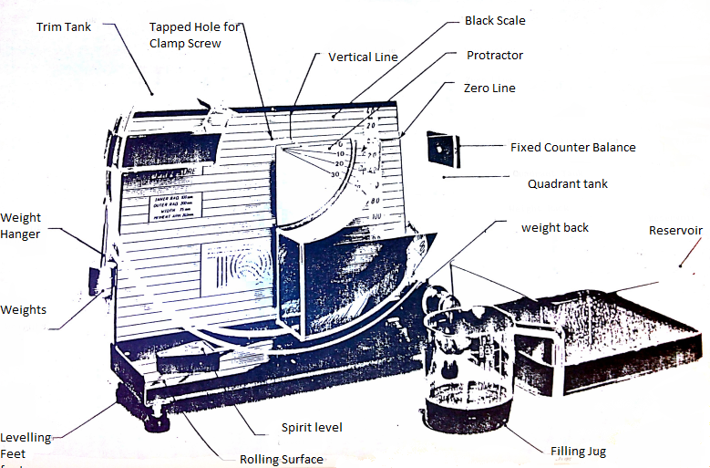
1.2 Installation and Preparation

It is essential that at all times in using this apparatus the ROLLING SURFACE and the ROLLING EDGES of the tank assembly are treated CAREFULLY and are well PROTECTED WHEN STORED.

- Unscrew the clamping screw that secures the hopper to the back panel and hang it behind the unit. Lift the tank assembly and remove the protecting plate from the rolling surface. Clean the rolling surface and rolling edges with a soft cloth or tissue (not provided) and place the hopper gently onto the rolling surface.
- Check that the back scale on the panel lines up so that the zero line passes through the center of rotation and lines up with the 0ᵒ line on the hopper. The back panel is secured by three screws at the rear. To adjust its position, slacken the screws, move the panel in the slotted holes and retighten.
- Level the base plate by screwing the adjustable feet and observing the spirit level.
- After completing the experiment, the apparatus can be emptied into the reservoir tank in the following way:
- Pour the contents of the quadrant tank over the edge to which the fixed counter balance is attached. The water in the trim tank is contained by a partial lid during this operation.
- Having emptied the quadrant tank, the trim tank can now be emptied into the reservoir.
- On completion of the experiment, replace the protective plate and affix the tank assembly to the back plate.
- The apparatus should be cleaned regularly using a detergent solution or any good quality glass cleaner. When cleaning, care should be taken to ensure that no traces of grit or any hard abrasive materials are present on the cloth used. Do not use any materials containing man-made fibers as these will scratch the Perspex.

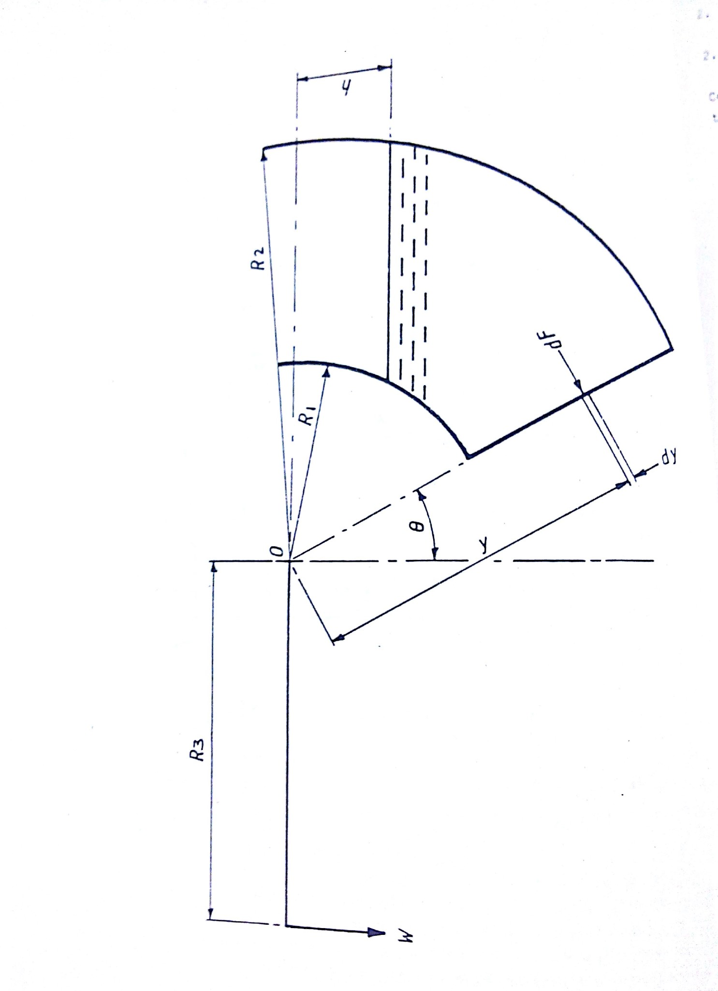
Fig 2 Schema of Centre of Pressure Apparatus
2 THEORY
2.1 Definition of center of pressure
Center of Pressure may be defined as the point in a plane at which the total fluid thrust can be said to be acting normal to that plane.
2.2 Analysis
The following analysis applies to the condition of a plane surface at various angles when it is wholly or partially submerged in a fluid.
Let breadth (width) of quadrant = B
And weight per unit volume = ω
Referring to fig 2, consider an element at start depth y, width δy.
Therefore, force on element δF = ω (y cos θ - h) B dy
And moment of force on element about 0 = ω B ( y cos θ – h) y δ y
Therefore, total moment about 0 = M = w B ∫ (cosθy² - h y) dy

Case I Plane fully submerged

Limits R1 and R2
_{R2}
M=ωB ∫ (cosθy² - hy) dy
^{R1}
_{R2}
M = ωB $[\frac{cosθy^{3}}{3}-\frac{hy^{2}}{2}+c]$
^{R1}

$$M=\frac{ωBcosθ(R_{2}^{3}-R_{1}^{3})}{3}-\frac{ωB\left(R_{2}^{2}-R_{1}^{2}\right)h}{2} . . . . . . 1$$

This equation is of the form of y = mx + C.

A plot of M against h will yield a straight line graph of gradient$-\frac{ωB(R_{2}^{2}-R_{1}^{2})}{2}$ . The value of ω can now be calculated.

Case II Plans partially submerged

Limits R₂ and h sec θ

Hence $M=ωB\int_{hsecθ}^{R_{2}}{\left(cosθy^{2}-hy\right)dy}$
_{R2}
$$M=\left[\frac{ωB cosθy^{3}}{3}-\frac{hy^{2}}{2}+c\right]$$
^{h sec θ}
$$M=\frac{ωBcos θ(R_{2}^{3}-h^{3}\sec^{3}θ)}{3}-\frac{ωBh(R_{2}^{2}-h^{2}\sec^{2}θ)}{2}$$
$$M=\frac{ωBcosθR_{2}^{3}}{3}-\frac{ωB\sec^{2}θh^{3}}{3}-\frac{ωBR_{2}^{2}h}{2}+\frac{ωB\sec^{2}θh^{3}}{2}$$
$$\frac{ωBcosθR_{2}^{3}}{3}-\frac{ωBR_{2}^{2}h}{2}+\frac{ωB\sec^{2}θh^{3}}{6}$$
Re-arranging

$$M+\frac{ωBR_{2}^{2}h}{2}=\frac{ωB\sec^{2}θh^{3}}{6}+\frac{ωBcosθR_{2}^{3}}{3}$$
`Obtain ω from case I and plot h against M+$\frac{ωBR_{2}^{2}h}{2}$

Fig 4 shows the general form of the graphs expected from this experiment.

- EXPERIMENTAL PROCEDURE

Set up the equipment as previously described in section 1.2; affix the weight hanger to the cord. The apparatus will now require trimming in order to bring the submerged plane to the vertical (i.e. 0° position). This is achieved by gently pouring water into the trim tank until the desired position is achieved. The protractor on the tank assembly should be read against the zero line on the back scale. Should it be necessary to remove any water, a pipette is supplied which is dipped into the tank and water held by putting a finger on the top of the pipette and transferring the water to the reservoir. Once trimmed, the tank assembly should be set so that the center of the rolling radius lines up with the vertical line on the back panel. This ensures that there is sufficient room on the rolling surface from the tank assembly throughout the tests. Add a 20gm weight to the weight hanger. Pour water into the quadrant tank until a 0° balance is restored. Note the weight and the height reading of the water (h). Repeat the procedure for the full range of weights in steps of 20g.

Empty both tanks of water. Again, with the weight hanger alone in position, trim the assembly by gently adding water to the trim tank until a balance at 10° is achieved. Add weights in increments of 20g, restore balance to 10° point and record values for h for the full range of weights. The experiment can then be repeated for 20° and 30°.

Readings should be tabulated in the form outlined in fig 3 and the results calculated in line with the theory given in section 2.

W  (gm) | M  $$\frac{W*9.81*R3}{{10}^{3}}$$  (Nm) | h  (mm) | h  (m) | $$h^{3}$$  $${(m)}^{3}$$ | $$M+\frac{ωBR_{2}^{2}h}{2}$$  (Nm)  Note: ω-specific weight->N/$m^{3}$ | $$θ^{°}$$

Fig 3 Format of results table

θ = $0°$
M (Nm)
Plane fully submerged

h (m)

$$M+\frac{wBR_{2}^{2}}{2} (Nm)$$
P Plane partially submerged

$h^{3}(m^{3})$

Fig 4 Typical Graphs

