FLOW VISUALIZATION USING THE HYDROGEN BUBBLE GENERATOR

OBJECTIVE
To visually observe flow patterns which occur when a fluid flows around a solid body.

DESCRIPTION
A Model 9080 Hydrogen Bubble Generator (See Appendix) will be used to generate a mass of fine bubbles. These bubbles will follow the flow of the fluid and be swept across objects of differing shapes. With the flow illuminated, the student will be able to visually observe flow lines and how they behave as the fluid flows around a solid body. Areas of laminar and turbulent flow can be distinguished as well as how they vary when velocity (Reynolds Number) is increased.

Students will observe a variety of shapes under differing velocity magnitudes and directions and record their observations.

PROCEDURE
Step 1: Plug the apparatus into the wall outlet. Turn power ON. Adjust bubble intensity to maximum and generate a steady stream of bubbles. Turn lamp ON and adjust light direction as necessary to maximize observing conditions. Adjust free stream velocity of fluid to lower range of scale.
Step 2: Place solid object in the bubble stream.
Step 3: Observe and record streamlines. Take approximate dimensions of the object and the streamlines and sketch to scale. Label areas of laminar and turbulent flow. (Note: it is important that students use care in accurately preparing sketch)
Step 4: Estimate free stream velocity (distance / time), record water temperature and compute Reynolds Number.
Step 5: Adjust valve and change free stream velocity of fluid to upper range of scale. Observe and record streamlines. Take approximate dimensions of the object and streamlines and sketch to scale.
Step 6: Repeat Steps 2 thru 4 using at least 3 other shapes. (Changing the angle of approach qualifies as a different shape)
Step 7: A minimum of eight sketches (4 shapes at 2 velocities) should be prepared showing the objects and streamlines. Include velocity, and Reynold's Number data.
Step 8: Analysis of findings
a) Comment on changes to extent of turbulent areas due to the change in velocity. Be specific. Address each shape individually.
b) Review streamlines as related to shape of object. Comment on effect of shape on anticipated energy losses as fluid flows around objects. Comment on which shapes would be expected to have a lower coefficient of drag and the reason for the answer.

APPENDIX
HYDROGEN BUBBLE GENERATOR

TECHNOVATE FLOW  ARMFIELD VISUALIZATION  SYSTEMS | MODEL  9043  9045  9080
*DEVELOPED IN ENGLAND BY ARMFIELD TECHNICAL EDUCATION CO., LTD. MADE AND/OR SOLD IN U.S.A. BY TECHNOVATE, INC

This group of items of equipment has been developed to meet the need for direct visualization of fluid mechanics phenomena. With each item quantitative determination can be readily incorporated and this extends considerably the dexterity and research value of the systems. The equipment has been kept small and as light as possible so as to make it suitable for both laboratory and lecture work. It has been designed for use with closed circuit television so that the experiment can be seen in the whole of the auditorium and can also be recorded on tape for future use or for a more detailed study.
Model 9043
Hydrogen Bubble Flow Visualization System This complete system comprises the Hydrogen Bubble Generator Model 9080, the Flow Visualization Table Model 9045 and a set of familiarization models. Details of the technique involved and full specification of the equipment supplied are given below.
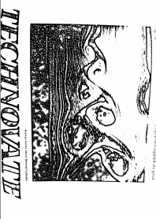

Model 9080
Hydrogen Bubble Generator

The hydrogen bubble technique for flow visualization has long been established. It has not however, been used extensively as a laboratory tool because hitherto its operation has proved somewhat difficult and unreliable. The present equipment has eliminated these disadvantages and provides a compact, easy to use apparatus offering all the technical advantages of the hydrogen bubble method. The technique involves the evolution of small hydrogen bubbles from a fine wire cathode which is positioned normal to the fluid flow. These bubbles are swept from the wire and because of their size, follow the flow accurately. A mass of fine bubbles is observed, and these are made clearly visible by the specially developed system of illumination.
The success of the technique depends upon the standard of illumination and the consistent quality of bubble evolution in terms of numerical density and size. This has been achieved as a result of extensive development work.
The provision of a pulse generator makes it possible to carry out both quantitative and qualitative analysis. The equipment is equally suited as a teaching aid or a research tool.
The generator kit can be used in conjunction with any suitable open channel. However, as it is mostly purchased in conjunction with the Flow Visualization Table (Model 9045), the system is specially tailored to suit this Flow Table.
General Specifications for Ordering Model 9080 (I) One hydrogen bubble pulse generator designed for connection to 110 volts single phase supply. The generator is housed in a compact bench mounting, fully labeled, metal cabinet. Output terminals are provided for direct current connection to the anode and cathode. A further pair &terminals is provided for connection to the illumination source. The connecting leads for both of these are included in our supply.
The generator will produce "on" and "off' of up to 2 seconds duration and provision is incorporated in the generator for varying both the "on" and "off' periods independently in stepless fashion. The pulsed D.C. voltage is adjustable and is coupled to a pre-selector control which may be set to short or long pulse emission. 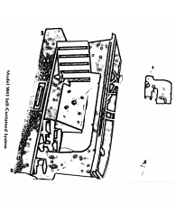

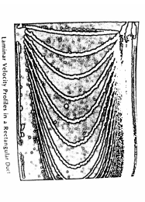

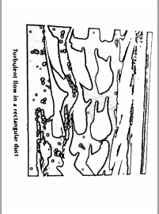
The pulse length available within this pre-set condition is infinitely variable is by means of fine facility controls available for both pulse and space length. Thc also incorporated on the pre-set to have continuous current production. The generator is provided with an on/off switch with and light control indicator and switches are also provided for pump
(ii) The light source consists of a ht cooled 55w. 12v. Tungsten iodine bulb backed by a concave mirror. The light guide is made of polished Plexiglas and works on the principle of total internal reflection. It produces a beam of light below the surface of the fluid and can be moved in a horizontal or vertical direction for optimum viewing conditions at any point of the channel. The intensity of light is adequate for simultaneous viewing by four or five students and photographic recording with a fast film (400 A.S.A.)
Turbulent flow in a rectangular duct
(iii) The cathode consists of a fine stainless steel wire supported in tension by a two-pronged fork holder. Two cathodes are supplied providing wire length of 1V2 in. And 3 in. The holder is insulated with cellulose and supplied complete with support rods which allows it to be positioned at any point along the Flow Visualization Table (Model 9045). The anode is supplied in the form of a stainless steel block.
(iv) A supply of the miscellaneous items required for the hydrogen bubble flow visualization technique is also provided including cellulose for insulation, spare cathode wire and a camel hair brush, etc.
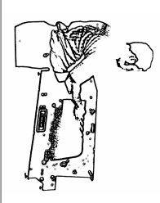
Model 9045
Flow Visualization Table
This item has been developed to meet the increasing importance attached to flow visualization in the study of fluid mechanics. The table is particularly suited for use in conjunction with the Hydrogen Bubble Generator Model 9080. However, the table can also be used to study the flow patterns which occur when water flows around a solid boundary or as an "aerodynalog" to demonstrate the analogy which exists between the flow of a perfect gas and the flow of water in an open channel. "Shock waves" and other phenomena are clearly demonstrated without the necessity to resort to expensive and complicated apparatus. The equipment is designed for use in conjunction with an overhead projector (not included) enabling the flow patterns to be viewed by a large group of students. The flow table is mounted on a steel baseplate provided with leveling screws and carrying handles. It is of unitary construction molded in fiberglass fitted with a clear plexiglas bed in the view section. The working

section is 11 in. long, 8 in. wide and 2 in. deep.
Water is circulated by means of a small electric pump and the flow is regulated by a valve located at the pump discharge. All pipework is of non-corroding material.
Standard Electrical Supply: A. C. Single phase, 115 volts, 60 cycles.

General Specifications of Ordering model 9045
Miniature flow visualization table shall be a self-contained bench-top system incorporating (1) an elevated molded flow channel section of shallow depth in relation to its width in the working area, having a transparent full-width plate in the bed, a stilling reservoir at the inlet end, a discharge sump at the outlet end, and means for mounting gridded plates under transparent plate; (2) a steel base section, upon which the channel proper is mounted, which has leveling lugs and lifting bars at each end and within which is contained a pump with motor, an appropriate fuse, a flow control valve, a drainage fitting, all piping necessary to maintain a constant flow through the flow channel, a three-wire grounded, motor-connection extension cord; (3) a basic set of Plexiglas section models.
Detailed Specifications Construction
Flow Channel Proper
Materials
Body………… Molded fibreglass
Pipe connections (concealed)………copper
Hold-down bolts (concealed)…….steel
Bed plate…………………………….plexiglas
Dimensions, Working Section (in.) Length................................................... 24 Width.................................................... 10 Depth......................................................2
Base Section
Materials
Body & lifting bars…….Heavy-gauge steel
Piping & fittings………Plastic
Pump & valves……….Corrosion-resisting
Electrical
Motor…………….Fractional HP
Power Requirements
EMF (v a/c) ………...110
Frequency (Hz)……….60
Phase…………… Single
Source……….. Grounded, 3-wire
Models………. airfoil, diamond, curved block
Size, Overall (in.)
Height (nominal)……………20
Depth…………. 16
Width…………… 40
Weight (lbs.) Net.................................................... 75
Shipping (est)………………………………… 90

FLOW VISUALIZATION SYSTEMS MODELS 9043, 9045, 9080
Model 9043-P Flow Visualization Table and
Hydrogen Bubble Generator with Overhead Projector
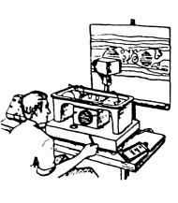
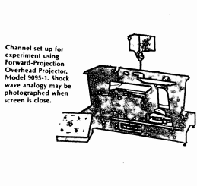
For direct observation of flow patterns by projection. The Forward-Projection Overhead Projector, Model 9095-1, provides certain unique instructional and experimental advantages. At short focal distances, for example, contrast is sufficient for excellent photographs of wave patterns. Secondly, the projector has been specially designed to provide high-intensity illumination with minimum distortion at the edges as well as the center of the image. Thirdly, the image is "right-reading," i.e., left is left, right is right, top is top, and so forth... an immense manipulative advantage. Lastly, by use of the transparent gridded plate, flow rates can be estimates and patterns sketched using the large scale of the screen projection rather than the small scale inherent in direct observation.
Option Models
To obtain obtain value from the Hydrogen Bubble Generator, we recommend the purchase of the following optional accessories

Two pairs of 9 in. flat guides. 93-05-023
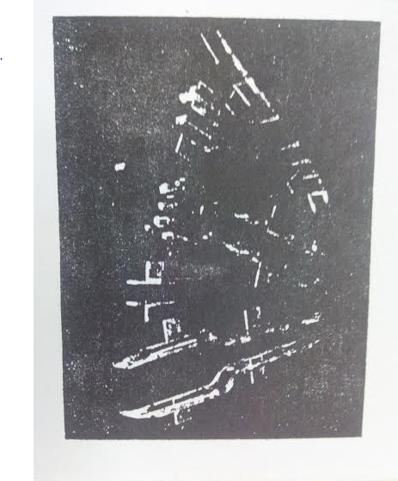
Two guides incorporating an 's' bend. 93-05-18
One curved guide. 93-05-024
One pair of 3 in. Long flat plates. 93-05-012
One pair of plates with radiused ends. 93-05-009
Two special sections, two flat plates with different Shaped ends. 93-05-002, 93-05-004
Four circular cylinders with slip-on-sections from 0.25 in. to 1.00 in. diameter. 93-05-028 to 031
The instruction manual supplied with Model 9080 does deal in depth with the use of these accessories which are all made of clear polished plexiglas.

Technovate reserves the right to make, without prior notice, such changes in this product as will improve its performance or broaden its capabilities.

