STABILITY OF A FLOATING BODY

1. INTRODUCTION
The question of the stability of a body such as a ship which floats in the surface of a liquid is one of obvious importance. Whether the equilibrium is stable, neutral or unstable is determined by the height of its center of gravity, and in this experiment the stability of a pontoon may be determined with its center of gravity at various heights. A comparison with calculated stability may also be made.
1.1 Description of Apparatus
The arrangement of the apparatus is shown in Fig 1. A pontoon of rectangular form floats in water and carries a plastic sail, with five rows of "v" slots at equi spaced heights on the sail. The slots' centers are spaced at 15mm intervals equally disposed about the sail center line. An adjustable weight, consisting of two machined cylinders which can be screwed together, fits into the "v" slots on the sail; this can be used to change the height of the center of gravity and the angle of list of the pontoon. A plumb bob is suspended from the top center of the sail and is used in conjunction with the scale fitted below the base of the sail to measure the angle of list.
1.2 Theory of Stability of a Floating Body
Consider the rectangular pontoon shown floating in equilibrium on even keel as shown in cross-section on fig 2(a). The weight of the floating body acts vertically downwards through its center of gravity G and this is balanced by an equal and opposite buoyancy force acting upwards through the center of buoyancy B, which lies at the center of gravity of the liquid displaced by the pontoon.
To investigate the stability of the system, consider a small angular displacement δθ from the equilibrium position as shown on fig 2(b). The center of gravity of the liquid displaced by the pontoon shifts from B to $B_{1}$.The vertical line of action of the buoyancy force is shown on the figure and intersects the extension of line BG and M, the metacenter.
The equal and opposite forces through G and B; exert a couple on the pontoon, and provided that M lies above G (as shown in fig 2(b)) this couple acts in the sense of restoring the pontoon to even keel, i.e. the pontoon is stable. If, however, the metacenter M lies below the center of gravity G, the sense of the couple is to increase the angular displacement and the pontoon is unstable. The special case of neutral stability occurs when M and G coincide.
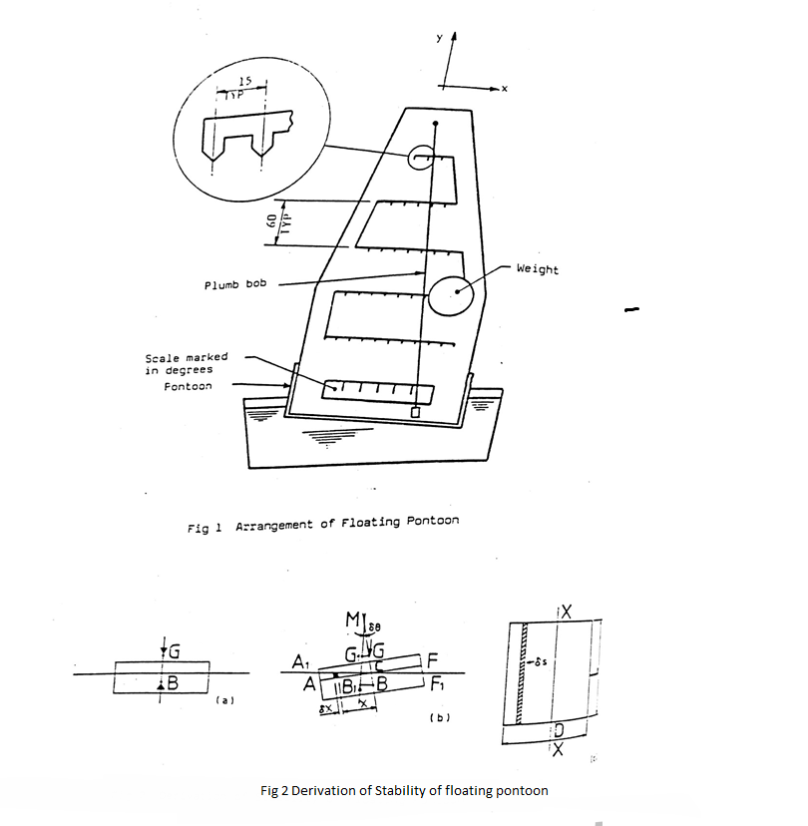

Fig 2(b) shows clearly how the metacentric height GM may be established experimentally using the adjustable weight (w) to displace the center of gravity sideways from G. For suppose the adjustable weight is moved a distance δx from its central position. If the weight of the whole floating assembly is W, then the corresponding movement of the center of gravity of the whole in a direction parallel to the base of the pontoon is $\frac{ω}{W} δx_{1}.$ If this movement produces a new equilibrium position at an angle of list δθ, then in Fig 2(b), $G_{1}$ is the new position of the center of gravity of the whole, i.e.

$GG_{1}= \frac{ω}{W} δX_{1}$ . . . . . . . 1

Now, from the geometry of the figure
$GG_{1}=GM.δθ$ . . . . . . . . 2

Eliminating G$G_{1}$ between these equations we derive
$GM=\frac{ω}{W } \frac{δx_{1}}{δθ}$ . . . . . . . . .3

Or in the limit
$GM= \frac{ω}{W}(\frac{dx_{1}}{dθ})$ . . . . . . . . 4

The metacentric height may thus be determined by measuring $\left(\frac{dx_{1}}{dθ}\right)$knowing ω and W. Quite apart from experimental determinations, BM may be calculated from the mensuration of the pontoon and the volume of liquid which it displaces. Referring again to fig 2(b), it may be noted that the restoring moment about B, due to shift of center of buoyancy to $B_{1 }$is produced by additional buoyancy represented by triangle ${AA}_{1}C$ to one side of the center line and reduced buoyancy represented by triangle ${FF}_{1}C$to the other. The element shaded in Fig 2((b) and 2(c) has an area δs in plain view and a height xδθ in vertical section, So that its volume is $xδsδθ$.

The weight of liquid displaced by this element is wxδsδθ, where w is the specific weight of the liquid, and this is the additional buoyancy due to the element. The moment of this elementary buoyancy force about B is $wx^{2}δsδθ$, so that the total restoring moment about B is given by the expression:

$$w δθ\int{x^{2}ds}$$
where the integral extends over the whole area s of the pontoon at the plane of the water surface. The integral may be referred to as I, where
$I=\int{x^{2}}ds$ . . . . . . . 5 the second moment of area of s about the axis XX.
The total restoring moment about B may also be written as the total buoyancy force, wV, in which V is the volume of liquid displaced by the pontoon, multiplied by the lever arm B$B_{1}$. Equating this product to the expression for total restoring moment derived above:
$$wV.BB_{1}=w δθ\int{x^{2}}ds$$
Substituting from equation (5) for the integral and using the expression
$BB_{1}=BM. δθ$ . . . . . . . . 6
Which follows from the geometry of fig 2(b), leads to
$BM=\frac{I}{V}$ . . . . .. .. . 7
This result, which depends only on the mensuration of the pontoon and the volume of liquid which it displaces, will be used to check the accuracy of the experiment. It applies to a floating body of any shape, provided that I is taken about an axis through the centroid of the area of the body at the plane of the water surface, the axis being perpendicular to the place in which angular displacement takes place. For a rectangular pontoon, B lies at a depth below the water surface equal to half the total depth of immersion, and I may readily be evaluated in terms of the dimensions of the pontoon as
$I=\int{x^{2}ds=\int_{-D/2}^{D/2}{x^{2}Ldx=\frac{1}{12}}}LD^{3}$ . . . . . . . . 8

1.3 Installation Instructions
Fit the sail into its housing on the pontoon and tighten the clamp screws. Check that the plumb bob hangs vertically downwards on its cord and is free to swing across the lower scale.
1.4 Routine Care and Maintenance
After use, the water in the tank should be poured away and the pontoon and tank wiped dry with a lint-free cloth. The pontoon should never be left permanently floating in the water.

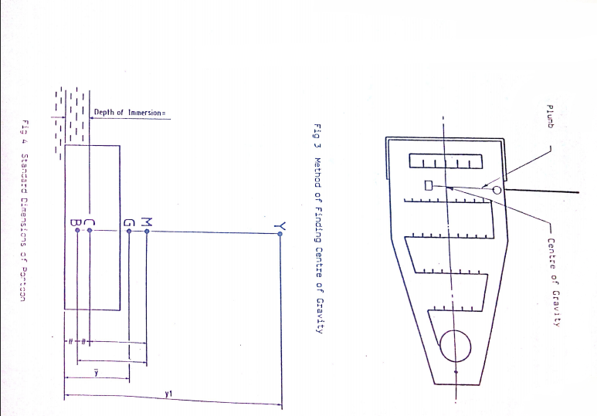

2. EXPERIMENTAL PROCEDURE

The total weight of the apparatus (including the adjustable weight and the two magnetic weights) W and the adjustable weight are stamped on a label affixed to the sail housing. Measure the length and breadth of the pontoon and also the thickness of the sheet metal bottom (nominally 2mm).
The height of the center of gravity may be found as follows: (Refer to Fig 3). (i) Fit the two magnetic weights to the base of the pontoon.
(ii) Fit the thick knotted cord, with the plumb weight, through the hole in the sail, ensuring that the plumb weight is free to hang down on the side of the sail which has the scored center line.
(iii) Clamp the adjustable weight into the "V" slot on the center line of the lowest row and suspend the pontoon from the free end of the thick cord. Mark the point, where the plumb line crosses the sail center line with typists correcting fluid or a similar marking fluid.
(iv) Repeat paragraph (iii) for the other four rows.
With the adjustable weight situated in the center of one of the rows allow the pontoon to float in water and position the two magnetic weights on the base of the pontoon to trim the vessel. When the vessel has been trimmed correctly, the adjustable weight may be moved to positions either side of the center line for each of the five rows. At each position the displacement can be determined by the angle the plumb line from the top of the sail makes with the scale on the sail housing.

3. RESULTS AND CALCULATION
Total weight of floating assembly (w) = Kg
Adjustable weight (ω) = Kg
Breadth of pontoon (D) = mm
Length of pontoon (L) = mm
Second moment of area I =$\frac{LD^{3}}{12}*{10}^{-12}$ = $m^{4}$
Volume of water displaced $v= \frac{W}{{10}^{3}}$ = $m^{3}$
Height of metacenter above center of buoyancy $BM=\frac{I}{V}$ = m
Depth of immersion of pontoon = $\frac{v}{LD}$ = m
Depth of center of buoyancy CB, = $\frac{V}{2. LD}$ = m
It is suggested that Fig 3 is marked up to be referred to each time the apparatus is used. Note that when measuring the heights $\overline{y}$ and $y_{1}$, as it is only convenient to measure from the inside floor of the pontoon, the thickness of the sheet metal bottom should be added to $\overline{y}$ and $y_{1}$ measurements. The position of G (and hence the value of $\overline{y}$) and a corresponding value of y was marked earlier in the experiment when the assembly was balanced.
The height of $\overline{y}$ of G above the base will vary with the height y of the adjustable weight above the base, according to the equation:
$$\overline{y}=y_{1}.\frac{ω}{W}+A$$
(where A is a constant which pertains to the center of gravity of the pontoon minus the height of adjustable weight).
Using one set of results for the center of gravity of the pontoon and the height o fthe adjustable weight, then $\overline{y}$ and $y_{1}$ can be measured and the constant A calculated. This can be used in calculations for subsequent heights of $\overline{y}$ and $y_{1}$which can be checked against the markings made earlier.

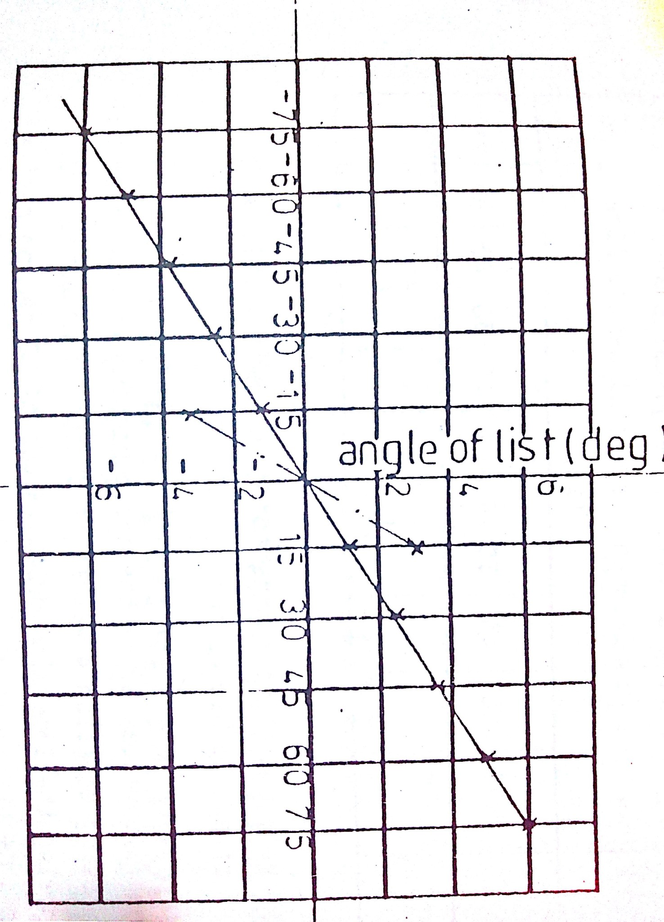
Lateral position
Of weight (mm)

Fig 5 Variations of Angle of List with Lateral Position of Weight
(Heights shown are max and min)

Values of angles of list produced by lateral movement of the adjustable weight height $y_{1}$ should be recorded in the form of table 1. A graph (Fig 5) for each height $y_{1}$, of lateral position of adjustable weight against angles of list, can then be plotted. Note: Decide which side of the sail centre line is to be termed negative and then term list angles on that side negative.

Height of adjustable weight $y_{1}$ mm  (i) | Angles of list for adjustable weight lateral displacement from sail centre line $x_{1}$ mm  (ii)
 | -75 | -60 | -45 | -30 | -15 | 0 | 15 | 30 | 45 | 60 | 75
Table 1 Values of list angles for height and position of adjustable weight

From Fig 5 for the five values of Y the corresponding values of $\frac{dx_{1}}{dθ}$ can be extracted. Using equation 4 values of GM can be obtained. Using equation 9 and knowing the immersion depth; values of CG can be derived. Also since CM = CG + GM values of CM can be calculated. The above values should be calculated and arranged in tabular form as shown in table 2.

Height of adjustable weight $y_{1}$(mm)  (i) | Height of G above water surface CG (mm)  (ii) | $$\frac{dx_{1}}{dθ}$$  (mm/º)  (iii) | Metacentric height GM(mm)  (iii) | Height of M above water surface CM(mm) (v)
Table 2 Derivation of Metacentric Height from experimental results

The values of $\frac{dx_{1}}{dθ}$ can now be plotted against CG the height of G above the water line. Extrapolation of this plot will indicate the limiting value of CG above which the pontoon will be unstable.

