EXPERIMENT #1
THE CENTER OF PRESSURE EXPERIMENT

- INTRODUCTION
The apparatus permits the moment due to the total fluid thrust on a wholly or partially submerged plane surface to be measured directly and compared with theoretical analysis. Provision is made for varying the inclination of the plane surface subjected to fluid pressure so that the general case may be studied.

1.1 DESCRIPTION OF APPARATUS (ref fig 1)
Water is contained in a quadrant of a semi-circular Perspex tank assembly which is allowed to roll on a smooth surface. The cylindrical sides of the quadrant have their axes coincident with the centre of rotation of the tank assembly, and therefore the total fluid pressure acting on these surfaces exerts no moment at that centre. The only moment present is that due to fluid pressure acting on the plane surface. This moment is measured experimentally by applying weights to a weight hanger mounted on the semi-circular assembly on the opposite side to the quadrant tank.

A second tank, situated on the same side of the assembly as the weight hanger, provides a trimming facility and enables different angles of balance to be achieved.

The angular position of the plane and the height of water above it are measured on a protractor scale mounted on the tank and a linear scale on the back panel.

The apparatus is completed by base levelling feet and spirit level together with a water reservoir and filling jug. A plate is supplied to protect the rolling surface when the equipment is not in use.

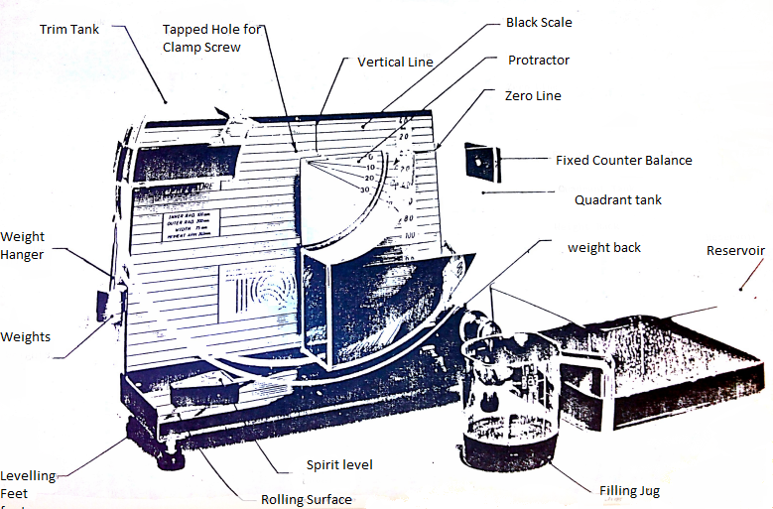
1.2 Installation and Preparation

It is essential that at all times in using this apparatus the ROLLING SURFACE and the ROLLING EDGES of the tank assembly are treated CAREFULLY and are well PROTECTED WHEN STORED.

- Unscrew the clamping screw that secures the hopper to the back panel and hang it behind the unit. Lift the tank assembly and remove the protecting plate from the rolling surface. Clean the rolling surface and rolling edges with a soft cloth or tissue (not provided) and place the hopper gently onto the rolling surface.
- Check that the back scale on the panel lines up so that the zero line passes through the centre of rotation and lines up with the 0ᵒ line on the hopper. The back panel is secured by three screws at the rear. To adjust its position, slacken the screws, move the panel in the slotted holes and retighten.
- Level the base plate by screwing the adjustable feet and observing the spirit level.
- After completing the experiment, the apparatus can be emptied into the reservoir tank in the following way:
- Pour the contents of the quadrant tank over the edge to which the fixed counter balance is attached. The water in the trim tank is contained by a partial lid during this operation.
- Having emptied the quadrant tank, the trim tank can now be emptied into the reservoir.
- On completion of the experiment, replace the protective plate and affix the tank assembly to the back plate.
- The apparatus should be cleaned regularly using a detergent solution or any good quality glass cleaner. When cleaning, care should be taken to ensure that no traces of grit or any hard abrasive materials are present on the cloth used. Do not use any materials containing man-made fibres as these will scratch the Perspex.

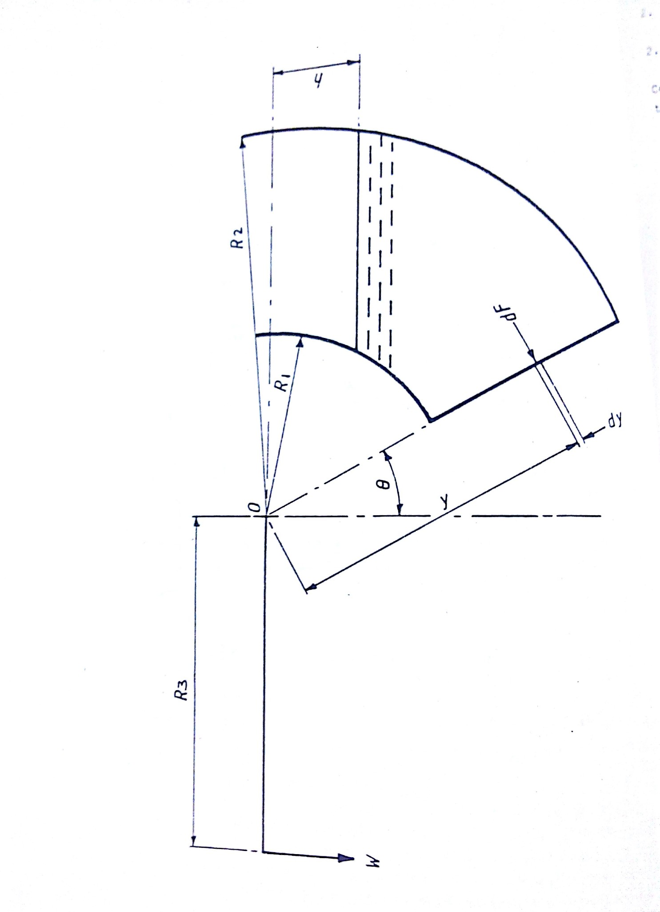
Fig 2 Schema of Centre of Pressure Apparatus

2 THEORY

2.1 Definition of centre of pressure
Centre of Pressure may be defined as the point in a plane at which the total fluid thrust can be said to be acting normal to that plane.

2.2 Analysis
The following, analysis applies to the condition of a plane surface at various angles when it is wholly or partially submerged in a fluid.
Let breadth of quadrant = B
And weight (width) per unit volume = ω
Referring to fig 2, consider an element at start depth y, width δy.
Therefore, force on element δF = ω (y cos θ - h) B dy
And moment of force on element about 0 = ω B ( y cos θ – h) y δ y
Therefore, total moment about 0 = M = w B ∫ (cosθy² - h y) dy
Case I Plane fully submerged
Limits R1 and R2
_{R2}
M=ωB ∫ (cosθy² - hy) dy
^{R1}
_{R2}
M = ωB $[\frac{cosθy^{3}}{3}-\frac{hy^{2}}{2}+c]$
^{R1}

$$M=\frac{ωBcosθ(R_{2}^{3}-R_{1}^{3})}{3}-\frac{ωB\left(R_{2}^{2}-R_{1}^{2}\right)h}{2} . . . . . . 1$$

This equation is of the form of y = mx + C.

A plot of M against h will yield a straight line graph of gradient$-\frac{ωB(R_{2}^{2}-R_{1}^{2})}{2}$ . The value of ω can now be calculated.

Case II Plans partially submerged

Limits R₂ and h sec θ

Hence $M=ωB\int_{hsecθ}^{R_{2}}{\left(cosθy^{2}-hy\right)dy}$
_{R2}
$$M=\left[\frac{ωB cosθy^{3}}{3}-\frac{hy^{2}}{2}+c\right]$$
^{h sec θ}
$$M=\frac{ωBcos θ(R_{2}^{3}-h^{3}\sec^{3}θ)}{3}-\frac{ωBh(R_{2}^{2}-h^{2}\sec^{2}θ)}{2}$$
$$M=\frac{ωBcosθR_{2}^{3}}{3}-\frac{ωB\sec^{2}θh^{3}}{3}-\frac{ωBR_{2}^{2}h}{2}+\frac{ωB\sec^{2}θh^{3}}{2}$$
$$\frac{ωBcosθR_{2}^{3}}{3}-\frac{ωBR_{2}^{2}h}{2}+\frac{ωB\sec^{2}θh^{3}}{6}$$
Re-arranging

$$M+\frac{ωBR_{2}^{2}h}{2}=\frac{ωB\sec^{2}θh^{3}}{6}+\frac{ωBcosθR_{2}^{3}}{3}$$
`Obtain ω from case I and plot h against M+$\frac{ωBR_{2}^{2}h}{2}$

Fig 4 shows the general form of the graphs expected from this experiment.

- EXPERIMENTAL PROCEDURE

Set up the equipment as previously described in section 1.2; affix the weight hanger to the cord. The apparatus will now require trimming in order to bring the submerged plane to the vertical (i.e. 0° position). This is achieved by gently pouring water into the trim tank until the desired position is achieved. The protractor on the tank assembly should be read against the zero line on the back scale. Should it be necessary to remove any water, a pipette is supplied which is dipped into the tank and water held by putting a finger on the top of the pipette and transferring the water to the reservoir. Once trimmed, the tank assembly should be set so that the centre of the rolling radius lines up with the vertical line on the back panel. This ensures that there is sufficient room on the rolling surface from the tank assembly throughout the tests. Add a 20gm weight to the weight hanger. Pour water into the quadrant tank until a 0° balance is restored. Note the weight and the height reading of the water (h). Repeat the procedure for the full range of weights in steps of 20g.

Empty both tanks of water. Again, with the weight hanger alone in position, trim the assembly by gently adding water to the trim tank until a balance at 10° is achieved. Add weights in increments of 20g, restore balance to 10° point and record values for h for the full range of weights. The experiment can then be repeated for 20° and 30°.

Readings should be tabulated in the form outlined in fig 3 and the results calculated in line with the theory given in section-2.

W  (gm) | M  $$\frac{W*9.81*R3}{{10}^{3}}$$  (Nm) | h  (mm) | h  (m) | $$h^{3}$$  $${(m)}^{3}$$ | $$M+\frac{ωBR_{2}^{2}h}{2}$$  (Nm)  Note: ω-specified weight->N/$m^{3}$ | $$θ^{°}$$

Fig 3 Format of results table

θ = $0°$
M (Nm)
Plane fully submerged

h (m)

$$M+\frac{wBR_{2}^{2}}{2} (Nm)$$
P Plane partially submerged

$h^{3}(m^{3})$

Fig 4 Typical Graphs

EXPERIMENT #2
STABILITY OF A FLOATING BODY

1. INTRODUCTION
The question of the stability of a body such as a ship which floats in the surface of a liquid is one of obvious importance. Whether the equilibrium is stable, neutral or unstable is determined by the height of its centre of gravity, and in this experiment the stability of a pontoon may be determined with its centre of gravity at various heights. A comparison with calculated stability may also be made.
1.1 Description of Apparatus
The arrangement of the apparatus is shown in Fig 1. A pontoon of rectangular form floats in water and carries a plastic sail, with five rows of "v" slots at equi spaced heights on the sail. The slots' centres are spaced at 15mm intervals equally disposed about the sail centre line. An adjustable weight, consisting of two machined cylinders which can be screwed together, fits into the "v" slots on the sail; this can be used to change the height of the centre of gravity and the angle of list of the pontoon. A plumb bob is suspended from the top centre of the sail and is used in conjunction with the scale fitted below the base of the sail to measure the angle of list.
1.2 Theory of Stability of a Floating Body
Consider the rectangular pontoon shown floating in equilibrium on even keel as shown in cross-section on fig 2(a). The weight of the floating body acts vertically downwards through its centre of gravity G and this is balanced by an equal and opposite buoyancy force acting upwards through the centre of buoyancy B, which lies at the centre of gravity of the liquid displaced by the pontoon.
To investigate the stability of the system, consider a small angular displacement δθ from the equilibrium position as shown on fig 2(b). The centre of gravity of the liquid displaced by the pontoon shifts from B to $B_{1}$.The vertical line of action of the buoyancy force is shown on the figure and intersects the extension of line BG and M, the metacentre.
The equal and opposite forces through G and B; exert a couple on the pontoon, and provided that M lies above G (as shown in fig 2(b)) this

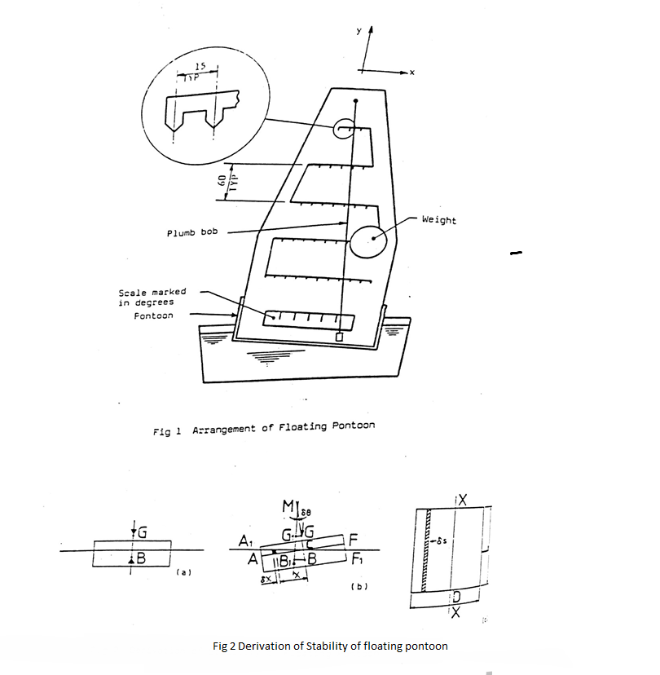

couple acts in the sense of restoring the pontoon to even keel, i.e. the pontoon is stable. If, however, the metacentre M lies below the centre of gravity G, the sense of the couple is to increase the angular displacement and the pontoon is unstable. The special case of neutral stability occurs when M and G coincide.
Fig 2(b) shows clearly how the metacentric height GM may be established experimentally using the adjustable weight (w) to displace the centre of gravity sideways from G. For suppose the adjustable weight is moved a distance δx from its central position. If the weight of the whole floating assembly is W, then the corresponding movement of the centre of gravity of the whole in a direction parallel to the base of the pontoon is $\frac{ω}{W} δx_{1}.$ If this movement produces a new equilibrium position at an angle of list δθ, then in Fig 2(b), $G_{1}$ is the new position of the centre of gravity of the whole, i.e.
$GG_{1}= \frac{ω}{W} δX_{1}$ . . . . . . . 1
Now, from the geometry of the figure
$GG_{1}=GM.δθ$ . . . . . . . . 2
Eliminating G$G_{1}$ between these equations we derive
$GM=\frac{ω}{W } \frac{δx_{1}}{δθ}$ . . . . . . . . . 3
Or in the limit
$GM= \frac{ω}{W}(\frac{dx_{1}}{dθ})$ . . . . . . . . 4

The metacentric height may thus be determined by measuring $\left(\frac{dx_{1}}{dθ}\right)$knowing ω and W. Quite apart from experimental determinations, BM may be calculated from the mensuration of the pontoon and the volume of liquid which it displaces. Referring again to fig 2(b), it may be noted that the restoring moment about B, due to shift of centre of buoyancy to $B_{1 }$is produced by additional buoyancy represented by triangle ${AA}_{1}C$ to one side of the centre line and reduced buoyancy represented by triangle ${FF}_{1}C$to the other. The element shaded in Fig 2((b) and 2(c) has an area δs in plain view and a height xδθ in vertical section, So that

its volume is $xδsδθ$ . The weight of liquid displaced by this element is wxδsδθ, where w is the specific weight of the liquid, and this is the additional buoyancy due to the element. The moment of this elementary buoyancy force about B is $wx^{2}δsδθ$, so that the total restoring moment about B is given by the expression:

$$w δθ\int{x^{2}ds}$$
where the integral extends over the whole area s of the pontoon at the plane of the water surface. The integral may be referred to as I, where
$I=\int{x^{2}}ds$ . . . . . . . 5 the second moment of area of s about the axis XX.
The total restoring moment about B may also be written as the total buoyancy force, wV, in which V is the volume of liquid displaced by the pontoon, multiplied by the lever arm B$B_{1}$. Equating this product to the expression for total restoring moment derived above:
$$wV.BB_{1}=w δθ\int{x^{2}}ds$$
Substituting from equation (5) for the integral and using the expression
$BB_{1}=BM. δθ$ . . . . . . . . 6
Which follows from the geometry of fig 2(b), leads to
$BM=\frac{I}{V}$ . . . . .. .. . 7
This result, which depends only on the mensuration of the pontoon and the volume of liquid which it displaces, will be used to check the accuracy of the experiment. It applies to a floating body of any shape, provided that I is taken about an axis through the centroid of the area of the body at the plane of the water surface, the axis being perpendicular to the place in which angular displacement takes place. For a rectangular pontoon, B lies at a depth below the water surface equal to half the total depth of immersion, and I may readily be evaluated in terms of the dimensions of the pontoon as

$I=\int{x^{2}ds=\int_{-D/2}^{D/2}{x^{2}Ldx=\frac{1}{12}}}LD^{3}$ . . . . . . . . 8

1.3 Installation Instructions
Fit the sail into its housing on the pontoon and tighten the clamp screws. Check that the plumb bob hangs vertically downwards on its cord and is free to swing across the lower scale.
1.4 Routine Care and Maintenance
After use, the water in the tank should be poured away and the pontoon and tank wiped dry with a lint-free cloth. The pontoon should never be left permanently floating in the water.

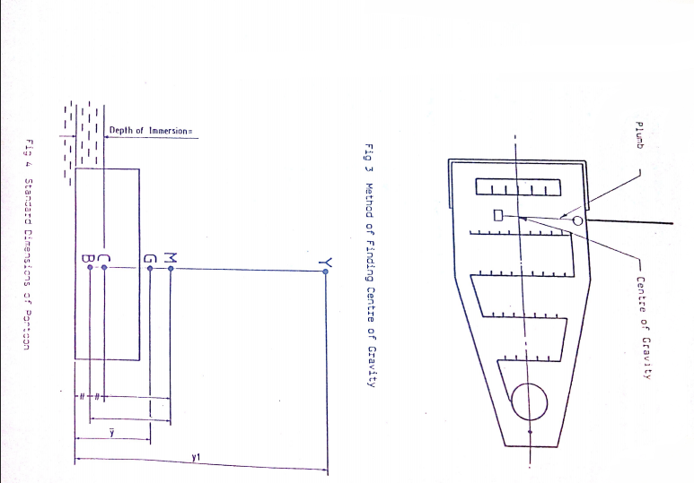

2. EXPERIMENTAL PROCEDURE

The total weight of the apparatus (including the adjustable weight and the two magnetic weights) W and the adjustable weight are stamped on a label affixed to the sail housing. Measure the length and breadth of the pontoon and also the thickness of the sheet metal bottom (nominally 2mm).
The height of the centre of gravity may be found as follows: (Refer to Fig 3). (i) Fit the two magnetic weights to the base of the pontoon.
(ii) Fit the thick knotted cord, with the plumb weight, through the hole in the sail, ensuring that the plumb weight is free to hang down on the side of the sail which has the scored centre line.
(iii) Clamp the adjustable weight into the "V" slot on the centre line of the lowest row and suspend the pontoon from the free end of the thick cord. Mark the point, where the plumb line crosses the sail centre line with typists correcting fluid or a similar marking fluid.
(iv) Repeat paragraph (iii) for the other four rows.
With the adjustable weight situated in the centre of one of the rows allow the pontoon to float in water and position the two magnetic weights on the base of the pontoon to trim the vessel. When the vessel has been trimmed correctly, the adjustable weight may be moved to positions either side of the centre line for each of the five rows. At each position the displacement can be determined by the angle the plumb line from the top of the sail makes with the scale on the sail housing.

3. RESULTS AND CALCULATION
Total weight of floating assembly (w) = Kg
Adjustable weight (ω) = Kg
Breadth of pontoon (D) = mm
Length of pontoon (L) = mm
Second moment of area I =$\frac{LD^{3}}{12}*{10}^{-12}$ = $m^{4}$
Volume of water displaced $v= \frac{W}{{10}^{3}}$ = $m^{3}$
Height of metacentre above centre of buoyancy $BM=\frac{I}{V}$ = m
Depth of immersion of pontoon = $\frac{v}{LD}$ = m
Depth of centre of buoyancy CB, = $\frac{V}{2. LD}$ = m
It is suggested that Fig 3 is marked up to be referred to each time the apparatus is used. Note that when measuring the heights $\overline{y}$ and $y_{1}$, as it is only convenient to measure from the inside floor of the pontoon, the thickness of the sheet metal bottom should be added to $\overline{y}$ and $y_{1}$ measurements. The position of G (and hence the value of $\overline{y}$) and a corresponding value of y was marked earlier in the experiment when the assembly was balanced.
The height of $\overline{y}$ of G above the base will vary with the height y of the adjustable weight above the base, according to the equation:
$$\overline{y}=y_{1}.\frac{ω}{W}+A$$
(where A is a constant which pertains to the centre of gravity of the pontoon and the height of adjustable weight, then $\overline{y}$ and $y_{1}$ can be measured and the constant A calculated. This can be used in calculations for subsequent heights of $\overline{y}$ and $y_{1}$which can be checked against the markings made earlier.

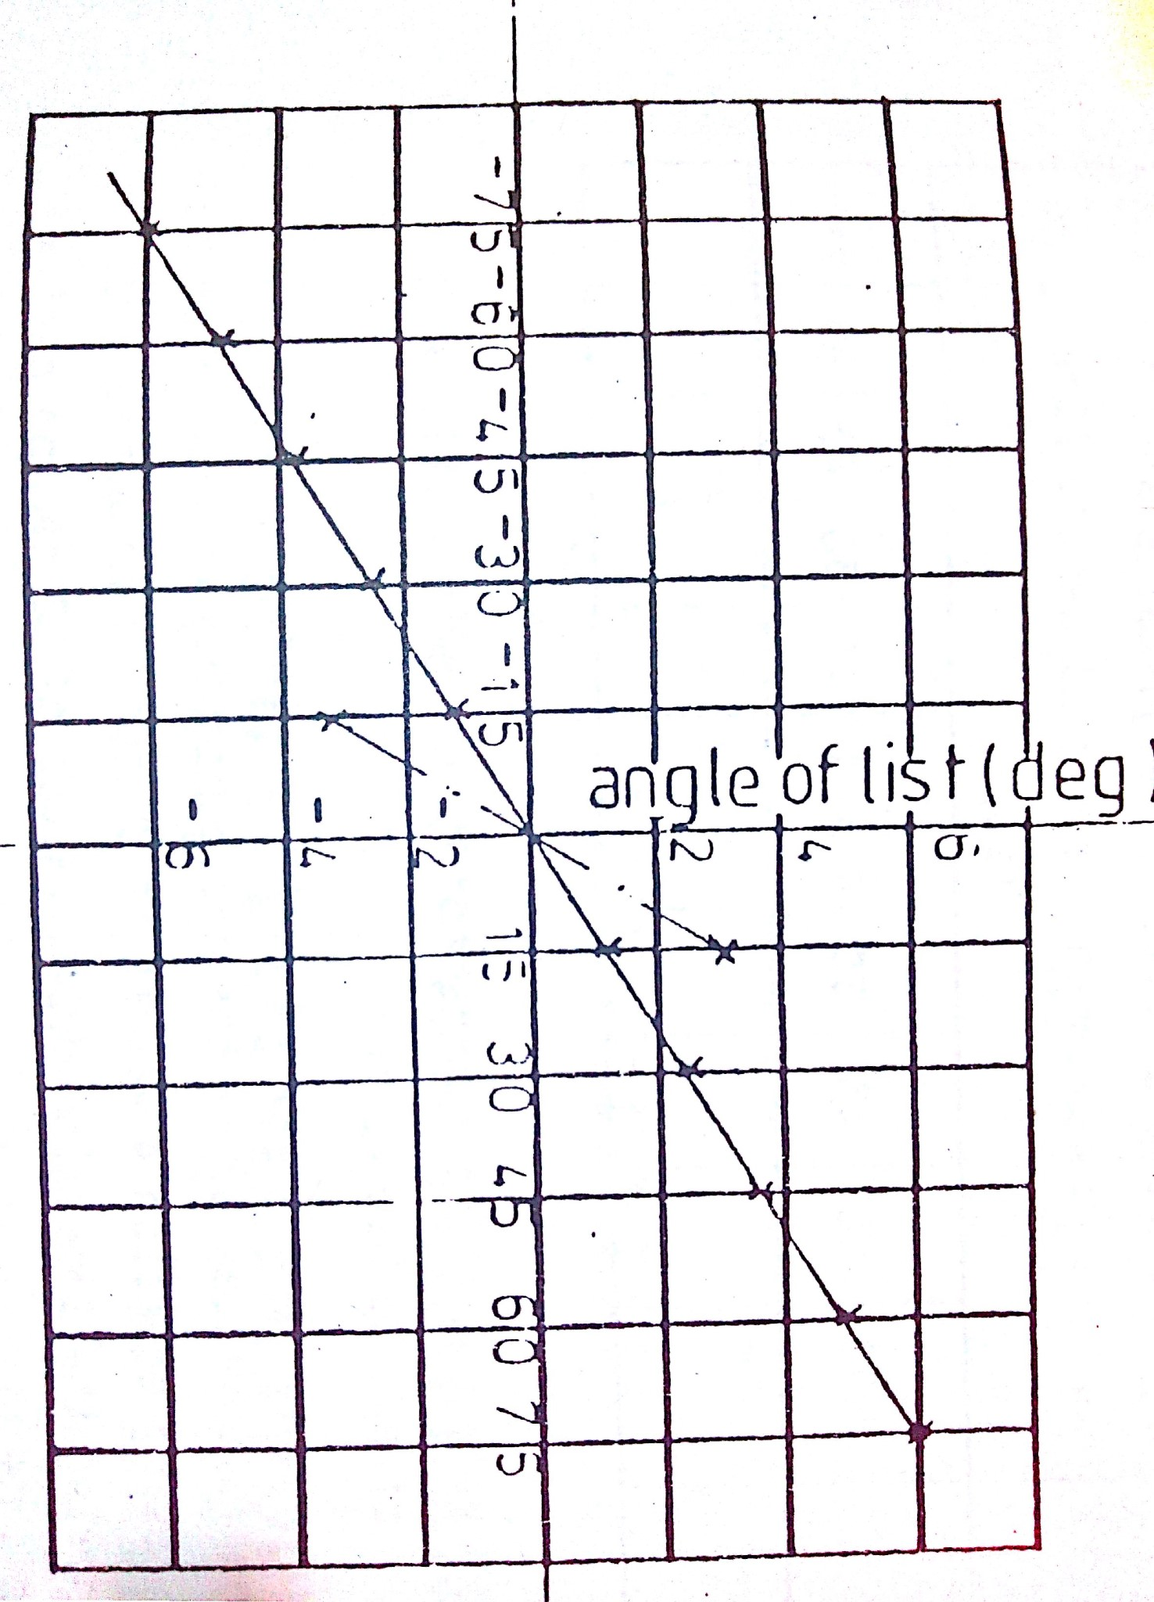
Lateral position
Of weight (mm)

Fig 5 Variations of Angle of List with Lateral Position of Weight
(Heights shown are max and min)

Values of angles of list produced by lateral movement of the adjustable weight height $y_{1}$ should be recorded in the form of table 1. A graph (Fig 5) for each height $y_{1}$, of lateral position of adjustable weight against angles of list, can then be plotted. Note: Decide which side of the sail centre line is to be termed negative and then term list angles on that side negative.

Height of adjustable weight $y_{1}$ mm  (i) | Angles of list for adjustable weight lateral displacement from sail centre line $x_{1}$ mm  (ii)
 | -75 | -60 | -45 | -30 | -15 | 0 | 15 | 30 | 45 | 60 | 75
Table 1 values of list angles for height and position of adjustable weight

From Fig 5 for the five values of Y the corresponding values of $\frac{dx_{1}}{dθ}$ can be extracted. Using equation 4 values of GM can be obtained. Using equation 9 and knowing the immersion depth; values of CG can be derived. Also since CM = CG + GM values of CM can be calculated. The above values should be calculated and arranged in tabular form as shown in table 2.

Height of adjustable weight $y_{1}$(mm)  (i) | Height of G above water surface CG (mm)  (ii) | $$\frac{dx_{1}}{dθ}$$  (mm/º)  (iii) | Metacentric height GM(mm)  (iii) | Height of M above water surface CM(mm) (v)
Table 2 Derivation of Metacentric Height from experimental results

The values of $\frac{dx_{1}}{dθ}$ can now be plotted against CG the height of G above the water line. Extrapolation of this plot will indicate the limiting value of CG above which the pontoon will be unstable.

EXPERIMENT #3
CALIBRATION OF WIND TUNNEL AIR SPEED USING A PITOT STATIC PROBE

GENERAL
HAMPDEN MODEL H-6910 WIND TUNNEL
Bench:
The Hampden H-6910 Wind Tunnel is equipped with the basic facilities for generating air flows which are used with the Hampden H-6910 series experiments. The unit is equipped with a bench, control panel, wind tunnel including an inlet cone, clear experiment section, outlet cone and screen; manual traverse unit, linear track with carrier; and main AC circuit breaker. The bench includes a shelf and lockable drawer for storage. The entire unit is mounted on four casters, two of which are locking. A power cord and cord rack are also provided.
The manual traverse unit is mounted on the carrier. The carrier rides along the table rail which includes a scale calibrated in millimeters. The manual traverse unit is used to position an air probe in the experiment section. The unit is capable of both linear and rotary positioning. The linear scale is 25 cm long with minor divisions of 0.2 cm and resolution of 0.02 cm if the vernier is used. The protractor is graduated in 2° steps over a full 360°. With the vernier, it has a resolution of 0.2°. Interchangeable mounting collets are provided for locking probes firmly in place without damaging them. The pressure seals are not necessary for unit opera-tion but are included to complete the manual traverse assembly. To mount a probe in the manual traverse unit, perform the following:

1. Select the desired air probe.
2. Select the proper mounting collet.
3. Place the probe into the mounting collet.
4. Insert the mounting collet and probe into the manual traverse unit. Make sure that the slot is rotated 90° from the setscrew located on the front of the manual traverse unit.
5. Align the head of the probe with zero on the protractor scale.
6. Tighten the setscrew until the probe is held firmly in place.
To use the bench, first plug the power cord into an electrical outlet with the proper service rating for the bench. The fan is operated by turning the main AC circuit breaker to the on position and switching the Variable AC motor to the start position. Adjust the speed with the knob (Refer to the AC Tech Manual for operational procedures and diagnostics).
Pitot Tubes
On the Hampden H-6910 Wind Tunnel, the total and static pressures of an air stream are measured with pitot tubes and indicated by manometers. The term pitot tube is used to encompass a specific class of instruments that measure fluid pressures. There are different types of "pitot tubes", among which are: (1) static pressure tube; (2) total pressure tube which is also known as Pitot or stagnation tube and (3) Pitot-static tube. Pressure measuring probes which are used to measure fluid pressures are: ( 1 ) Kiel probe, (2) two-dimensional probe, (3) three-dimensional probe and (4) boundary layer probe. Each of the previously mentioned instruments have a specific application.
A. PITOT TUBES - are used to measure the total and static pressure at the same point in a moving fluid. If the temperature of the fluid is also known, then the density, flow velocity, mass flow rate, total energy, momentum flux, viscosity, etc. can be calculated.
The geometry of a pitot tube affects its measuring capabilities. The shape of the probe sensing head governs its sensitivity to non-parallel flows, i.e. yaw and pitch angles. The length of the sensor head determines its sensitivity to flow velocity or Mach number; with longer sensor heads being more accurate over wider flow ranges. The pitot tubes used on the Hampden. H-6910 Wind Tunnel are modified Prandtl type.
The Mach number range of the pitot tubes utilized with the Hampden H-6910 Wind Tunnel depend upon several factors. While there is no minimum Mach number for pitot tubes, the lower usable limit is dependent upon the sensitivity of the indicating device. For general purpose laboratory inclined manometers, the minimum Mach number is approximately 0.06, or 70 ft/sec for standard air (density of 0.075 lbs/cuft). The upper limit for total pressure measurements is approximately Mach 0.95 and the upper limit for static pressure measurements is approximately Mach 0.70. The upper limit for static pressure measurements is lower than that for total pressure measurements due to local shock waves that form on or near the tip of the sensor.

Pitot tubes are affected by Reynolds number at low fluid velocities. The minimum Reynolds number for total pressure measurement is approximately 30. This is the point where the characteristic length of the pitot tube is equal to the diameter of the impact hole. Below this value, the indicated impact pressure is higher than the stream impact pressure due to viscosity effects. For air at standard atmospheric conditions, the error due to low Reynolds numbers is only apparent for air velocities less than 12 ft/sec. And this is for pitot tubes with impact hole diameters of 0.010" or less. This corresponds to a differential pressure that is well below the sensitivity most manometers.
The accuracy of pitot tubes is also affected if the sensor head is not parallel to the fluid flow. The total and static pressure measurement error due to yaw and pitch angles increases rapidly above angles of 5°. Fortunately, they cancel each other out so velocity pressure measurements are 2% accurate up to angles of attack of 30°.

The measurement of static pressure is also sensitive to the presence of fluid boundaries. The sensor head and fluid boundary form a Venturi which results in an indicated velocity pressure greater than the actual velocity pressure. The presence of' a pitot tube in a pipe also affects the static pressure. The pitot tube partially blocks the flow passage which increases the flow velocity in the vicinity of the device. This results in an indicated static pressure which is less than the actual static pressure.

The speed of response of pitot tubes is also geometry dependent. The diameter of the air passage within the probe, the diameter and length of the interconnecting tubes, and the displacement volume of the manometer determines the time constant. For tube diameters greater than 1/8" and ordinary manometer connections, the time constant is very short. However, the time constant increases rapidly for smaller diameter tubes, with a response time of approximately 15 to 60 seconds for tubes having a 1/16" diameter. One common problem with pitot tubes that have very small diameters is that they tend to choke up easily if there is fine dirt in the fluid.

The three basic types of pitot tubes are as follows:

1. Pitot tube - measures the total pressure of a moving fluid, also known as total pressure tube or stagnation tube.
2. Static tube - measures the static pressure of a fluid.
3. Pitot-static tube - simultaneously measures the total and static pressure in moving fluids, also known as a total-static tube.
B. AIR PROBES - The Hampden H-6910 Wind Tunnel utilizes several other air pressure measuring devices (or probes) in addition to pitot tubes. Each of these probes has a specific function. In general, the probes have the same characteristics as pitot tubes except where noted. The air probes used are:

1. Kiel probe - measures the total pressure in a moving fluid where the flow direction is unknown or changing. Variance in yaw and pitch angles up to ±50° will not result in an error in the indicated total pressure. Kiel probes indicate the true total pressure up to a Mach number of 1. The yaw angle has a slight Mach number sensitivity above Mach numbers of 0.3. This decreases the range of the Yaw angle by approximately 4% at Mach 1
Sensitivity to Reynolds number is only evident at very low velocities. For air, the limiting velocity is approximately 4 ft/sec.
While turbulence induced errors are negligible, severe turbulence may decrease the range of yaw and pitch angles. Kiel probes are slightly sensitive to steep total pressure gradients which are found near solid boundaries or behind objects in the fluid flow. Under these conditions, there is a shift in the effective center of the probe. This shift corresponds to a streamline 0.5d away from the geometric center of the probe and is in the direction of the higher pressure.
The time constant of the Kiel probe supplied with the unit is 36 seconds. This is for an installation including an 1/8" O.D. connecting hose up to 20 feet long and a liquid manometer of 1/4" O.D. The yaw range is ±52° and the pitch range is +47° to -40°.
2. Boundary layer probe - measures the total pressure in a fluid near fluid boundaries. The tips of these probes are flattened to minimize potential errors in total pressure measurement due to flow turbulence or acceleration. If used in conjunction with an adjacent static tap and a manual traverse unit, boundary layer probes are effective in determining velocity gradients near fluid/solid interfaces. Boundary layer probes provide accurate to within a distance from the interface that is equal to 23%, of the probe outer diameter. Otherwise, they are subject to the same restrictions as pitot tubes.
3. Two dimensional directional probe - measures total and static pressures; and yaw and pitch angles of a moving fluid. Two dimensional directional probes only indicate flow direction in a plane perpendicular to the probe axis. Prism and wedge type probes are used to measure both total and static pressure. There are three sensing holes on the probe. The center hole measures Pl, and the side holes measure P2 and P3 respectively. If the probe is rotated until P2 equals P3, then P1 is the total pressure of the fluid. The connections to the probe are shown in Figure 1. It is not essential to indicate the static pressure, Pi — P2, or use the choke. The choke speeds up reading process. It provides an average pressure which equals$\frac{P2+P3}{2}$. This average pressure changes slowly with yaw angle which allows the indicated pressure to be recorded when P2 and P3 are not exactly equal.

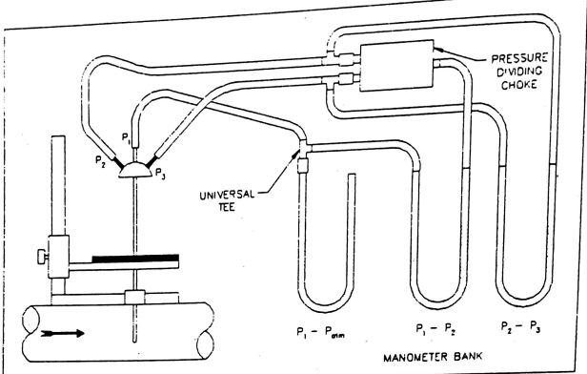Figure 1

Static pressure is also affected by the presence of the probe itself. Whenever a probe is introduced into a small passage, the static pressure in the vicinity of the probe is changed due to the reduction of the cross-sectional flow area. For round probes perpendicular to flow, the drop in the static pressure at the probe cross-section and downstream from it is approximated by:
$$\frac{P_{s1}-P_{s2}}{P_{t}-P_{s1}}=1.2 \frac{a}{A}$$
Where$P_{s1}$ and $P_{s2}$ are the original and modified static pressure, Pt is the total pressure and a/A is the fraction of the passage area, A, blocked by the cross-sectional area of the probe, a.
Subject to the above restrictions, the probe can be assumed to sense the true static pressure when the sensing holes are 10 probe diameters away from the boundary they project through and the probe tip at least one diameter from the opposite wall.
This probe is insensitive to pitch angles of up to 20° and Mach numbers up to Mach 0.7. The probe is calibrated and this data is found in the appendix.

- Three dimensional directional probe - measures total and static pressure; and yaw and pitch angles of fluid flow. The probe is a prism type with five sensing holes (See Figure 3 for location of sensing holes). The central sensing hole measures P1 which indicates total pressure when P2 is equal to P3. If the probe is used with the manual traverse unit, the yaw angle of the flow is indicated by the rotary protractor when P2 is equal to P3. The pitch angle, θ, is determined by calculating
$$\frac{P_{4}-P_{5}}{P_{1}-P_{2}}$$
and consulting the proper calibration curve. At any given pitch angle; the velocity coefficient, (Pt - Ps)/(P1 - P2), and the total pressure coefficient, (P1 -Pt)/(Pt - Ps) can be read from the appropriate curves.
The three dimensional directional probe is furnished with calibrations curves for pitch angles up to ±40° and is usable up to Mach 0.7. They are subject to blockage effects as are the two dimensional directional probes. Refer to Figure 2 for proper connections to the probe.
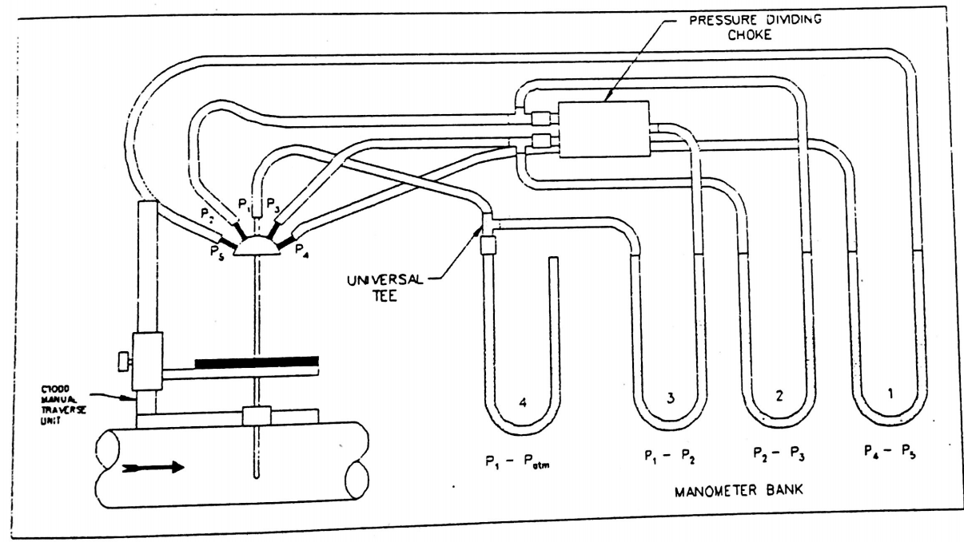
Figure 2
ACCESSORIES - in order to interconnect the air probes to the manometers, the following items are necessary:
1. Plastic tubing - supplied in ten foot lengths with three different outer diameters; 1/16" O.D., 118" 0.D. and 1/4" O.D. The plastic tubing is used to interconnect the air probes with the manometers.
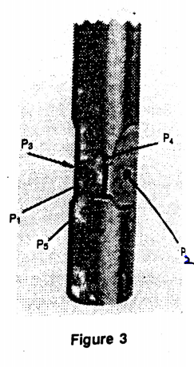
2. Straight connector - adapts the air probe size to the pressure dividing choke or manometer tubing size.
3. Universal tee connector - divides a single pressure line into two lines for interconnection to two separate devices.
4. Pressure dividing choke - provides a high resistance bleed across the differential P2 - P3 and outputs the average of P2 and P3. It also quickens the response time of two and three dimensional probes.
HAMPDEN H-6910-05 Manometer Package
The manometers utilized on the Hampden H-6910 Wind Tunnel are well-type with precision bored wells. . The instruments use a colored gauge oil. This gauge oil is a stable petroleum base oil with a carefully controlled specific gravity which gives a consistent, high visibility meniscus. The scales are clear, sharp, accurate and easy to read. The scales feature a silkscreened legend on polished chrome plated brass which reflects the image of the meniscus. To assure parallax free readings, always align the meniscus with its image. The scales are compensated to account for the specific gravity of the indicating fluid and "well drop".
A. Inclined-Vertical Manometer - a precision instrument with an accuracy of ±1/4% This manometer has an inclined range of 0 - 2 inches of water column and a vertical range of 2.1 - 5 inches of water column. The former scale has minor divisions of 0.01 and the latter scale has minor divisions of 0.1.
Leveling - the manometer must be leveled to ensure maximum accuracy. There is a ground glass bubble level sensitive to 115 - 125 sec./2mm and is provided with two red lines for easy visibility and alignment. To level the manometer, perform the following procedure:
a. loosen the leveling screws located at the bottom of the manometer.
b. adjust the position of the manometer until the bubble is between the red lines of the glass bubble level.
c. tighten the leveling screws.

2. Filling - the manometers are filled with red gauge oil. The specific gravity of the oil is 0.826. Be careful to not overfill the manometer. To fill the manometer, perform the following:
a. remove the right-hand tubing connector (rotate it counterclockwise).
b. open the left-hand tubing connector by rotating it one full turn counter-clockwise.
c. center the fluid level plunger adjustment.
d. fill the left-hand side with the red gauge fluid until it is close to zero.
e. replace the left-hand tubing connector.
f. close both tubing connectors.
3. Zeroing - a manometer must always be zeroed before it is used. This will ensure an accurate reading by having a known reference point. To zero the manometer, adjust the fluid level plunger until the meniscus is lined up with zero on the manometer.
4. Configuration - the manometer can be configured to read positive, negative or differential pressures. Open both tubing connectors by rotating them one full turn counterclockwise. Determine the type of pressure to be measured and connect the pressure lines to the manometer according to the following:
a. positive pressure - attach the high pressure line to the left-side tubing connector (no connection is necessary to the right-side tubing connector).
b. negative pressure - attach the high pressure line to the right-side tubing connector (no connection is necessary to the left-side tubing connector).
c. differential pressure - attach the high pressure line to the left-side tubing connector and the low pressure line to the right-side tubing connector.
B. Inclined Manometer - a precision instrument with an accuracy of ± 1%. This manometer has a range of 0.05 - 0.5 inches of water column. The scale has minor divisions of 0.005. This unit features over-pressure safety traps to assure that a sudden over-range pressure does not force fluid out of the manometer. 1. Leveling - the manometer must be leveled to ensure maximum accuracy. There is a ground glass bubble level sensitive to 115 - 125 sec./2mm and is provided with two red lines for easy visibility and alignment. To level the manometer, perform the following procedure:
a. loosen the leveling screw located at the side of the manometer.
b. adjust the position of the manometer until the bubble is between the red lines of the glass bubble level.
c. tighten the leveling screw.

2. Filling - the manometers are filled with red gauge oil. The specific gravity of the oil is 0.826. Be careful to not overfill the manometer. To fill the manometer,
perform the following:
a. remove the right hand tubing connector (rotate it counterclockwise).
b. open the left-hand tubing connector by rotating it one full turn counter-clockwise. c. center the scale.
d. fill the left-hand side with the red gauge fluid until it is close to zero.
e. replace the left-hand tubing connector.
f. close both tubing connectors.
3. Zeroing - a manometer must always be zeroed before it is used. This will ensure an accurate reading by having a known reference point. To zero the manometer, loosen the scale lock nut and adjust until the meniscus is lined up with zero on the manometer. Tighten the scale lock nut.
4. Configuration - the manometer can be configured to read positive, negative or differential pressures. Open both tubing connectors by rotating them one full turn counterclockwise. Determine the type of pressure to be measured and connect the pressure lines to the manometer according to the following:
a. positive pressure - attach the high pressure line to the left-side tubing connector (no connection is necessary to the right-side tubing connector).
b. negative pressure - attach the high pressure line to the right-side tubing connector (no connection is necessary to the left-side tubing connector).
c. differential pressure - attach the high pressure line to the left-side tubing connector and the low pressure line to the right-side tubing connector.
C. Inclined Manometer - a precision instrument with an accuracy of ±2%. This manome-ter has a range of 0.02 - 0 - 2 inches of water column. The scale has minor divisions of 0.02.
1. Leveling - the manometer must be leveled to ensure accuracy. There is a ground glass bubble level sensitive to 115 - 125 sec./2mm and is provided with two red lines for easy visibility and alignment. To level the manometer, perform the following procedure:
a. loosen the mounting screws located on each side of the manometer.
b. adjust the position of the manometer until the bubble is between the red lines of the glass bubble level.
c. tighten the mounting screws.

2. Filling - the manometers are filled with red gauge oil. The specific gravity of the oil is 0.826. Be careful to not overfill the manometer. To fill the manometer, perform the following:
a. remove the right-hand tubing connector (rotate it counterclockwise).
b. open the left-hand tubing connector by rotating it one full turn counter-clockwise.
c. center the scale.
d. fill the left-hand side with the red gauge fluid until it is close to zero.
e. replace the left-hand tubing connector.
f. close both tubing connectors.

3. Zeroing - a manometer must always be zeroed before it is used. This will ensure an accurate reading by having a known reference point. To zero the manometer, loosen the scale lock nut and adjust until the meniscus is lined up with zero on the manometer. Tighten the scale lock nut.

4. Configuration - the manometer can be configured to read positive, negative or differential pressures. Open both tubing connectors by rotating them one full turn counterclockwise. Determine the type of pressure to be measured and connect the pressure lines to the manometer according to the following:
a. positive pressure - attach the high pressure line to the left-side tubing connector (no connection is necessary to the right-side tubing connector).
b. negative pressure - attach the high pressure line to the right-side tubing connector (no connection is necessary to the left-side tubing connector).
c. differential pressure - attach the high pressure line to the left-side tubing connector and the low pressure line to the right-side tubing connector.

CALIBRATION OF WIND TATUNNEL AIR SPEED USING A
PITOT-STATIC PROBE

OBJECTIVE:
To learn the techniques for 1) air pressure measurements and, 2) the use of a
pitot-static probe for air velocity measurements.

DISCUSSION:
The total pressure of an air stream flowing in a duct is the sum of two pressures. First, there is the static pressure. This pressure, also known as bursting pressure is that being exerted on the duct sidewalls. The second pressure is the velocity, or impact, pressure caused by the moving air. We can't really measure velocity pressure directly. A measurement of the pressure of the air against a target is the total pressure. The pressure of the air perpendicular to the air flow is static pressure.
What we do is to measure the total pressure and measure the static pressure subtracting the two with a differential manometer. The difference will be the velocity pressure. The differential manometer is an oil-filled tube having a low pressure connection at the top, above the oil, and a high pressure connection at the bottom, below the oil. The oil is forced upward by the pressure at the bottom, and opposed by the pressure at the top. The net distance the oil rises, then, is proportional to the difference in these two pressures. The graduated tube is inclined at an angle so as to produce more graduations per inch, for more accurate reading.
The unit for air pressure measurement is "W.C. (for inches water column). The meaning is this: one "W.C. is the pressure that supports a one-inch-high column of water at standard conditions).
Measuring air pressure is a means of arriving at air velocity in feet per minute, and the rate of air flow in cubic feet per minute (cfm) See Figure 1-1 below. Air velocity is proportional to the square root of velocity pressure. The constant of proportionality is 4004.4, assuming an air density of 0.075 pounds per cubic foot — which corresponds to thy air at 70° Fahrenheit and a barometric pressure of 29.92 "Hg. If the velocity calculation is to be precise, the actual air density must be used. It can be calculated from relative humidity, temperature and barometric pressure.

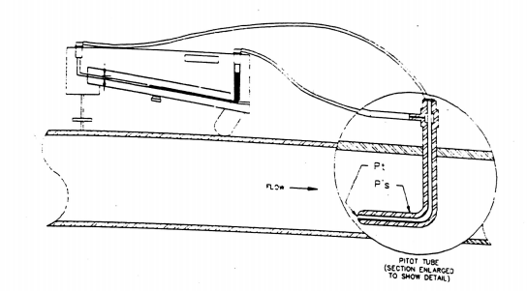
Figure 1-1 Pitot tube senses total and static pressures.
Manometer measures velocity pressure - (Difference between total and static pressures).

The equation for Air Velocity is:
$v=4004.4\sqrt{∆P}(for Air at .075\frac{lb}{{ft}^{3}}70℉, 29.92$in Hg Barametric press) Eq 1.1 where
V = Velocity in ft./min.
$∆$p = Velocity pressure in inches of water
In this experiment we will learn how air pressure is measured with a Pitot (pronounced Pe-tow) tube, and how air velocity is calculated.
Essentially, a Pitot tube consists of an impact tube (which receives total pressure input) fastened concentrically inside a tube of slightly larger diameter. The outside tube receives receives static pressure input from radial sensing holes around the tip. The air space between inner and outer tubes permits transfer of pressure from the sensing holes to the static pressure connection, which is at the opposite end of the Pitot tube. From this connection, connecting tubing carries this pressure to the low pressure side of the manometer. The total pressure connection is made to the high side of the manometer through similar tubing. The manometer indicates velocity pressure directly.
PROCEDURE
Step 1. Install the standard test section in the wind tunnel.
Step 2. Install a pitot-static probe in the probe positioner and through the duct access hole in the test section.

Step 3 Connect pressure tubing from the static and total pressure taps on the pitot-static tube to one of the manometers with a range of -0.2 to +0.2 in $H_{2}o$ per Figure 1-1 above.
Step 4 Using the variable frequency drive control to adjust fan speed and the pitot tube positioner to locate the pitot tube vertical location in the duct, read and record the velocity pressures($∆P in H_{2}o$) at various locations within the duct.
Fan control  Knob position | Probe position(cm) above Duct Center Line
Fan control  Knob position | C.L. | 2 | 4 | 6 | 8
20
40
60
80
100

Step 5 With the data in Table 1-1, calculate the average velocity (using Equation 1.1 above)

Calculate the volumetric flow rate ($\frac{{ft}^{3}}{min}.)$ (Using Equation 1.2 below).

${ V}_{f}=V_{AVE}*A$ Eq 1.2

Where ${ V}_{f}$= volumetric flow rate $\frac{{ft}^{3}}{min}$
$v_{AVE}$= average air velocity $\frac{ft}{min}$
A= Area of inside of duct. (HEC standard test section is 0.444${ ft}^{2}$
inside dimensions)

EXPERIMENT #4
AN EXPERIMENTAL STUDY OF THE VELOCITY AND TEMPERATURE PROFILES OF THE FLOW ACROSS A DIAMETER OF A PIPE

INTRODUCTION

A basic knowledge of the theory of forced convection heat transfer is of considerable value in many fields of engineering, including particularly the design of heat exchangers.

This apparatus enables the student to experimentally investigate the theory and associated formulae related to forced convection in pipes. Measured experimental data enables the student to calculate the heat transfer (film) coefficient 'h', the pipe friction coefficient 'f' and various non-dimensional groups including Reynolds Number 'Re', Nusselt Number 'Nu' and Stanton Number 'St'. The values obtained can be compared with those derived from accepted empirical formulae and the validity of Reynolds Analogy may be explored.

A pitot tube traverse unit and additional manometer may be fitted to the apparatus as an optional extra, thus enabling the student to study the velocity and temperature profiles of the flow across a diameter of the pipe.

2. DESCRIPTION OF THE APPARATUS
The apparatus is shown in detail in figure 1. It consists of an electrically driven centrifugal fan which draws air through a control valve and discharges into a 76.2 mm (3 in) diameter, U-shaped pipe. The fan speed remains constant throughout. A British Standard orifice plate 40 mm diameter (1.625 in on English equipment) is fixed in this pipe to measure the air flow rate. This pipe is connected to a copper test pipe which is 3048 mm tip (10 ft) long, 32.6 mm (1.284 in) internal diameter and has a wall thickness of 1.20 mm (0.047 in). The test pipe, which discharges to atmosphere, is electrically heated over the final 1753 mm (69 in) by a heating tape wrapped around the outside of the pipe. The power input to the tape can be varied by means of a variable transformer fitted to the apparatus, the input being measured with the aid of a voltmeter and ammeter fixed to the instrument panel. The test pipe is insulated with 25 mm (1 in) thick fibreglass lagging. All the pipework rests on wooden blocks supported by the steel frame of the apparatus.

A 1524 mm (60 in) test length, situated within the heated length of the test pipe, has pressure tappings at each end which are connected to a water manometer on the instrument panel. Other manometers fixed to the instrument panel measure fan discharge pressure and the orifice pressure drop.

Seven thermocouples (numbers 1 to 7) are fixed to the wall of the copper test pipe at various points along the heated length. A further six thermocouples (numbers 8 to 13) are situated at points within the lagging. The positions of all the thermocouples are shown on a diagram displayed on instrument panel and shown in figure 2. A mercury in glass thermometer measures the air temperature at the inlet to the test pipe.

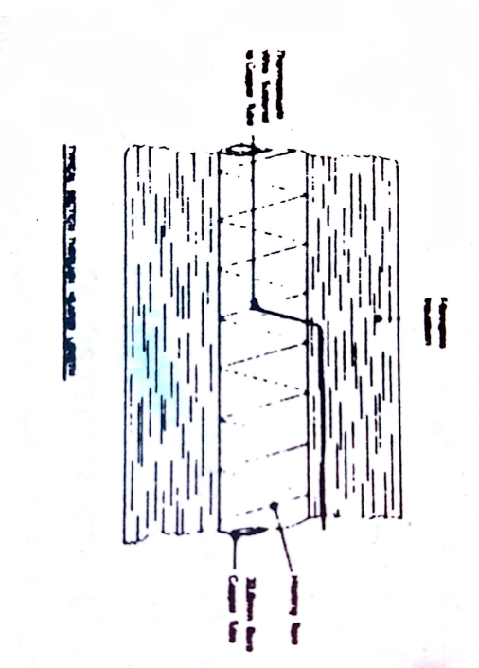
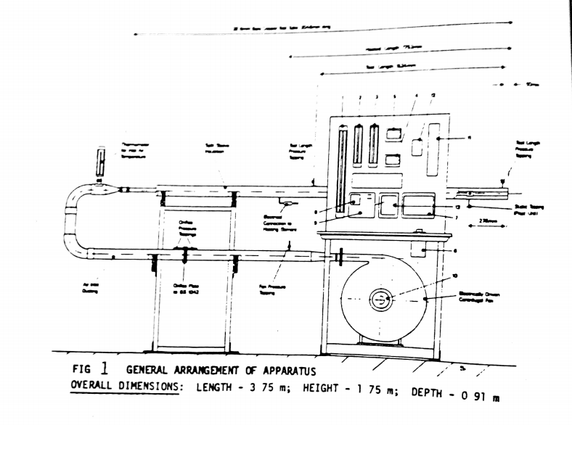
Key to instruments & controls

1. Manometer Measuring Fan Pressure
2. Manometer measuring pressure drop over the ORIFICE PLATE
3. Manometer Measuring Pressure Drop over Test Length
4. Ammeter Indicating Heater Current
5. Voltmeter Indicating Heater voltage
6. Variac Transformer to vary the heater Load
7. Isolater and starter For Fan Motor
8. Thermocouple Selector Switch
9. Terminal for connection to Instrument
10. Air Flow Control Value
11. Pitot Manometer & Pitot Traverse (optional)
12. Heater Signal Light and Fuses
13. Contractor For Heater

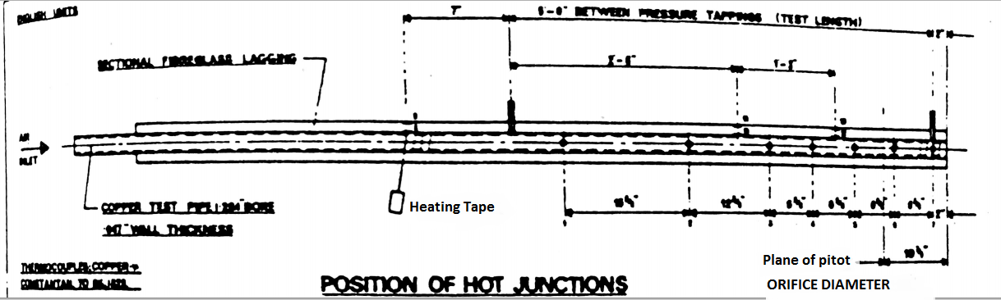

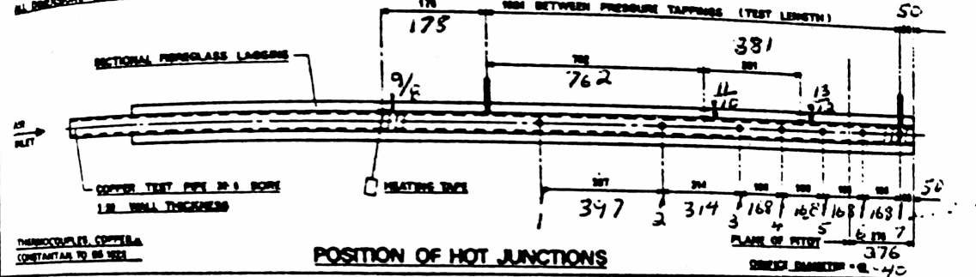

FIG 2 DIAGRAMS SHOWING POSITION OF THERMOCOUPLES

The output from any thermocouple may be chosen with a selector switch fitted to the instrument panel and measured with an electronic thermometer or potentiometer. A suitable electronic thermometer (REF.TD.30a) can be supplied as an optional extra, if required.

The velocity and temperature traverse assembly, as shown in figure 3, if fitted, comprises of a Pitot tube which may be traversed across a diameter of the heated pipe. Its position at any point is read directly from a combined linear scale and vernier. The Pitot tube measures the stagnation pressure only, the associated static pressure being sensed at a tapping point in the wall of the heated pipe. The difference between the two pressures is measured by a differential water manometer mounted on the panel, and is used to calculate the velocity at points across the plane of traverse.

The temperature of the air is measured by a thermocouple situated in the Pitot tube just behind the piezometer opening. The output from this thermocouple appears at selector switch position 14.

The whole assembly is mounted on a small flange secured to the heated pipe in such a position that the plane of the piezometer opening is at a distance of 276 mm (10.9 in) from the discharge end of the pipe.

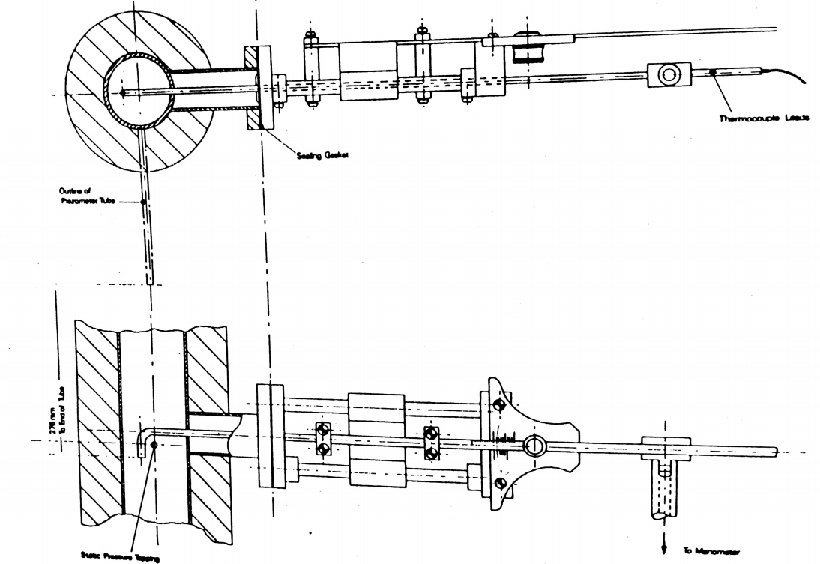Fig 3 Detail of PITOT TRAVERSE UNIT
- PARTICULARS OF THE APPARATUS

Metric Apparatus English Apparatus

Orifice plate diameter 40 mm 1.625 in
Pipe internal diameter 32 6 mm 1.284 in
Pipe wall thickness 1 20 mm 0.047 in
'k' for pipe material (copper) 380 6 J/msºC 220 Btu/ft.h. ºF
Thickness of lagging 25 mm 1 in
'k' for pipe lagging material 0 0415J/msºC 0.024 Btu/ft.h. ºF
Heated length of pipe 1753 mm 69 in
Thermocouple material copper constantan to B.S. 1828

The pressure tappings on the pipe are at 51 mm (2 in) and 1575 mm (5ft 2 in) from the exit.
Electrical Supply: 380/440v, 3 phase neutral and earth, 50.Hz, 15 amp. as standard. Other supplies can be accommodated to suit customers requirements.
Maximum Allowable Tube Temperature - 150°C (Thermocouples l to 7)
Note: These particular's apply to apparatus serial numbers 022 onwards. Earlier apparatus incorporated Imperial copper tubes and Ni Cr/Ni Al thermocouples, full details being given on the apparatus information plate.

- A TYPICAL EXPERIMENT USING THE PITOT TUBE ASSEMBLY
4.1 OBJECT
To examine the velocity and temperature profiles of air flowing in a section of heated pipe. Also to determine the mean temperature rise in the air and to compare the mean velocity of the air by (a) the mass flow/mean density and (b) velocity profile methods.
  - EXPERIMENTAL PROCEDURE
Switch on the fan with inlet valve fully open. When this has been done, the heater current can be switched on with the variable transformer
SET AT ZERO. Increase the voltage to give a maximum current of about 4,5A. Leave the apparatus to warm up for at least thirty minutes to attain steady temperature conditions. The following observations can then be taken.
- Air pressure before the orifice plate (fan pressure).
- Pressure drop across the orifice plate.
- Air temperature at inlet to the test pipe.
- Barometric pressure/Ambient temperature.
- Pitot pressure at 2 mm intervals across the section of the pipe.
- Pitot thermocouple readings at 2 mm intervals.
- Ammeter reading.
- Voltmeter reacting.
On completion of the experiment allow the fan to run for at least five minutes after the heater has been switched off to avoid overheating of the thermocouples. It should also be noted that when the pitot tube is in a position near to the walls of the tube a “whistling” sound may be heard. This is in no way injurious to the apparatus and will not affect the results. The velocity and temperature measured by the pitot tube cannot be made at points 1ess than half the diameter of the pitot tube from the walls of the pipe. The diameter of the pitot tube is 2 mm (0.080 in).
  - Calculations and Theory
4.3.1 MASS FLOW RATE
Air pressure at orifice = (Barometric pressure + Fan pressure) kN/$m^{2}$
Air density at orifice,
ρ = $\frac{Air pressure at orifice (\frac{kN}{m^{2}})}{0.2871*Air temperature at orifice (K)}$ (4.1)
Air mass flow rate,
W= ρ * orifice area * $c_{d}$* $\sqrt{\frac{2∆D}{ρ}}$ (4.2)
Where:
$c_{d}=$ 0.613 the orifice discharge coefficient
ΔP = pressure drop across the orifice (N/$m^{2})$
For determining Δp it may be noted that 1mm of water = 9.81 N/$m^{2}$
4.3.2 AIR VELOCITY AT A POINT IN THE PITOT PLANE
Air velocity at any point,
$$v=\sqrt{\frac{2*\left(ρ_{s}-ρ\right) }{ρ}}$$
Where:
$ρ_{s}$= stagnation pressure (N/$m^{2})$
$ρ$= static pressure (N/$m^{2})$
$\overline{ρ}$= mean air density in pitot plane (kg/$m^{2})$
4.3.3 AIR DENSITY IN PITOT PLANE
Mean air temperature rise,
$=\frac{Heat input rate \left(\frac{kJ}{s}\right)}{Mass flow rate \left(\frac{kg}{s}\right)}$* $\frac{Haet loss factor}{C_{p}}*\frac{b}{1753}(4.4)$
Where b is the length of heater tape up to the pitot plane (1477 mm) and the heat loss factor may be taken as 0.94 or as determined from prior experiment.
Cp for air may be taken as 1 kJ/k$g^{2}$C
Mean air temperature = Inlet air temperature + temperature rise
Mean density in pitot plane,
$\overline{ρ}=\frac{static pressure in pitot plane}{0.2871*Mean air temperature}$ (4.5)
The static pressure in the pitot plane can be taken as Barometric pressure plus($\frac{276}{1524})*$ test length pressure drop.
Having obtained the mean air density, values of local velocity may be calculated by equation 4.3 and the velocity profile then plotted.
4.3.4 MEAN AIR VELOCITY IN PITOT PLANE
(a) Mean velocity from mass flow
Mean velocity in pitot plane = $\frac{mass flow rate}{\overline{ρ}*area of pipe}$ (4.6)
(b) Mean velocity from velocity profile

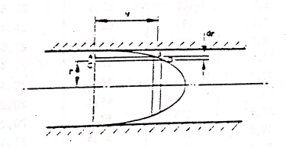
VELOCITY PROFILE
Suppose the velocity of air at a radius r mm be v m/s then,
Mean velocity * area of pipe = 2πrv dr * ${10}^{-6}$
Referring to the diagram above, this may be expressed as,
Mean velocity = $\frac{2π* {10}^{-6}}{pipe area \left(m^{2}\right)}\sum{ar}ea of ABCD*r$ (4.7)

Test Results
Room Temperature = 24.6˚C
Barometric pressure = 766 mm of mercury
Air inlet temperature = 34.6˚C
Fan Pressure = 542 mm of water
Orifice pressure drop* = 118 mm of water
Test length measure drop = 167 mm of water
Heater current = 4.95 Amp
Heater voltage = 230 volt
*Note: orifice diameter was 41.3 mm (1.625 in)
Pitot Traverse Distance mm | Actual Distance Across Tube mm | ($ρ_{s}-ρ$) mm of water | v  m/s | Air Temperature (above Inlet)  ˚C
66.5  68.0  70.0  72.0  74.0  76.0  78.0  80.0  82.0  84.0  86.0  88.0  90.0  92.0  94.0  95.3 | 0  1.5  3.5  5.5  7.5  9.5  11.5  13.5  15.5  17.5  19.5  21.5  23.5  25.5  27.5  28.8 | 103  138  162  183  198  213  222  226  227  218  209  198  180  163  139  111 | 43.2  50.0  54.2  57.6  60.0  62.1  63.4  64.0  64.1  52.8  61.5  60.0  57.1  54.4  50.2  44.9 | 43.3  33.7  29.7  26.8  24.4  22.6  21.4  20.4  20.0  20.2  21.1  22.5  24.3  25.5  29.7  37.1

4.4 Typical set of results and calculations
A typical set of results is given in Fig. 4.1. The velocity and temperature profiles in the pipe are shown in Figs. 4.2 and 4.3 respectively. It should be noted that these results were obtained on an apparatus with an orifice plate of 41.3 mm (1.625 in) diameter. A set of sample calculations are given in the following sections.
4.4.1 MASS FLOW RATE
Air pressure at orifice = Barometric pressure + Fan pressure
= $(766*13.56$+542)*$\frac{9.81}{{10}^{3}}$ kN/$m^{2}$
= 107 kN/$m^{2}$

Orifice temperature = 34.5 + 273.2
Air density at orifice,
$$ρ=\frac{107}{0.2871*307.3}$$

= 1.211 kg/$m^{3}$
Hence from equation 4.2
Mass flow rate = 1.211 * $\frac{π}{4}*\frac{{\left(41.3\right)}^{2}}{{10}^{6}}*0.613*\sqrt{\frac{2*118*9.81}{1.211}}$
= 0.0435 kg/s
4.4.2 AIR DENSITY AND LOCAL VELOCITIES
From equation 4.4:-
Mean air temperature rise = $\frac{4.95*230}{0.0435*1000}*\frac{0.94}{1}*\frac{1477}{1753}$

Mean temperature in pitot plane =34.5+20.3+273.2
= 328.6 k (55.4 ˚C)

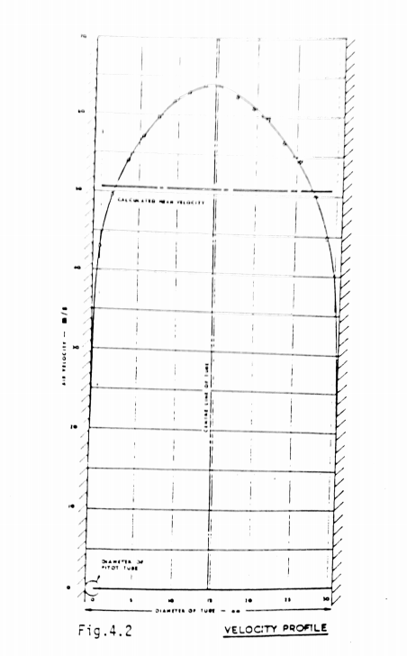
Main pressure in pitot plane = $\left[\left(756*13.56\right)+\frac{276}{1524}*167\right]*\frac{9.81}{{10}^{3}}$
= 102.2 kN/$m^{2}$
Hence from equation 4.5:-
Mean air density $\overline{ρ}=\frac{102.2}{0.2871*328.6}$
= 1.083 kg/$m^{3}$
The values of local velocity can now be calculated using equation 4.3 and tabulated as shown in Fig 4.1. The velocity and temperature profiles are then plotted as shown in Figs 4.2 and 4.3.
4.4.3 MEAN AIR VELOCITY
The mean velocity is first calculated from the mass flow using equation 4.5:-
Mean velocity in pitot plane = $\frac{0.0435}{1.083}*\frac{4*{10}^{6}}{π*31.{75}^{2}}$
= 50.7 m/s
The second method is to calculate the mean velocity from the velocity profile using equation 4.7:-
Mean velocity = $\frac{2π*{10}^{-5}*{10}^{6}}{\frac{π}{4}*31.{75}^{2}}*(area moment of profile)$
=($\frac{8}{31.{75}^{2}})$*(area moment of profile)
The area moment of the profile is obtained using values of velocity read from Fig 4.2 as follows.
0 – 2mm radius = 64.0 * 2.0 * 1.0 = 128.0
2 – 5 mm radius = 62.9 * 3.0 * 3.5 = 661.0
5 – 10mm radius = 59.2 * 5.0 * 7.5 = 2225.0
10 – 13 mm radius = 53.6* 3.0* 11.5 = 1850.0
13 – 14 mm radius = 48.5 * 1.0 * 13.5 = 655.0
14 – 15 mm radius = 44.3 * 1.0 * 14.5 = 643.0
15 – 15,875 mm radius = 29.5 * 0.875 * 15.44 = 399.0
Total = 6561.0

Hence, mean velocity = $\frac{8}{(31.{75)}^{2}}*6561$
= 52.2 m/s
The results demonstrate that the two methods give values of mean velocity which are in close agreement.

