LAB REPORT EXPECTATIONS
- A separate lab report will be due from each student for each lab.
- Each lab report should contain the following sections:
* "Title Page" indicating course, lab name and number, student name, instructor's name, and date.
* "Introduction" (or equivalent) giving a brief overview of the theory behind the lab, the objectives and purpose of the lab, and the procedures followed. Photocopied diagrams from the lab manual are acceptable supplements. Do not need to repeat all theory presented in manual.
* "Data" listing assumed values, and measured and recorded data.
* "Sample Calculations" showing one example of a set of calculations (with equations) for each portion of the lab. (It is not necessary to show multiple sets of repetitive calculations, only one of each).
* "Results", or" Conclusions" (as applicable) summarizing calculations and containing tables, graphs and values requested by the lab.
* "Comment" summarizing a brief thoughtful analysis of the results or what you have gained, if anything, by performing this lab. When plotting graphs in color, avoid such colors as yellow, light blue and others which are difficult to read.
C. Each lab report should be neat and organized. It should be bound or stapled and have a transparent cover. All text and tables should be typed. Graphs or plots may also be prepared on a word processor but better results may be more easily obtained when the "best fit" curve or line through a set of data points is drawn manually.
D. Lab reports will be considered to be "due" within three weeks of the date the lab was performed. No lab report will be accepted after the last class session.
LAB GRADE VALUES
A. Lab #1 10
#2 10
#3 10
#4 10
#5 12
#6 8
#7 10
#8 10
80

EXPERIMENT #1
STABILITY OF FLOATING BODY

1. INTRODUCTION
The question of the stability of a body such as a ship which floats in the surface of a liquid is one of obvious importance. Whether the equilibrium is stable, neutral or unstable is determined by the height of its centre of gravity. In this experiment the stability of a pontoon will be determined with its centre of gravity at various heights. A comparison with calculated stability will also be made.

1.1 Description of Apparatus
The arrangement of the apparatus is shown in Fig 1. A pontoon of rectangular form floats in water and carries a plastic sail, with five rows of "V" slots at equispaced heights on the sail. The slots' centres are spaced at 15mm intervals equally disposed about the sail centre line. An adjustable weight, consisting of two machined cylinders which can be screwed together, fits into the "V" slots on the sail. This can be used to change the height of the centre of gravity and the angle of list of the pontoon. A plumb bob is suspended from the top centre of the sail and is used in conjunction with the scale fitted below the base of the sail to measure the angle of list.

1.2 Theory of Stability of a Floating Body
Consider the rectangular pontoon shown floating in equilibrium on even keel as shown in cross-section on fig 2(a). The weight of the floating body acts vertically downwards through its centre of gravity G. This is balanced by an equal and opposite buoyancy force acting upwards through the centre of buoyancy force acting upwards through the centre of buoyancy B, which lies at the centre of gravity of the liquid displaced by the pontoon..
To investigate the stability of the system, consider a small angular displacement 60 from the equilibrium position as shown on fig 2(b). The centre of gravity of the liquid displaced by the pontoon shifts from B to B1. The vertical line of action of the buoyancy force is shown on the figure and intersects the extension of line BG and M, the metacentre.

The equal and opposite forces through G and B1 exert a couple on the pontoon, and provided that M lies above G (as shown in fig 2(b)) this couple acts in the sense of restoring the pontoon to even keel, i.e. the pontoon is stable. If however, the metacentre M lies below the centre of gravity G, the sense of the couple is to increase the angular displacement and the pontoon is unstable. The special case of neutral stability occurs when M and G coincide.

Fig 2(b) shows clearly how the metacentric height GM may be established experimentally using the adjustable weight ($ω$) to displace the centre of gravity sideways from G. For suppose the adjustable weight is moved a distance $δ$x from its central position. If the weight of the whole floating assembly is W, then the corresponding movement of the centre of gravity of the whole in a direction parallel to the base of thepontoon is$\frac{ω}{W}δx_{1}$. If this movement produces a new equilibrium position at an angle of list $δθ$, then in Fig 2(b), G1 is the new position of the centre of gravity of the whole, i.e.
$GG_{1}=\frac{ω}{W}δx_{1}$ ….1
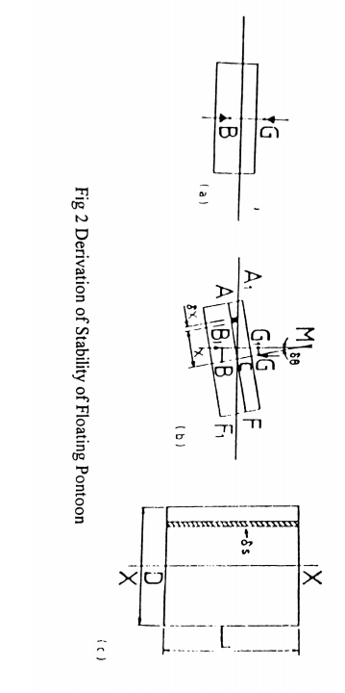
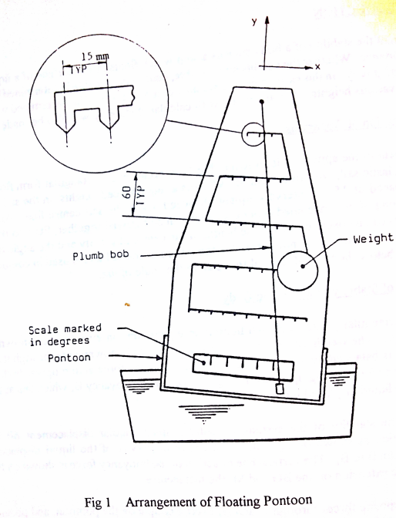

Now, from the geometry of figure

${ GG}_{1}=GM.\tan{θ}$ …2
Eliminating ${ GG}_{1}$ between these equations we derive

$GM=\frac{ω}{W}\frac{δx_{1}}{\tan{δθ}}$ …3
Or in the limit

$GM=\frac{ω}{W}\frac{(dx_{1})}{\tan{dθ}}$ …4

The metacentric height may thus be determined by measuring ($\frac{dx_{1}}{\tan{dθ}}$) and knowing $ω$ and W. tan
Quite apart from experimental determinations, BM may be calculated from the measuration of the pontoon and the volume of liquid which it displaces. Referring again to Fig 2(b), it may be noted that the restoring moment about B, due to shift of the centre of buoyancy to B1, is produced by additional buoyancy represented by triangle A$A_{1}$C to one side of the centre line, and reduced buoyancy represented by triangle FF1C to the other. The element shaded in Fig 2(b) and 2(c) has an area $δ$s in plan view and a height x$δθ$ in vertical section, so that its volume is$xδsδθ$. The weight of liquid displaced by this element is $wxδsδθ$, where w is the specific weight of the liquid, and this is the additional buoyancy due to the element The moment of this elementary buoyancy force about B is $wx^{2}δsδθ$ so that the total restoring moment about B is given by the expression:

$$w δθ \int{x^{2} ds}$$

Where the integral extends over the whole areas of the pontoon at the plane of the water surface. Theintegral may be referred to as I, where
$I=\int{x^{2}ds}$ ….5
the second moment of area of s about the axis xx.
The total restoring moment about B may also be written as the total buoyancy force, wV, in which V is the volume of liquid displaced by the pontoon, multiplied by the lever arm B$B_{1}$. Equating this product to the expression for total restoring moment derived above:
$$wV.BB_{1}=wδθ\int{x^{2}ds}$$

Substituting from equation (5) for the integral and using the expression
$BB_{1}=BM.tanδθ$ …..6
which follows from the geometry of fig 2(b), leads to
$BM=\frac{I}{V}$ …..7
This result, which depends only on the measuration of the pontoon and the volume of liquid which it displaces, will be used to check the accuracy of the experiment. It applies to a floating body of shape, provided that I is taken about an axis through the centroid of the area of the body at the plane of the water surface, the axis being perpendicular to the place in which angular displacement takes place, For a rectangular pontoon, B lies at a depth below the water surface equal to half the total depth of immersion, and I may readily be evaluated in terms of the dimensions of the pontoon as
$$I=\int{x^{2}ds=\int_{-D/2}^{D/2}{x^{2}Ldx=\frac{1}{12}LD^{3}}}$$

1.3 Installation Instructions
Fit the sail into is housing on the pontoon and tighten the clamp screws. Check that the plumb bob hangs vertically downwards on its cord and is free to swing across the lower scale.
1.4 Routine care and Maintenance
After use, the water in the tank should be poured away and the pontoon and tank wiped dry with a lint-free cloth. The pontoon should never be left permanently floating in the water.

2. EXPERIMENTAL PROCEDURE

Step 1: The total weight of the apparatus(including the adjustable weight and the two magnetic weights)W is stamped on a label affixed to the sail housing. Measure the length and breadth of the pontoon and also the thickness of the sheet metal bottom(nominally 2mm).

Total weight of floating assembly (W) including $ω$ = kg
Adjustable weight ($ω$) = kg
Breadth of pontoon (D) = mm
Length of pontoon (L) = mm
Second moment of area$I=\frac{LD^{3}}{12}$ = $m^{4}$
Volume of water displaced V = $m^{3}$
Height of metacentre above centre of buoyancy BM=$\frac{I}{V}$ = m
Depth of immersion of pontoon=$\frac{V}{LD}=z$ = m
Depth of centre of buoyancy CB, = $\frac{V}{2LD}$ = m

Step 2: The height of the centre of gravity ($\overline{y}$) may be found as follows: (Refer to Fig 3.)

(i)Fit the two magnetic weights to the base of the pontoon.

With the adjustable weight situated in the centre of one of the rows allow the pontoon to float in water and position the two magnetic weights on the base of the pontoon to trim the yowl When the vessel has been trimmed correctly, the adjustable weight may he moved to positions either side of the centre line for each of the five rows. At each position the displacement can be determined by the angle the plumb line from the top of the sail makes with the scale on the sail housing.
(ii) Fit the thick knotted cord, with the plumb weight, through the hole in the sail, ensuring that the plumb weight is free to hang down on the side of the sail which has the scored centre line (See Figure 3)
(iii) Clamp the adjustable weight into the "V" slot on the centre line of the lowest row and suspend the pontoon from the free end of the thick cord. Mark the point where the plumb line crosses the sail centre line with typists correcting fluid or a similar marking fluid, Measure and record values of $\overline{y}$ and $y_{1}$.
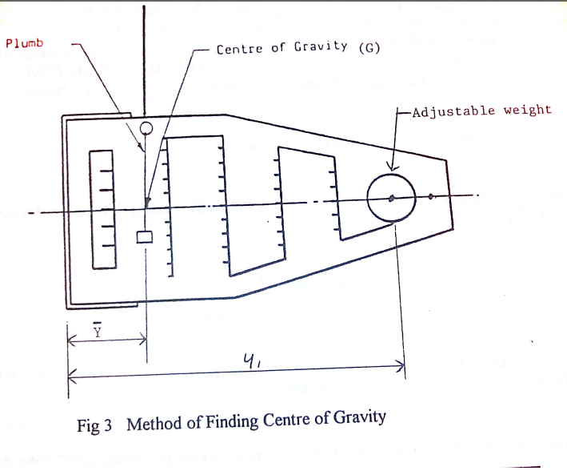

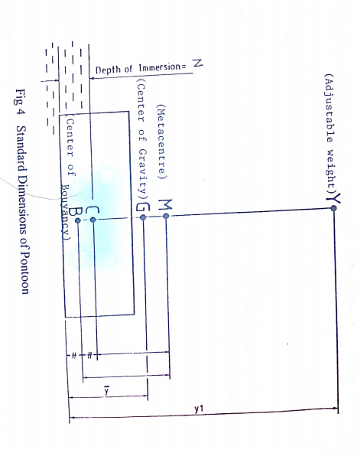
It is suggested that Fig 3 is marked up to be referred to each time the apparatus is used. Note that when measuring the heights$\overline{y}$and $y_{1}$, as it is only convenience to measure from the inside floor of the pontoon, the thickness of the sheet metal bottom should be added to$\overline{y}$ and $y_{1}$measurements. The position of G (and hence the value of $\overline{y})$and a corresponding value of y was marked earlier in the experiment when the assembly was balanced.
(iv) Repeat paragraph (iii) for the other four rows.

Step 3: The height of G above the base ($\overline{y}$) will vary with the height $y_{1}$of the adjustable weight above the base, according to the equation:
$\overline{y}=y_{1}\frac{ω}{W}+A$ …..9

(This is an equation of the form "y = mx + b". A is a constant which pertains to the centre of gravity of the pontoon minus the adjustable weight).

To minimize deviation in measured values, determine "corrected" values for$\overline{y}$. Using the measured results for the centre ofgravity of the pontoon and the height of the adjustable weight, ($\overline{y}$and $y_{1}$) from Step 2, calculate the most probable value of constant A.

(Note: Student may elect to either 1.) Plot measured $\overline{y}$ versus$y_{1}$ values and base the calculation of A on best fit through data points or 2.) Calculate A for each set of data and average.)

Using the most probable value of the constant A and equation 9, calculate corrected (theoretical) values of $\overline{y}$ for each value of$y_{1}$, in Step 2. Compare theoretical and measured values of $\overline{y}$. (Use the corrected values of $\overline{y}$ in all subsequent calculations.)

Step 4: Place the pontoon in the water At each level, laterally move the adjustable weight to each "V" slot position (dx) and note the resultant angle of list (d$θ$) (See Figure 1.) Values of angles of list should be recorded in the form of Table 1 (Note: Decide which side of the sail centre line is to be termed negative and then term list angles on that side negative. )

Height of adjustable weight $y_{1}$ (mm)  (i) | Angles of list for adjustable weight lateral displacement from sail centre line $x_{1}(mm)$  (ii)
 | -75 | -60 | -45 | -30 | -15 | 0 | 15 | 30 | 45 | 60 | 75

Table 1 Values of list angles for height and position of adjustable weight

Step 5: A plot (similar to Fig 5) for each height $y_{1}$, of lateral position of adjustable weight against tangent of angles of list, can then be prepared (5 total). (Note: use a straight edge through each set of data points to establish "best fit" linear relationship.) (Note: The best fit linear relationship must pass through the origin if the pontoon is properly trimmed.)

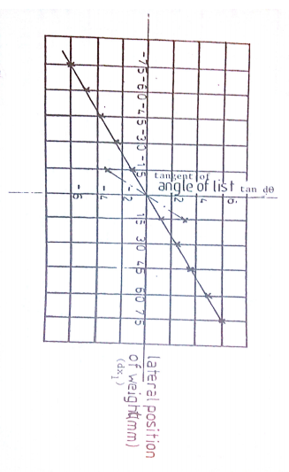

Note: For each set of $y_{1}$ data points, slope of best fit curve equals(inverse of) d$x_{1}$/tand$θ$

Fig 5 Variations of angle of list with lateral position of Weight (Height shown are max and min)

Step 6:Based on the slope of the best fit line, the corresponding values of dx,/ tan de can be graphically determined for each of five values of y, Using equation 4, values of GM can then be calculated. The above values should be calculated and arranged in tabular form as shown in Table 2.
Height of adjustable weight $y_{1}$(mm)  (i) | $$\frac{dx_{1}}{\tan{dθ}}$$  (mm)  (ii) | Metacentric height  GM(mm)  GM=$\frac{ωdx_{1}}{Wtan dθ}$  (iii)

Table 2 Derivation of Metacentric Height from Experimental Results
Step 7: Determine limiting stable value of y, from experimental data:
If the metacentric height (GM) is positive, the body is stable. If GM is negative, the body is unstable. Therefore, the limiting stable value of $y_{1}$ will occur when GM = 0. Using the values assembled in Table 2 (Step 6), plot $y_{1}$vs GM. Extrapolate the (best fit) plot to determine the limiting value of $y_{1}$. (See example shown on Figure 6.)
Step 8: Determine limiting stable value of $y_{1}$ from theoretical data:
As stated in Step 6, the limiting stable value of $y_{1}$ will occur when GM=0 See Figure 4. The metacentric height (GM) equals the height of the metacentric above the center of buoyancy (BM) less the difference between the center of gravity and the center of buoyancy (BG) or GM = BM - GB where BM = I/V and GB = y - CB. Using the measured and calculated values of BM and CG from Step 1, determine y max. Using Equation 9, determine the theoretical limiting value of $y_{1}$.
Step 9: Analysis of Findings
a ) How does the experimentally determined limiting valve of $y_{1}$, (Step 7) compare with the theoretical valve (Step 8)?

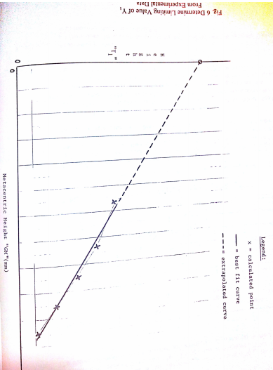

EXPERIMENT #3
AN EXPERIMENTAL STUDY OF THE VELOCITY PROFILES OF THE FLOW ACROSS A DIAMETER OF A PIPE

INTRODUCTION
A pitot tube traverse unit, flow measuring devices and manometer will enable the student to study the velocity profiles of the flow across a diameter of a pipe.

2. DESCRIPTION OF THE APPARATUS

The apparatus is shown in detail in figure 1. It consists of an electrically driven centrifugal fan which draws air through a control valve and discharges into a 76.2 mm (3 in) diameter, U-shaped pipe. The fan speed remains constant throughout. A British Standard orifice plate 40 mm diameter (1.625 in on English equipment) is fixed in this pipe to measure the air flow rate. This pipe is connected to a copper test pipe which is 3048 mm(10 ft) long, 32.6 mm (1.284 in) internal diameter and has a wall thickness of 1.20 mm (0.047 in ). All the pipework rests on wooden blocks supported by the steel frame of the apparatus.
Manometers fixed to the instrument panel measure fan discharge pressure and the orifice pressure drop.

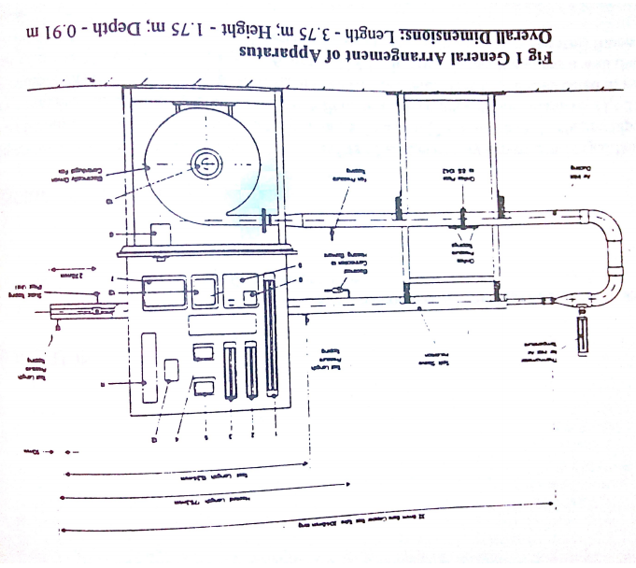
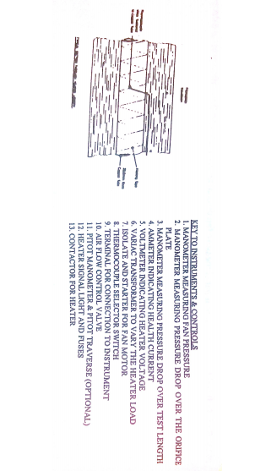
The velocity traverse assembly, as shown in figure 3, comprises a Pitot tube which may be traversed across a diameter of the pipe. Its position at any point is read directly from a combined linear scale and Vernier. The Pitot tube measures the stagnation pressure only, the associated static pressure being sew at a tapping point in the wail of the pipe. The difference between the two pressures is measured by a differential water manometer mounted on the panel, and is used to calculate the velocity at points across the plane of traverse.
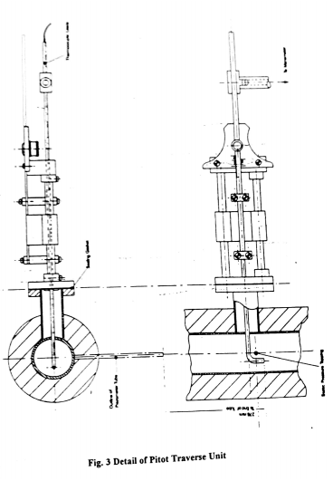
3. PARTICULARS OF THE APPARATUS
 | Metric Apparatus | English Apparatus
Orifice plate diameter | 40 mm | 1.625 in
Pipe internal diameter | 32.6 mm | 1.284 in
Pipe wall thickness | 1.20 mm | 0.047 in
1 atm =29.92 inches Hg
= 760 mm Hg
= 101 K pa
= 1013 millibars
4. A TYPICAL EXPERIMENT USING THE PITOT TUBE ASSEMBLY
4.1 OBJECT
To examine the velocity profiles of air flowing in a section ofpipe. Also to compare the mean velocity of the air by (a) the mass flow/mean density and (b) velocity profile methods.
4.2 EXPERIMENTAL PROCEDURE
Step 1. Switch on the fan with inlet valve fully open. Allow the apparatus to warm up for a few minutes to attain steady conditions.
Step 2. The following observations can then be taken.
- Air pressure before the orifice plate (fan pressure)
- Pressure drop across the orifice plate.
- Air temperature at outlet of the test pipe.
- Barometric pressure/Ambient temperature.
- Initial pitot pressure reading at zero velocity.
- Pitot pressure at 2 mm intervals across the section of the pipe
It should also be noted that when the pitot tube is in a position near to the walls of the tube a "whistling" sound may be heard. This is in no way injurious to the apparatus and will not affect the results. The velocity measured by the pitot tube cannot be made at points less than half the diameter of the pitot tube from the walls of the pipe. The diameter of the pitot tube is 2 mm (0.080 in).

4.3 CALCULATIONS AND THEORY
Step 3. 4.3.1 DETERMINE MASS FLOW RATE(Based on Orifice)
Air pressure at orifice = (Barometric pressure + Fan pressure) kN/$m^{2}$
Air density at orifice,
$ρ=\frac{P}{RT}=\frac{Air pressure at orifice(\frac{kN}{m^{2}})}{\begin{aligned}0.2871*Air temperature at orifice\left(K\right)\end{aligned}}$ (4.1)
Air mass flow rate,
$W=ρ*orifice area*C_{d}*\sqrt{\frac{2∆p}{ρ}}$ (4.2)
Where $C_{d}$=0.613 the orifice discharge coefficient
$∆$P=pressure drop across the orifice (N/$m^{2})$
(For determining $∆p,$it may be noted that 1 mm of water = 9.81 N/$m^{2}$)
Step 4. 4.3.3 MEAN AIR VELOCITY IN PITOT PLANE USING MASS FLOW RATE
Determine mean velocity from mass flow
Mean velocity in pitot plane = $\frac{Mass flow rate}{ρ*area of pipe}$ (4.3)
Step 5 4.3.2 DETERMINE AIR VELOCITY AT A POINT IN THE PITOT PLANE
The pitot tube converts the velocity head into a pressure head:
$$\frac{V^{2}}{2g}=P/γ$$
Therefore air velocity at any point, becomes
$v=\sqrt{\frac{2*(p_{s}-p)}{ρ}}$ (4.6)
Where:
$P_{s}$= stagnation pressure (N/$m^{2})$
P =static pressure (N/$m^{2})$
$ρ$= mean air density in pitot plane(kg/$m^{3})$

Step 6 Plot point velocities across inside pipe diameter. Graph velocity profile (smooth symmetric curve through data points across entire diameter of pipe). (Reminder – the inside diameter of pipe is 32.6mm)

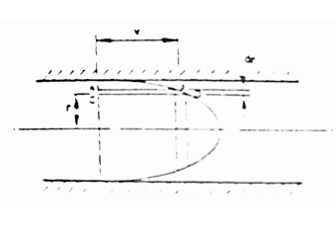
VELOCITY PROFILE
Step 7 MEAN VELOCITY USING AREA OF VELOCITY PROFILE
Flow rate = mean velocity * area of pipe (Q=$V_{ave} X A)$
Also, Flow rate = $\sum{area of {ring}_{i}}$ X $velocity_{i}$
= $\sum{π}\left({r^{2}}_{i}-{r^{2}}_{i-1}\right)V_{i}$
Equating the flow rates, this may be expressed as;
Mean velocity =$\sum{\frac{({r^{2}}_{i}-{r^{2}}_{i-1})v_{i}}{r^{2}}}$ (4.7)
Where $V_{i}$= average velocity in a ring from $r_{i}-r_{i-1}$
Show mean velocity on the velocity profile drawn during step 6.
Step 8 ANALYSIS OF FINDINGS
- Is the shape of the velocity profile plotted in Step 6 of this form you expected? Compare computed mean velocities determined by the two methods. (steps 4 and 7)

APPENDIX – A:-
TYPICAL SET OF RESULTS AND CALCULATIONS
A typical set of results is given in Fig. 4.1. The velocity profiles in the pipe are shown in Figs. 4.2 and 4.3 respectively. It should be noted that these results were obtained on an apparatus with an orifice plate of 41.3 mm (1.625) in diameter. A set of sample calculations are given in the following sections.
A.I. Test results
Room temperature = 24.6°C
Barometric pressure = 766 mm of mercury
Air outlet temperature= 34.6°C
Fan pressure= 542 mm of water
Orifice pressure drop*= 118 mm of water
Test length measure drop = 167 mm of water

*Note: orifice diameter was 41.3 mm (1.625 in)
Pitot Traverse Distance  mm | Actual Distance Across Tube  mm | ($P_{s}-ρ)$  Mm of water | V  m/s
66.5  68.0  70.0  72.0  74.0  76.0  78.0  80.0  82.0  84.0  86.0  88.0  90.0  92.0  94.0  95.3 | 0  1.5  3.5  5.5  7.5  9.5  11.5  13.5  15.5  17.5  19.5  21.5  23.5  25.5  27.5  28.8 | 103  138  162  183  198  213  222  226  227  218  209  198  180  163  139  111 | 43.2  50.0  54.2  57.6  60.0  62.1  63.4  64.0  64.1  62.8  61.5  60.0  57.1  54.4  50.2  44.9

FIG 4.1 TYPICAL SET OF RESULTS FROM PITOT TRAVERSE
A.2. MASS FLOW RATE
Air pressure at orifice = Barometric pressure + Fan pressure
= (766 X 13.56 + 542)X $\frac{9.81}{{10}^{3}}$kN/$m^{2}$
= 107kN/$m^{2}$
Air temperature = 34.5 + 273.2
= 307.8 K
Air density at orifice,
$$ρ= \frac{P}{RT}=\frac{107}{0.2871 X 307.8}$$
= 1.211 kg/$m^{3}$
Hence from equation 4.2,
Mass flow rate = 1.211 X $\frac{π}{4}$ X $\frac{({41.3)}^{2}}{{10}^{6}}$ X 0.613 X $\sqrt{\frac{2 X 118 X 9.81}{1.211}}$
= 0.0435 kg/s
A.3. MEAN AIR VELOCITY USING MASS FLOW RATE
Air pressure at pitot = barometric pressure
= 766 X 13.56 X 9.81/1000 = 101.9 KN/$m^{2}$
Air temperature at pitot = 307.8 K
Density = $ρ= \frac{P}{RT}=\frac{101.9}{.2871 X 307.8}$ = 1.153 k/$m^{3}$
The mean velocity is first calculated from the mass flow using equation 4.6:-
Mean velocity in pitot plane = $\frac{0.0435}{1.153} X \frac{4X{10}^{6}}{π X {31.75}^{2}}$
= 47.7 m/s

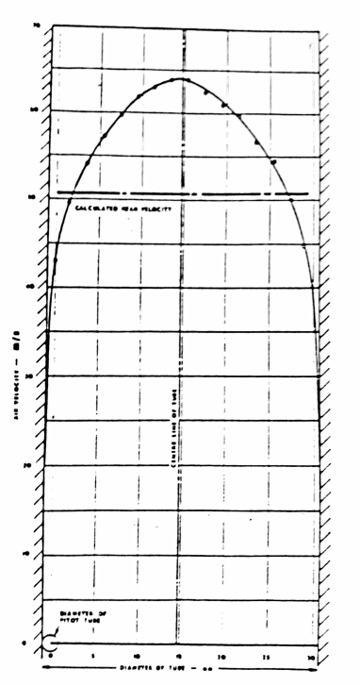

FIG 4.2 VELOCITY PROFILE

A.4.AIR DENSITY AND LOCAL VELOCITIES
The values of local velocity are calculated using equation 4.2 and tabulated as shown in Fig.4.1. The velocity profiles are then plotted as shown in Figs 4.2.
A.5. MEAN AIR VELOCITY FROM VELOCITY PROFILE
The second method is to calculate the mean velocity from the velocity profile using equation 4.7:
Mean velocity = $\frac{\sum{dA_{i}}XV_{i}}{A_{τ}}$
= $\frac{\sum{V_{i}({r^{2}}_{i}-{r^{2}}_{i-1})}}{r^{2}}$
The velocity profile is divided into a number of concentric rings or bands between $r_{1}$and $r_{i-1}$. The average velocity in each ring ($V_{i}$) is read from the smooth curve of the symmetric velocity profile Fig. 4.2. The calculations are extended as follows:
Portion of Profile | $$V_{i}({r^{2}}_{i}-{r^{2}}_{i-1})$$ | Extension
0-2 mm radius | = 64.0 X 4 | = 256.0
2-5 mm radius | = 62.9 x 21 | = 1320.9
5-10 mm radius | = 59.2 x 75 | = 4440.0
10-13 mm radius | = 53.6 x 69 | = 3698.4
13-14 mm radius | = 48.5 x 27 | = 1309.5
14-15 mm radius | = 44.3 x 29 | = 1284.7
15-15.875 mm radius | = 29.5 x 27.02 | = 797.0
Total = 13,106.5

Hence, mean velocity = $\frac{13,106.5(\frac{m}{s}){mm}^{2}}{15.{875}^{2}mm^{2}}$
= 52.0 m/s
The two methods give values of mean velocity which are in close agreement.
(Note that the inside diameter of the pipe used in Experiment #3 is 32.6 mm)

EXPERIMENT #4
DETERMINATION OF DISCHARGE AND HEAD LOSS USING A FLOW-MEASURING APPARATUS

1. INTRODUCTION
Through use of the Flow-Measuring Apparatus, this experiment is designed to accustom students to typical methods of measuring the discharge of an essentially incompressible fluid, whilst at the same time giving applications of the Steady-Flow Energy Equation (Bernoulli's Equation). The discharge is determined using a Venturi Meter, an Orifice Plate Meter and a Rotameter.
Also, head losses associated with each meter are determined and compared as well as those arising in two fittings (a rapid enlargement and a 90-degree elbow). The loss coefficients associated with these fittings can be determined.
The unit is designed for use with TecQuipment's Hydraulic Bench H1, which provides the necessary liquid service and gravimetric evaluation of flow rate. See Appendix B for a description of the Hydraulic Bench's operating procedures.
1.1 Description of Apparatus
The Flow-Measuring Apparatus is shown in Fig 1. Water from the Hydraulic Bench enters the equipment through a perspex Venturi Meter, which consists of a gradually-converging section, followed by a throat, and a long gradually-diverging section. After a change in cross-section through a rapidly diverging section, the flow continues along a settling length and through an Orifice Plate Meter. The Orifice Plate Meter is manufactured in accordance with B.S. 1042, from a plate with a hole of reduced diameter through which the fluid flows.
Following a further settling length and a right-angled bend, the flow enters the Rotameter. This consists of a transparent tube in which a float takes up an equilibrium position. The position of this float is a measure of the flow rate.
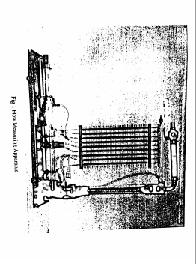
After the Rotameter, the water returns via a control valve to the Hydraulic Bench and the weightank. The equipment has nine pressure tappings as detailed in Fig 2, each of which is connected to its own manometer for immediate read out.
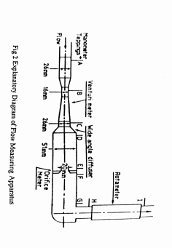
1.2 Installation and Preparation
a) Remove the transit wire from the glass rotameter by first removing the control valve, elbow assembly from the top of the Rotameter. Replace the valve, elbow assembly securely.
b) Connect the supply hose from the Hydraulic Bench to inlet of the Venturi Meter and secure with a hose clip. Connect a hose to the control valve outlet and direct its free end into the central hole in the Bench. Before continuing, refer to the Hydraulics Bench Manual to find method of flow evaluation by weighing.
c) With the air purge-valve closed, close the apparatus valve then open it by about 1/3. Switch on the Bench and slowly open its valve until water starts to flow. Allow the apparatus to fill with water. Continue to open the bench valve until it is fully open. Close the apparatus valve fully. Couple the bicycle pump to the purge salve and pump down until all the manometer read approximately 280 mm. Dislodge entrained air from the manometers by gentle tapping with the fingers. Check that the water levels are constant. A steady rise in Levels will be seen if the purge valve is leaking.
d) Check that the tube ferrules and the top manifold are free from water blockage, (this will suppress the manometer level). Ferrules blockage can be cleared by a sharp burst of pressure from the bicycle pump.
1.3 Routine Care and Maintenance
a) When not in use water should not be allowed to stand in the apparatus for long periods. After use, fully drain the apparatus and dry externally with a lint-free cloth.
b) If the control valve shows signs of leaking, the procedure for checking and inspecting is as detailed in the H1 Hydraulic Bench technical manual.
c) If plastic manometer tubes become discolored, a stain and Deposit Remover is available

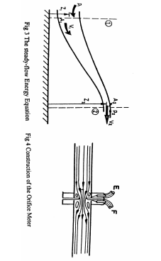
2. THEORY

2.1 Bernoulli’s Equation
For steady, adiabatic flow of an incompressible fluid along a stream tube (see fig 3). Bernoulli’s equation can be written in the form;
$\frac{P_{1}}{ρg}+\frac{{V_{1}}^{2}}{2g}+Z_{1}=\frac{P_{2}}{ρg}+\frac{{V_{2}}^{2}}{2g}+Z_{2}+∆H_{12}$ (Eq. 4-1)
Where $\frac{P}{ρg}$ is termed the hydrostatic head or pressure head.
$\frac{V^{2}}{2g}$ is termed the kinetic head or velocity head (V is the mean velocity i.e. the ratio of volumetric discharge to cross-sectional area of tube).
Z is termed potential head or elevation head
$\frac{P}{ρg}+\frac{V^{2}}{2g}+Z$ represents the total head.
The head loss $∆H_{12}$may be assumed to arise as a consequence of vorticity in the stream. Because the flow is viscous, a wall shear stress exists and a pressure force must be applied to overcome it. The consequent increase in flow work appears as increased internal energy. Also, because the flow is viscous, the velocity profile at any section is non-uniform. The kinetic energy per unit mass at any section is then greater than $v^{2}/2g$ and Bernoulli's equation incorrectly assesses this term. The fluid mechanics entailed in all but the very simplest internal flow problems is too complex to permit the head loss $∆$H to be obtained by other than experimental means. Since a contraction of stream boundaries can be shown (with incompressible fluids) to increase flow uniformity and a divergence correspondingly decreases it, $∆$H is typically negligibly small between the ends of a contracting duct but is normally significant when the duct walls diverge.
2.2. Fitting Head Loss Coefficients
2.2.1. Expansion
Friction head losses through an expansion (wide angled diffuser) may be estimated using an equation of the form:
$h_{L}=K_{E}\frac{{v_{1}}^{2}}{2g}$ (Eq 4 - 2)
Where $\frac{{v_{1}}^{2}}{2g}$ is the approach velocity head and $K_{E}$ is a constant head loss coefficient associated with the ratio of the diameters and the angle of the expansion.

2.2.2. Elbow
Friction head losses through an elbow (90° bend) may be estimated using an equation of the form
$h_{L}=K_{b}\frac{v^{2}}{2g}$ (Eq. 4-3)
where $v^{2}$/2g is the velocity head of the flow and $K_{b}$ is a constant head loss coefficient associated with the sharpness of the bend.
3. EXPERIMENTAL PROCEDURE
Step 1: With the equipment set as in Section 1.2, measurements can be taken in the following manner. Open the apparatus valve until the rotameter shows a reading of about 10 mm. When a steady flow is maintained measure the flow with the Hydraulic Bench as outlined in its manual (Appendix B). During this period, record the readings of the manometers in a table of the form of Fig 8. Repeat this procedure for a number of equidistant values of rotameter readings up to a maximum of approximately 220 mm. At least 6 sets of data should be taken. Finally, record a set of readings with no flow.
Step 2: For each set of data, compute the mass flow rates for the venturi, orifice, rotameter and weigh tank.
Step 3: For each set of data, compute the head losses associated with each meter and the fittings. Discuss findings. Plot head losses vs flow rate for each meter. Also, plot head loss per kinetic head vs kinetic head (see Fig 9) for each meter.
Step 4: Compute the friction head losses associated with the two fittings. a. For each set of data, determine the velocity head and the head loss ($∆H_{CD}$) across the expansion Plot $h_{L}$, versus the velocity head. Determine the slope (best fit) of the line through these points. Determine $K_{E}$ from your results and compare with published values.
b. For each set of data, determine the velocity head and the head loss ($∆H_{GH}$) across the elbow Plot $h_{L}$, versus the velocity head. Determine the slope (best fit) of the line through these points. Determine $K_{b}$ from your results and compare with published values.
Step 5: Analysis of findings
a. Based on your findings, discuss the accuracy and limitations of each method of flow measurement
b. Review head loss findings
c. Review head loss coefficient findings for fittings.
4.RESULTS AND CALCULATIONS
4.1 Calculations of Discharge
The Venturi meter, the orifice plate Meter and the Rotameter are all dependent upon Bernoulli’s equation for their principle of operation. The following have been prepared for a typical set of results to show in form of calculations.
4.1.1 Venturi Meter
Since $∆$H₁₂ is negligibly small between the ends of a contracting duct it, along with the Z terms, can be omitted from equation 1 between stations A and B.
From continuity ($ρ$V_{A}A_{A} =$ρ$V_{B}A_{B})
The discharge, Q= A_{B}V_{B}
= ${A_{B}\frac{2g}{1-{(\frac{A_{B}}{A_{A}})}^{2}}\frac{P_{A}}{ρg}-\frac{P_{B}}{ρg}}^{ 1/2}$
With the apparatus provided, the bores of the meter at A and B are 26 mm and 16 mm respectively. Thus:- ${A_{B}}/{A_{A}}$ = 0.38 and $A_{B=}$ 2.01 x 10⁻⁴ m², since g=9.81m/s² and ${P_{A}}/{ρ_{g}}$ , ${P_{B}}/{ρ_{g}}$ are respectively heights of the manometric tubes A and B meters, we have from equation 2:
Q = .962 x 10⁻⁴(h_{A} – h_{B})^{1/2} m³/s
Taking the density of water as 1000 kg/m³, the mass flow will be
m = 0.962(h_{A} – h_{B})^{1/2} kg/s
e.g. if h_{A} = 372mm, h_{B} = 116mm then ${{[(h_{A} – h_{B})}/{1000}}^{1/2}$ = 0.51
and m = 0.962 x 0.51 = 0.49kg/s
(The corresponding weightank assessment was 0.47kg/s)
4.1.2 Orifice Meter
Between tappings (E) and (F), $∆H_{12}$ in equation 1 is by no means negligible. Re-writing the equation with the appropriate symbols,
$\frac{{V_{F}}^{2}}{2g}$ - $\frac{{V_{F}}^{2}}{2g}$ = $\frac{P_{F}}{ρg}$ - $\frac{P_{F}}{ρg}$ - $∆H_{12}$
i.e. the effect of the head loss is to make the difference in manometric height ($h_{E }$- $h_{F}$) less than it would otherwise be.
An alternative expression is $\frac{{V_{F}}^{2}}{2g}$ - $\frac{{V_{F}}^{2}}{2g}$ = K² $\frac{P_{F}}{ρg}$ - $\frac{P_{F}}{pg}$
Where the coefficient of discharge K is given by previous experience in B.S.1042(1943)* for the particular geometry of the Orifice Meter. For the apparatus provided K is given as 0.601
Reducing the expression in exactly the same way as for venturi meter,
$$Q=A_{F}V_{\begin{aligned}F \\ \end{aligned}}$$
$$={KA}_{F}{[\frac{2g}{1-{\left(\frac{A_{F}}{A_{E}}\right)}^{2}}\left(\frac{P_{E}}{ρg}-\frac{P_{F}}{ρg}\right)]}^{\frac{1}{2}}$$
Since the apparatus provided, the bore at E is 51 mm and at F is 20 mm.
$$Q=1.89 x {10}^{-4}x\frac{{\left(2 x 9.81\right)}^{\frac{1}{2}}}{1-0.155}{(h_{E}-h_{F})}^{1/2}$$
$Q=9.10 x {10}^{-4}{(h_{E}-h_{F})}^{1/2} m^{3}/s$
Thus m=0.910($h_{E}-h_{F})^{\frac{1}{2}} kg/s$
e.g. If $h_{E}=354 mm, h_{F}=44 mm then [\frac{h_{E}-h_{F}}{1000}]^{\frac{1}{2}}=0.55$
and m = 0.910 x 0.55 =0.50 kg/s
(The corresponding weightank assessment was 0.47 kg/s)
*N.B. It is found that the value of C given in the 1943 BS1042 publication gives better results over the velocity range of the apparatus than the figures given in later edictions and has thus been retained for use in this manual.
4.1.3 Rotameter
Observation of recordings for the pressure drop across the Rotameter, (H) - (I), shows that this difference is large and virtually independent of discharge. Though there is a term which arises because of wall shear stresses and which is therefore velocity dependent, since the Rotameter is of large bore this term is small. Most of the observed pressure difference is required to maintain the float in equilibrium and as the float is of constant weight, this pressure difference is independent of discharge.
The cause of this pressure difference is the head loss associated with the high velocity of water around the float periphery. Since this head loss is constant then the peripheral velocity is constant. To maintain a constant velocity with a varying discharge rate, the cross sectional area will arise as the float moves up and down the tapered Rotameter tube.
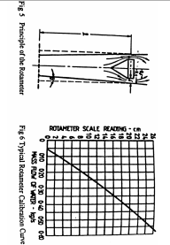
From Fig 5, if the float radius is $R_{f }$and the local bore of the Rotameter tube is 2$R_{τ}$ then,
$π\left({R_{τ}}^{2}-{R_{f}}^{2}\right)=2πR_{f}δ$ = Cross sectional area
= Discharge/Constant peripheral velocity
Now $δ=10$, where 1 is the distance from datum to the cross section at which the local bore is $R_{τ}$ and 0 is the semi-angle of tube taper. Hence 1 is proportional to discharge. An approximately linear calibration characteristic would be anticipated for the Rotameter.
4.2 Calculations of Head Loss-Meters
By reference to equation 1 the head loss associated with each meter can be evaluates.
4.2.1 Venturi Meter
Applying the equation between pressure tappings (A) and (C)
$$\frac{P_{A}}{ρg}-\frac{P_{c}}{ρg}= ∆H_{AC}$$
i.e. $h_{A}-h_{c}=∆H_{AC}$
This can be made dimensionless by dividing it by the inlet kinetic head ${V_{A}}^{2}/2g$
Now ${V_{B}}^{2}=\frac{2g}{1-(A_{B}/A_{A})^{2}}[\frac{P_{A}}{ρg}-\frac{P_{B}}{ρg}]$
And ${V_{A}}^{2}={V_{B}}^{2}(A_{B}/A_{A})^{2}$
Thus $\frac{{V_{A}}^{2}}{2g}=\frac{{A_{B}}^{2}}{A_{A}}[\frac{1}{1-(A_{B}/A_{A})^{2}}\left(\frac{P_{A}}{ρg}-\frac{P_{B}}{ρg}\right)]$
With the apparatus provided, $A_{B}/A_{A}$=0.38 and thus the inlet kinetic head
$$\frac{{V_{A}}^{2}}{2g}=0.144 x 1.16 \left(\frac{p_{A}}{ρg}-\frac{P_{B}}{ρg}\right)=0.167(h_{A}-h_{B})$$
e.g. If $h_{A}$=372 mm, $h_{B}$=116 mm and $h_{c}$= 332 mm then:
$$∆H_{AC}=h_{A}-h_{c}=40 mm$$
$$\frac{{V_{A}}^{2}}{2g}=0.167\left(h_{A}-h_{B}\right)=0.167 X 256=42.75 mm$$
Head Loss = $\frac{∆H_{AC}}{{V_{A}}^{2}/2g}=\frac{40 mm}{42.75 mm}=0.936 inlet kinetic heads$

4.2.2 Orifice Meter
Applying equation 1 between E and F by substituting kinetic and hydrostatic heads would give an elevated value to the head loss for the meter. This is because, at an obstruction such as an orifice plate, there is a small increase in pressure on the pipe wall due to part of the impact pressure on the plate being conveyed to the pipe wall. BS 1042 (Section 1.1 1981) gives an approximate expression for finding the head loss and generally this can be taken as 0.83 times the measured head difference.
Therefore: $∆H_{EF}=0.83\left(h_{E}-h_{F}\right)mm$
= 0.83(354-44) mm
= 257 mm
The orifice plate diameter is approximately twice the venture inlet diameter, therefore the orifice inlet kinetic head is approximately 1/16 that of venturi = 1/16 X 42.75 mm = 2.67 mm
Therefore $∆H_{EF}=\frac{257}{2.67}=96$inlet kinetic heads
4.2.3 Rotameter
For this meter, application of equation 1 gives
$$\frac{P_{H}}{ρg}+Z_{H}-\frac{P_{1}}{ρg}+Z_{1}=∆H_{HI}$$
Then as shown in fig 7: $h_{H}-h_{I}=∆H_{HI}$
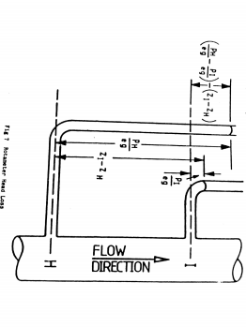
$∆$ Inlet kinetic head | Elbow (17)
$∆$ Inlet kinetic head | Diffuser (16)
$∆$ Inlet kinetic head | Rota meter (15)
$∆$ Inlet kinetic head | Orifice (14)
$∆$ Inlet kinetic head | Venturi (13)
M(kg/s) | Weigh tank
M(kg/s) | Rota meter Fig 6
M(kg/s) | Orifice (11)
M(kg/s) | Venturi (8)
 | T (seconds)
 | Water w (kg)
Hydr
Bench
Weight(kg)
 | Rota meter (cm)
Manometric levels(mm) | I
Manometric levels(mm) | H
Manometric levels(mm) | G
Manometric levels(mm) | F
Manometric levels(mm) | E
Manometric levels(mm) | D
Manometric levels(mm) | C
Manometric levels(mm) | B
Manometric levels(mm) | A
 | Test no
Inspection of the table of experimental results show that this head loss is virtually independent or discharge and has a constant value of about 100 mm of water. As has already been shown, this is a characteristic property of the Rotameter. For comparative purposes it could be expressed in ter : of the inlet kinetic head. For example, since the connecting tube has a 26 min bore, with the test results under consideration the inlet kinetic head is 42.75 mm of water as it is with the Venturi Meter Hence the Rotameter head loss is then 2.3 inlet kinetic heads. However when the velocity is very low the head loss remains the same and thus becomes many, many times the inlet kinetic head.
It is instructive to compare the head losses associated with the three meters with those associated with the rapidly diverging section, or wide-angled diffuser, and with the right-angled bend or elbow. The same procedure is adopted to evaluate these losses.

4.2.4 Wide angled diffuser
The inlet to the diffuser may be considered to be at (c) and the outlet at
(D). Applying equation 1,
$$\frac{P_{c}}{ρg}+\frac{{v_{c}}^{2}}{2g}=\frac{P_{D}}{ρg}+\frac{{V_{D}}^{2}}{2g}+∆H_{CD}$$
Since the area ratio, inlet to outlet, of the diffuser is 1:4, the outlet kinetic head is one-sixteenth of the inlet kinetic head.
e.g. if $h_{A}$= 372 mm, $h_{B}$= 116 mm, $h_{c}$=332 mm and $h_{D}$= 337 mm
the inlet kinetic head = 42.75 mm, ( see Venturi meter head loss calculations).
The corresponding outlet kinetic head = 1/16 x 42.75 = 2.67 mm
And thus $∆H_{CD}$= (332-337) + (42.75 – 2.67) = -5 + 40.08 = 35.08 mm of water.
Head loss = 35.08/42.75 = 0.821 inlet kinetic heads
4.2.5 Right angled bend
The inlet to the bend is at (G) where the pipe bore is 51 mm and outlet is at (H) where the bore is 26 mm.
Applying equation 1: $\frac{P_{G}}{ρg}+\frac{{V_{G}}^{2}}{2g}=\frac{P_{H}}{ρg}+\frac{{V_{H}}^{2}}{2g}+∆H_{GH}$
The outlet kinetic head is now approximately sixteen times the inlet kinetic head.
e.g. if $h_{A}$=372 mm, $h_{B}$=116 mm, $h_{G}$= 94 mm and $h_{H}$= 33 mm
The inlet kinetic head = 2.67 mm and the outlet kinetic head =42.75 mm
And thus $∆H_{GH}$= (94-33)+(2.67-42.75) = 61 – 40.08 = 20.92 mm of water.
Head loss = 20.92/2.67 = 7.8 inlet kinetic heads.
4.3 Calculations of Head Loss coefficients
4.3.1 Expansion
Measured values - $H_{c}$= 277 mm
$H_{D}$ = 285 mm
Weightank mass flow rate = .40 Kg/sec
Q=m/p =$\frac{.40 kg/sec}{.998 kg/m^{3}}$ = .00040 $m^{3}$/sec
A = π(.026$)^{2}$/4 = .000531$m^{2}$
$v_{1}$=$\frac{Q}{A}$= $\frac{.00040}{.000531}$ = .753 m/sec
$\frac{{v_{1}}^{2}}{2g}=\frac{{\left(.753\right)}^{2}}{2 x 9.81}$ = .029 m
$∆H_{CD}$= 12 mm = .012 m
Experimental $K_{E}=∆H_{CD}$/velocity head = $\frac{.012}{.029}$ = .41
For $D_{1}$/$D_{2}$ = $\frac{26 mm}{51 mm}$ = .50, and 0 =80$°$
Theoretical $K_{E}$ -0.35

5. DISCUSSIONS
5.1. Discussion of the Meter Characteristics
There is little to choose in accuracy of discharge measurement between the Venturi Meter, the Orifice Meter and the Rotameter. All are dependent upon the same principle. Discharge coefficients and the Rotameter calibration are largely dependent on the way the stream forms a `vena contracta' or actual throat of smaller cross-sectional area than that of the constraining tube. This effect is negligibly small where a controlled contraction takes place in a Venturi Meter but is significant in the Orifice Meter. The Orifice meter discharge coefficient is also dependent on the precise location of the pressure tappings (E) and (F). Such data is given in B.S. 1042 which also emphasizes the dependence of the meter's behavior on the uniformity of the flow upstream and downstream of the meter. In order to keep the apparatus as compact as possible, the dimensions ache equipment in the neighborhood of the Orifice Meter have been reduced to their limit. Consequently, some inaccuracy in the assumed value of its discharge coefficient may be anticipated.
The considerable difference in head loss between the Orifice Meter and the Venturi Meter should be noted. The Orifice Meter is much simpler to make and use, for it is comparatively easy to manufacture a suitable orifice plate and insert it between two existing pipe flanges which have been appropriately pressure-tapped for the purpose. In contrast, the Venturi Meter is large, comparatively difficult to manufacture and complicated to fit into an existing flow system. But the low head loss associated with I the controlled expansion occurring in the Venturi Meter gives it an obvious superiority in applications where power to overcome flow losses may be limiting.
Rotameters and other flow-measuring instruments which depend on the displacement of floats in tapered tubes may be selected from a very wide range of specifications. They are unlikely to be comparable with the Venturi Meter from the standpoint of head loss but, provided the discharge range is not extreme, the ease of reading the instrument may well compensate for the somewhat higher head loss associated with it.
The head losses associated with the wide-angled diffuser and the right-angled bend are not untypical. Both could be reduced Wit were desirable to do so. The diffuser head loss would be minimized if the total expansion angle of about 50 degrees were reduced to about 10 degrees. The right-angled bend loss would be substantially reduced if' the channel, through which the water flows, was shaped in the arc of a circle having a large radius compared with the bore of the tube containing the fluid.
Large losses in internal flow systems are associated with uncontrolled expansions of the stream. Attention should always be paid to increases in cross-sectional area and changes of direction of the stream as these parts of the system are most responsive, in terms of associated head loss, to small improvements in design.

5.2 Discussion of Results
If mass flow results are plotted against mass flow rates from the weighing tank method, the accuracy of the various methods can be compared Since all are derived from Equation 1, similar results would be expected from the three methods. The differential mass flow measurement ($m_{meter}-m_{weightank}$) ) could be plotted against the weighing tank mass flow results for a better appraisal of accuracy.
Some overestimation in the Venturi Meter determination can he anticipated because its vena contracta has been assumed to be negligibly small. Similarly, the Rotameter determination may well be sensitive to the proximity of the elbow and the associated inlet velocity distribution. The Orifice Meter is likely to be sensitive to the inlet flow which is associated with the separation induced in the wide-angle diffuser upstream of it Thus both the Rotameter and the Orifice Meter calibrations would be likely to change if a longer length of straight pipe were introduced upstream of them.
In the calculations the head losses associated with the various meters and flow components have been made dimensionless by dividing by the appropriate inlet kinetic heads. The advantage of the Venturi Meter over the Orifice Meter and Rotameter is evident, though over a considerable range of inlet kinetic head, the loss associated with the Rotameter is sufficiently small to consider that it would be more than compensated by the relative ease in evaluation of mass flow from this instrument.
It should also be noted from Fig 9 that the dimensionless head losses of the Venturi Meter and the Orifice Meter are Reynolds Number dependent. This effect is also noticeable with the dimensionless head loss of the elbow.

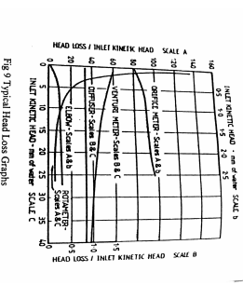
Fig 9 Typical Head Loss Graphs
6. CONCLUSIONS
The most direct measurement of fluid discharge is by the weightank principle. In installations where this is impracticable (e.g. on account of size of installation or gaseous fluid flow), one of the three discharge meters described may be used instead.
The Venturi Meter offers the best control to the fluid. Its discharge coefficient is little different from unity and the head loss it offers is minimal. But it is relatively expensive to manufacture and could be difficult to install in existing pipework.

The Orifice Meter is easiest to install between pipe flanges and, provided it is manufactured and erected in accordance with B.S. 1041, will give accurate measurements. But the head loss associated with it is very large compared with that of the Venture Meter.
The Rotameter given the easiest derivation of discharge, dependent only on sighting the float and reading a calibration curve. It needs to be chosen judiciously, however, so that the associated head loss is not excessive.

7. REFERENCES
Flow Measurement B.S. 1042 British Standards Institution 1943.
Flow Measurement B.S. 1042 British Standards Institution Section 1.1 1981.
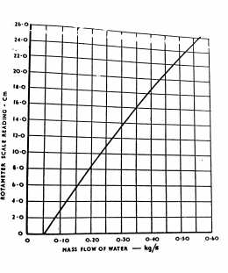
Rotameter calibration curve

EXPERIMENT #5
AN EXPERIMENT ON THE FRICTION LOSS ALONG A PIPE

1. INTRODUCTION
The frictional resistance to which fluid is subjected as it flows along a pipe results in a continuous loss of energy or total head of the fluid Fig 1 Mummies this in a simple case; the difference in levels between piezometer A and B represents the total head loss h in the length of pipe 1. In hydraulic engineering it is customary to refer to the rate of loss of total head along the pipe, dh/dl, by the term hydraulic gradient, denoted by the symbol i, so that

$\frac{dh}{dl}=i$
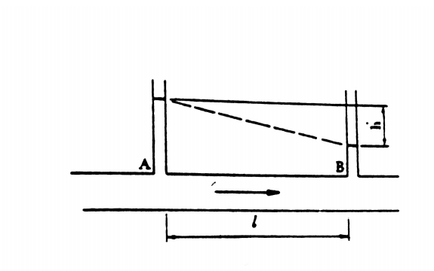

Fig 1 Diagram illustrating the hydraulic gradient

Osborne Reynolds, in 1883, recorded a number of experiments to determine the laws of resistance in Pipes. By introducing a filament of dye into the flow of water along a glass pipe he showed the existence of two different types of motion. At low velocities the filament appeared as a straight line which passed down the whole length of the tube, indicating laminar flow. At higher velocities, the f !lament, after passing a little way along the tube, suddenly mixed with the surrounding water,

indicating that the motion had now become turbulent. Experiments with pipes of different and with water at different temperatures led Reynolds to conclude that the parameter which determines whether the flow shall be laminar or turbulent in any particular case is
$$R=\frac{ρvD}{μ}$$
In which
R denotes the Reynolds Number of the motion
$ρ$ denotes the density of the fluid
v denotes the velocity of flow
D denotes the diameter of the pipe
$μ$ denotes the coefficient of viscosity of the fluid.

The motion is laminar or turbulent according as the value to R is less than or greater than a critical value. If experiments are made with increasing rates of flow, this value of R depends degree of care which is taken to eliminate disturbances in the supply and along the pipe. On the hand, if experiments are made with decreasing flow, transition from turbulent to laminar place at a value of R which is very much less dependent on initial disturbances. This value of P. about 2000, and below this, the flow becomes laminar sufficiently downstream of any disturbance. matter how severe it is.

Different laws of resistance apply to laminar and to turbulent flow. For a given fluid flowing along a given pipe, experiments show that
for laminar motion I$α$ V and …..3
for turbulent motion I $α V^{n}$ ……4

n being an index which lies between 1.7 and 2.0 (depending on the value of R and on the roughness of the wail of the pipe) Equation 3 is in accordance with Poiseuille's equation which can be written in the form
i=$\frac{32μv}{ρgD^{2}}$ ……5

There is no similar simple result for turbulent now, in engineering practice it is custom Darcy's Equation

$i=\frac{4fv^{2}}{D2g}$ ……6

in which f denotes an experimentally determined friction factor which varies with R and pipe roughness.

The object of the present experiment is to demonstrate the change in the law of resistance and to establish the critical value of R. Measurements of i in the laminar region may be used to find the co-efficient of viscosity from equation 5 and measurements in the turbulent region may be used to find the friction factor f from equation 6.

2. DESCRIPTION OF APPARATUS

2. 1 . Overview
Fig 2 shows the arrangement in which water from a supply tank is led through a flexible hose to the bell-mouthed entrance to a straight tube along which the frictional loss is measured Piezometer tappings are made at an upstream section which lies approximately 45 tube diameters away from the pipe entrance, and at a downstream section which lies approximately 40 tube diameters away from the pipe exit. These clear lengths upstream and downstream of the test section are required to prevent the results from being affected by disturbances near the entrance and exit of the pipe. The piezometer tappings are connected to an inverted U-tube manometer, which reads the differential pressure directly in mm of water, or a U-tube which reads in mm of mercury.

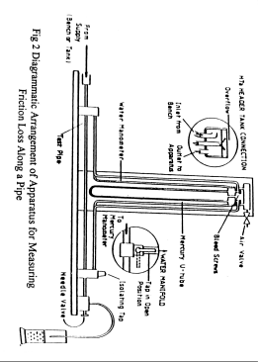
The rate of flow along the pipe is controlled by a needle valve at the pipe exit, and is measured by timing the collection of water in a measuring cylinder (the discharge being so small as to make the use of the H1 Hydraulic Bench weighing tank impracticable)

Fig 2 Diagrammatic Arrangement of Apparatus for Measuring Friction Loss Along a Pipe
2.2 Installation and Preparation
The apparatus is normally dispatched assembled and ready for use. In some instances, however, the manometer panel will be dismantled from the base-board of the apparatus. To reassemble:-
a) Secure the back panel supports to the baseplate with the two screws and washers provided.
These screws should not be excessively tightened.
b) Connect the free ends of the water and mercury manometer tubes to the pressure tapping block on the base board.
Secure these tubes with plastic ty-wrap clips using pliers to tighten them.
Superfluous lengths of ty-wrap should be cut off.
c) Assemble and connect the Header Tank, H7a, to the Hydraulic Bench supply and the inlet the 'friction in pipe' apparatus,
For higher flow rates, connect the plastic supply hose from the HI Hydraulic Bench directly to the inlet of the apparatus. Secure with the hose clip provided.

d) Connect the smaller bore plastic tube to the outlet port of the needle valve. Until measurements of flow are required, direct the free end of this tube into the access hole in the centre of the bench top.
For measurement direct the tube into a measuring flask. A litre flask ( not supplied), sub-divided into 10 millilitre divisions, is most suitable.

e) Fill the U-tube manometer up to the 270 millimetres mark with mercury (not supplied). Approximately 40 millilitres will be required for this. Access ports are provided in the lower appropriate header.

f) Before allowing water to flow through the apparatus, check that the respective air purge valve and screw caps on the water and mercury manometer are both tightly closed.

CHECKING WATER MANOMETER CIRCUIT
A tap is provided at the downstream end of the test pipe for selecting either a water or mercury manometer circuit.
Avoid syphoning of the water when using the mercury manometer.
To check the circuit:-
a) Direct the tap towards the open position.
b) Allow a nominal flow of water through the apparatus.
Lightly tap the manometer tubes to clear air from the circuit.
c) Adjust the water levels in the tubes to the same height.

It may be necessary to connect a bicycle pump to the purge valve in the manifold and manipulate the levels accordingly.

d) Increase the water flow to obtain an approximate maximum scale reading. Observe these levels to ensure that they remain steady.

If there is a steady rise in the manometer levels, check that the valve is tightened and sealed properly.
If tightening does not stop the leak, replace the valve seal.
Check that the tube ferrules in the manifold are free from water blockage as this will suppress water levels and cause erroneous results. If this is suspected, a sharp burst of pressure from the bicycle pump will normally clean the blockage.

PURGING MERCURY MANOMETER

a) Turn the isolating tap to the Mercury Manometer circuit.

b) Purge all air from the manometer tubes by releasing the screw caps in the mercury manifold.

c) When purged, firmly screw down the manifold caps.

2.3 Routine Care and Maintenance
After use, the apparatus should be drained as far as possible and all external surfaces dried with a lint-free cloth.

Dry the Header Tank if this has been used. Care must be taken not to bend or damage the needle valve tip if this is removed. If the plastic manometer tubes become excessively discoloured a stain and deposit remover should be use.

THEORY OF FRICTION LOSS ALONG A PIPE
3.1 Derivation of Poiseuille's Equation
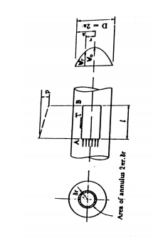
Fig 3 Derivation of Poiseuille's Equation
To derive Poiseuille's equation which applied to laminar flow along a tube, consider the motion indicated on Fig 3. Over each cross-section of the tube, the piezometric pressure is constant, and this pressure falls continuously along the tube. Suppose that between cross-sections A and B separated by length l of tube, the fall in pressure is p. Then the force exerted by this pressure difference on the ends of a cylinder having radius r, and its axis on the centre line of the tube, is $pπr^{2}$. Over any cross-section of the tube, the velocity varies with radius, having a maximum value of v_{o} the centre and falling to zero at the wall; let the velocity at radius r in any cross-section by denoted by v_{r}. Then the shear stress $τ$, in the direction shown on fig 3, due to viscous action on the curved surface of the cylinder, is given by
$$τ=\frac{μdv_{r}}{dr}$$
(Note that $\frac{dv_{r}}{dr}$, is negative so that the stress acts in the direction shown in the figure). The force on the cylinder is due to this stress $\frac{μdv_{r}}{dr}.2πrl$. Since the fluid is in steady motion under the action of the sum of pressure and viscous forces,

$$P.πr^{2}+\frac{μdv_{r}}{dr}2πrl=0$$
Therefore$\frac{dv_{r}}{dr}=\frac{-pr}{2lμ } ……8$

Integrating this and inserting a constant of integration such that
$v_{r}=0$ when r = a
$V_{r}=\frac{p}{4lμ}\left(a^{2}-r^{2}\right)$ ……9

This result shows that the velocity distribution across a section is parabolic, as indicated on fig 3, and that the velocity on the centre line, given by putting r = 0 in equation 9 is
$v_{o}=\frac{pa}{4lμ}$ …….10

The discharge rate Q may now be calculated. The flow rate through an annulus of radius r and width r is
$$δQ= V_{r}.2πrδr$$

Inserting $V_{r}$ from equation 9 and integrating
$$Q=\frac{p}{4lμ}2π\int_{0}^{a}{\left(a^{2}r-r^{3}\right)dr}$$
Therefore $Q=\frac{pπa^{4}}{8lμ}$ ……..11

Now the mean velocity V over the cross section is, by definition, given by
$$Q=v.πa^{2}$$

And elimimating Q between equation 11 and 12 gives
$V=\frac{pa^{2}}{8lμ}=\frac{pD^{2}}{32lμ}$ ………13

By use of the substitution
$$ρgh=p$$
And $\frac{h}{l}=i$
Eq. 13 may be written in the form
$i=\frac{32μV}{ρgD^{2}}$ …………..5
(which is an equation of the form : y=mx+b)
3.2 Derivation of Darcy's Equation
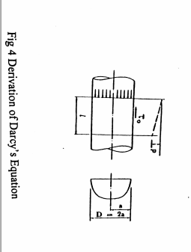
If the flow is turbulent, the analysis given above is invalidated by the continuous mixing process which takes place. Across the curved surface of the cylinder having radius r in Fig 3, this mixing is manifest as a continuous unsteady and random flow into and out of the cylinder, so that the apparent shear stress on this surface is greater than the value given in equation 7. Because of the mixing, the distribution of velocity over a cross-section is more uniform than the parabolic shape deduced for laminar flow, as indicated on Fig 4.

Although it is not possible to perform a complete analysis for turbulent flow, a useful result may be obtained by considering the whole cross-section as shown in Fig 4. It is reasonable to suppose that the shear stress $τ_{o}$on the wall of the tube will depend on the mean velocity v; let us assume for the present that

$$τ_{0}=f.\frac{1}{2ρv^{2}}$$
In which $\frac{1}{2ρv^{2}}$denotes the dynamic pressure corresponding to the mean velocity v and f is a friction factor (not necessarily constant). Since$τ_{o}$ and 1/2$ρv^{2}$ each have dimensions of force per unit area, f is dimensionless. The force on a cylinder of length l due to this stress id f.1/2p$v^{2}$.2$π$al, and the force due to the fall in pressure is p.$πa^{2}$ , so that
p.$πa^{2}$ = f. 1/2p$v^{2}$.2$π$al
Substituting
$$ρgh=p$$
h/l = i
and a=$\frac{D}{2}$

leads to the result
i=$\frac{4f}{D}.\frac{v^{2}}{2g}$

which is form of Darcy’s equation
The friction factor f which occurs in this equation was defined by equation 14 and is not necessarily constant. The results of many experiments show that f does, in fact, depend on both R, the Reynolds Number, and on the roughness of the pipe wall. At a given value of R, f increases with increasing surface roughness. For a given surface roughness, f generally decreases slowly with increasing R. This means that if R is increased by increasing v, so that the product fv² on which i depends equation 6 will increase somewhat less than v². In fact, over a fairly wide range, it is often possible, to represent the variation of i with v by the approximation

i = kv^{n}

where k and n are constants for a given fluid flowing along a given pipe, n having a value between 1.7 and 2.0.

4 EXPERIMENTAL PROCEDURE

4.1 Overview

The apparatus is set on the bench and leveled so that the manometers stand vertically. The water manometer is then introduced into the circuit by directing the lever on the tap towards the relevant connecting pipe. The bench supply valve is opened and adjusted until there is a steady flow down the supply tank overflow pipe. With the needle valve partly open to allow water to flow through the system, any trapped air is removed by manipulation of the flexible pipes. Particular care should be taken to clear the piezometer connections of air. The needle valve is then closed whereupon the levels in the two limbs of the inverted U-tube should settle to the same value. If they do not, check that flow has been stopped absolutely, and that all air bubbles have been cleared from the piezometer connections. The height of the water level in the manometer may be raised to a suitable value by allowing air to escape through the air valve at the top, or by pumping air through the valve.

Because of the large range of head differences involved, the readings are taken in two sets. Those for lower velocity flow rates, with the water manometer, and those for high velocity with the mercury manometer.

4.2 Water Manometer Readings

The needle valve is opened fully to obtain a differential head of at least 400 mm, and the collection of a suitable quantity of water in the measuring cylinder times. The values of h₁, (head in downstream manometer) and h₂ (head in upstream manometer) are now taken. Further readings may be taken at decreasing flows, the needle valve serving to reduce the discharge from each reading to the next. During this operation care should be taken: a) to ensure that the flow pipe exit is never below the surface of the water in the measuring cylinder; and b) to stand the measuring cylinder below the apparatus. Failure to observe these conditions will result in inaccurate flow rate readings, especially at the lower flow rates. The water temperature should be measured as accurately as possible at frequent intervals.
These readings should comfortably cover the whole of the laminar region and the transit turbulent flow; it is advisable to plot a graph of differential head against discharge as the experiment proceeds to ensure that sufficient readings have been taken to establish the slope of the straight line in the laminar region.

4.3 Mercury Manometer Readings.

The mercury manometer is now used, and the supply to the apparatus is taken directly from the bench supply valve instead of the elevated supply tank. Since the flexible hose between the bench supply valve and the apparatus will be subjected to the full pump pressure, it is advisable to secure the joints with hose
clips.

Isolate the water manometer by turning the tap shown in Fig 2.

With the needle valve partially open and the pump running, the bench supply valve is opened fully. Air which may be trapped in the flexible hose is removed by manipulation, and bubbles in the piezometer connections arc induced to rise to the top of the U-tube, where they are expelled through bleed valves. There should then be continuous water connections from the piezometer tappings to the two surfaces of mercury in the U-tube and, when the needle valve is closed, the two surfaces should settle at the same level.

Readings of h₁ and h₂ are now taken starting with a maximum discharge and reducing in steps, the needle valve being used to set the desired flows. The water temperature should be recorded at frequent intervals.

It is desirable to take one or two readings at the lower end of the range which overlap the range already covered by the water manometer. Since a reading of 20 mm on the mercury U-tube corresponds to 252 mm on the water manometer, this requires one or two readings in the region 20 mm.

The diameter of the tube and the length between the piezometer tappings should be noted.

4.4 Procedures
Step 1: Record at least 8 sets of data over the range of the water manometer (see Section 4.2) and another 8 or more over the range of the mercury manometer (see Section 4.3). Tables 1 and 2 show the format of suitable result tables.
Results given in this section are typical of those obtainable from the equipment supplied. There will, however, be slight differences between individual units.
Step 2: Plot graphs of hydraulic gradient i against mean velocity v, and log i against log v. (Figs 6 and 7 show the form of graphs expected). (Reminder - the two manometers generate data for different operating ranges of the same system. The student must combine the data sets to analyze the system over the entire range.)
Step 3: From the (best fit) graph of i against log v, or graph of i vs v, determine the velocity at which rapid transition occurs. Determine the critical Reynold's Number at this velocity. (The student may elect to "blow up" that portion of the graph between 0.3 and 1.2 m/s)
Step 4: From the (best fit) slope of the graphs, derive the relationship between v and i. For both the upper and lower ranges, determine k and n where i = kv^{n}
Step 5: From the gradient of i against v in the laminar range, determine the coefficient of viscosity and compare with theoretical values.
Step 6: In the turbulent region of flow, select 4 or 5 values of velocity. Compute friction factors and Reynold's Number at these velocity values. Plot friction factors against Reynold's Number (Moody's Diagram) Compare with theoretical values.

5. TYPICAL RESULTS AND SAMPLE CALCULATIONS
5.1 Relationships between I and u
Length of pipe between piezometer tappings, l ………..524 mm
Nominal diameter of pipe, D ………..3 mm
Cross-sectional area of pipe, A ………..7.06 mm²
Derivation of i over gauge length l
i) For water manometer
$i=\frac{(h_{1}-h_{2})}{l}$
ii) For mercury manometer
Referring to Fig 5, the specific gravity of mercury is taken as 13.6 writing the head difference in terms of water
$$i=\frac{\left(h_{1}-h_{2}\right)(13.6-1)}{l}$$

Qty  (ml) | t  (s) | v  (m/s) | h₁  (mm) | h₂  (mm) | h₁-h₂  (m) | i | $$θ$$  ($°C)$ | log i | log v

Table 1

Qty  (ml) | t  (s) | v  (m/s) | h₁  (mm) | h₂  (mm) | h₁-h₂  (m) | i | $$θ$$  ($°C)$ | log i | log v

Table 2

Qty  (ml) | t  (s) | v  (m/s) | h₁  (mm) | h₂  (mm) | h₁-h₂  (m) | i | $$θ$$  ($°C)$ | log i | log v
400  400  400  400  400  300  300  300  200  150  85  50 | 50.8  54.0  58.8  61.8  67.2  57.8  71.9  92.9  92.4  100.8  113.6  129.4 | 1.110  1.049  0.961  0.915  0.843  0.734  0.592  0.457  0.306  0.220  0.106  0.055 | 521.0  500.0  476.0  452.0  427.5  390.0  375.0  362.0  349.0  340.0  332.5  325.0 | 56.0  85.0  114.0  145.0  174.0  223.0  245.0  263.0  282.0  295.5  306.0  316.0 | 0.465  0.415  0.362  0.307  0.2535  0.167  0.130  0.099  0.067  0.455  0.0265  0.009 | 0.887  0.794  0.692  0.586  0.483  0.319  0.248  0.189  0.128  0.085  0.050  0.017 | 15.3  15.3  15.3 | -0.0521  -0.1002  -0.1599  -0.2321  -0.3161  -0.4962  -0.6055  -0.7235  -0.8928  -1.0771  -1.2958  -1.7645 | 0.0453  0.0208  -0.0173  -0.0586  -0.0742  -0.1343  -0.2277  -0.3401  -0.5143  -0.6576  -0.9747  -1.2596

Table 1. Results with Water Manometer

Qty  (ml) | t  (s) | v  (m/s) | h₁  (mm) | h₂  (mm) | h₁-h₂  (m) | i | $$θ$$  ($°C)$ | log i | log v
900  900  900  900  900  900  900  600  600  600  300 | 39.0  42.9  46.6  51.7  58.0  62.7  68.5  47.5  54.6  70.4  48.0 | 3.27  2.98  2.74  2.47  2.20  2.03  1.86  1.77  1.55  1.19  0.89 | 431.0  414.0  402.0  390.0  377.0  370.5  362.0  358.5  351.5  340.0  331.5 | 195.0  214.0  226.0  240.0  254.5  261.1  270.5  275.0  283.5  294.0  305.5 | 0.236  0.200  0.176  0.150  0.1225  0.1095  0.0915  0.0875  0.0680  0.0460  0.0360 | 5.77  4.81  4.23  3.60  2.94  2.52  2.20  2.01  1.69  1.11  0.87 | 15.5  15.9 | 0.7612  0.6821  0.6263  0.5563  0.4683  0.4014  0.3426  0.3052  0.2146  0.0434  -0.0625 | 0.5145  0.4742  0.4378  0.3927  0.3424  0.3075  0.2695  0.2480  0.1903  0.0755  -0.0531

Table 2. Results with Mercury U-tube

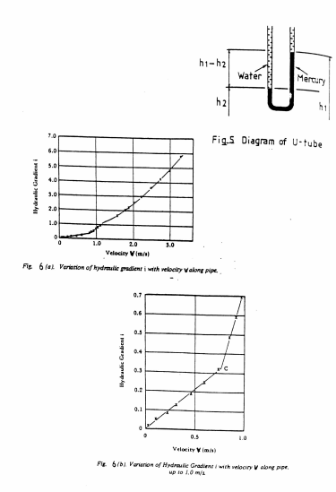

From Fig 6a, graph of v against i, it can be seen that for small values of v, the frictional loss is proportional to velocity.
i.e. $i∝v$
Fig 6b has been drawn with a larger scale for velocities up to 1 m/s.
This graph shows a fairly distinct change in the slope of the line at C when v is in the region of 0.77m/s. Up to this point the relationship is given by
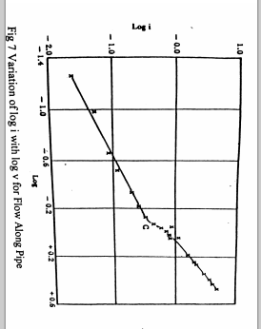
i = 0.419 v (see section 5.3.1)
Point C marks the starts of a distinct transition phase where the flow characteristics change considerably.
In Fig.7 the same results are plotted to logarithmic scales.
Points up to C lie on a straight line of slope 1, confirming the frictional loss is proportional to velocity (See also Section 5.3.1)
For points above C we can write:-
$i∝v^{1.69}$ for values of v greater than 1.5m/s (See also Section 5.3.2)

5.2 Calculations of Critical Reynolds Number
In Figures 6 and 7, Point C marks the distinct transition phase between laminar and turbulent flow. The velocity at Point C is approximately 0.77m/s
Recalling:- $R= \frac{ρvD}{μ}$ ----2
Substituting values we get at 15$°$C:
$R= \frac{999X0.77X0.003}{11.4X{10}^{-4}}$
= 2024

5.3 Calculation of Relationship between v and i
5.3.1 Laminar Range
$i=kv^{n}$
therefore, algebraically log i= log k + n log v
which is an equation of the forth y = mx+b
from Table 1, for v=306 and .592 (these points on best fit curve)
$n= \frac{∆\log{i}}{∆\log{v}}$ = $\frac{.6055-(-.8928)}{.2277-(-.5143)}$ = $\frac{.2873}{.2866}$ = 1.002
say n = 1.00
log k = log i – n log v = -0.6055 – (1.00) (-.2277) = -.3778
k = .419
i = .419v^{1.00}

5.3.2 Turbulent Range
as noted above; log i = log k + n log v
from Table 2, for v = 1.55 and 2.47
$n= \frac{∆\log{i}}{∆\log{v}}$ = $\frac{.5563- .2146}{.3927- .1903}$ = $\frac{.3417}{.2024}$ = 1.688
Say n = 1.69
log k = log i – n log v = .5563 – 1.69(.3927) = -.1073
k = 0.781
i = 0.781 v^{1.69}
5.4 Calculation of Coefficient of Viscosity
In the laminar range; i = $\frac{32μv}{ρgD^{2}}$ (Eq. 5), which is an equation of the form y = mx + b
The slope of the plot is therefore = $\frac{32μ}{ρgD^{2}}$ Where slope = k = 0.419 (Section 5.3.1)
This can be rewritten in the form
$μ=k\frac{ρgD^{2}}{32}$
Substituting values we get
$μ=k \frac{ρgD^{2}}{32}$
Substituting values we get
$$μ= \frac{0.419x999x9.81x9x{10}^{-6}}{32}$$
$μ= 11.6 x {10}^{-4}$ N.s/m²

5.5 Calculation of Friction Factor
In the turbulent region $i = \frac{4fv^{2}}{D2g}$ ------6

We can draw up table 3, giving values of f corresponding to various values of v, in the turbulent region of flow.
v(m/s) | I | $$\frac{v^{2}}{2gD}$$ | f | R
1.6  2.2  2.8 | 1.75  3.00  4.45 | 43.7  82.2  132.8 | 0.0100  0.0092  0.0084 | 4260  5860  7450

Table 3 Calculation of the Friction Factor f in Darcy’s Equation
6. DISCUSSION OF RESULTS
6.1 Measurements of frictional loss alone, the pipe at different velocities have shown two well-defined regions to which different laws of resistance apply. As the velocity is decreased from 3.3 to 1.5 m/s, frictional loss varied as v¹⁶⁹. Between 1.5 and 0.77, the loss decreased rather more steeply and as v decreased from 0.77 to zero, the loss varied directly as v. The critical velocity of 0.77 corresponds to a Reynolds number of 2024, this value being close to the figure of about 2000 at which transition from turbulent to laminar flow is usually found to take place.
6.2 The value of $μ$ calculated by Poiseuille's equation applied to the results in the laminar region is
$μ$ = 11. 6 x 10⁻⁴ Ns/m at 15.3°C.
The accepted value at this temperature is
$μ$ =11.4 x 10⁻⁴ Ns/m²
Since the accepted values are based on experiments with similar but more refined apparatus, the discrepance reveals an error of about 2% in the apparatus used here.
6.3 The results in the turbulent region have been used to calculate the friction factor f in Darcy's equation, and are found to fall with increasing v as shown in Table 4.

EXPERIMENT #6
FLOW VISUALIZATION USING THE HYDROGEN BUBBLE GENERATOR

OBJECTIVE
To visually observe flow patterns Which occur when a fluid flows around a solid body.

DESCRIPTION
A Model 9080 Hydrogen Bubble Generator (See Appendix 6) will be used to generate a mass of fine bubbles. These bubbles will follow the flow of the fluid and be swept across objects of differing shapes. With the flow illuminated, the student will be able to visually observe flow lines and how they behave as the fluid flows around a solid body. Areas of laminar and turbulent flow can be distinguished as well as how they vary when velocity (Reynolds Number) is increased.

The student will observe a variety of shapes under differing velocity magnitudes and directions and record his observations.

PROCEDURE
Step 1: Plug the apparatus into the wall outlet. Turn power ON. Adjust bubble intensity to maximum and generate a steady stream of bubbles. Turn lamp ON and adjust light direction as necessary to maximize observing conditions. Adjust free stream velocity of fluid to lower range of scale.
Step 2: Place solid object in the bubble stream.
Step 3: Observe and record streamlines. Take approximate dimensions of the object and the streamlines and sketch to scale. Label areas of laminar and turbulent flow. (Note: important that student use care in accurately preparing sketch)
Step 4: Estimate free stream velocity (distance / time), record water temperature and compute Reynolds Number.
Step 5: Adjust valve and change free stream velocity of fluid to upper range of scale. Observe and record streamlines. Take approximate dimensions of the object and streamlines and sketch to scale.
Step 6: Repeat Steps 2 thru 4 using at least 3 other shapes. (Changing the angle of approach qualifies as a different shape)
Step 7: A minimum of eight sketches (4 shapes at 2 velocities) should be prepared showing the objects and streamlines. Include velocity, and Reynold's Number data.
Step 8: Analysis of findings
a) Comment on changes to extent of turbulent areas due to the change in velocity. Be specific. Address each shape individually.
b) Review streamlines as related to shape of object. Comment on effect of shape on anticipated energy losses as fluid flows around objects. Comment on which shapes would be expected to have a lower coefficient of drag and why. (see also Experiment #8)

APPENDIX 6
HYDROGEN BUBBLE GENERATOR

TECHNOVATE FLOW  ARMFIELD VISUALIZATION  SYSTEMS | MODEL  9043  9045  9080
*DEVELOPED IN ENGLAND BY ARMFIELD TECHNICAL EDUCATION CO., LTD. MADE AND/OR SOLD IN U.S.A. BY TECHNOVATE, INC

This group of items of equipment has been developed to meet the need for direct visualization of fluid mechanics phenomena. With each item quantitative determination can be readily incorporated and this extends considerably the dexterity and research value of the systems. The equipment has been kept small and as light as possible so as to make it suitable for both laboratory and lecture work. It has been designed for use with closed circuit television so that the experiment can be seen in the whole of the auditorium and can also be recorded on tape for future use or for a more detailed study.
Model 9043
Hydrogen Bubble Flow Visualization System This complete system comprises the Hydrogen Bubble Generator Model 9080, the Flow Visualization Table Model 9045 and a set of familiarization models. Details of the technique involved and full specification of the equipment supplied are given below.


Model 9080
Hydrogen Bubble Generator

The hydrogen bubble technique for flow visualization has long been established. It has not however, been used extensively as a laboratory tool because hitherto its operation has proved somewhat difficult and unreliable. The present equipment has eliminated these disadvantages and provides a compact, easy to use apparatus offering all the technical advantages of the hydrogen bubble method. The technique involves the evolution of small hydrogen bubbles from a fine wire cathode which is positioned normal to the fluid flow. These bubbles are swept from the wire and because of their size, follow the flow accurately. A mass of fine bubbles is observed, and these are made clearly visible by the specially developed system of illumination.
The success of the technique depends upon the standard of illumination and the consistent quality of bubble evolution in terms of numerical density and size. This has been achieved as a result of extensive development work.
The provision of a pulse generator makes it possible to carry out both quantitative and qualitative analysis. The equipment is equally suited as a teaching aid or a research tool.
The generator kit can be used in conjunction with any suitable open channel. However, as it is mostly purchased in conjunction with the Flow Visualization Table (Model 9045), the system is specially tailored to suit this Flow Table.
General Specifications for Ordering Model 9080 (I) One hydrogen bubble pulse generator designed for connection to 110 volts single phase supply. The generator is housed in a compact bench mounting, fully labeled, metal cabinet. Output terminals are provided for direct current connection to the anode and cathode. A further pair &terminals is provided for connection to the illumination source. The connecting leads for both of these are included in our supply.
The generator will produce "on" and "off' of up to 2 seconds duration and provision is incorporated in the generator for varying both the "on" and "off' periods independently in stepless fashion. The pulsed D.C. voltage is adjustable and is coupled to a pre-selector control which may be set to short or long pulse emission. 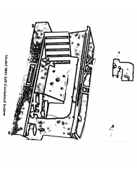

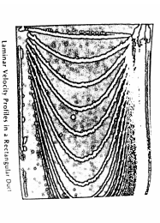

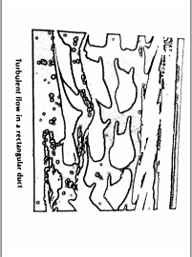
The pulse length available within this pre-set condition is infinitely variable is by means of fine facility controls available for both pulse and space length. Thc also incorporated on the pre-set to have continuous current production. The generator is provided with an on/off switch with and light control indicator and switches are also provided for pump
(ii) The light source consists of a ht cooled 55w. 12v. Tungsten iodine bulb backed by a concave mirror. The light guide is made of polished Plexiglas and works on the principle of total internal reflection. It produces a beam of light below the surface of the fluid and can be moved in a horizontal or vertical direction for optimum viewing conditions at any point of the channel. The intensity of light is adequate for simultaneous viewing by four or five students and photographic recording with a fast film (400 A.S.A.)
Turbulent flow in a rectangular duct
(iii) The cathode consists of a fine stainless steel wire supported in tension by a two-pronged fork holder. Two cathodes are supplied providing wire length of 1V2 in. And 3 in. The holder is insulated with cellulose and supplied complete with support rods which allows it to be positioned at any point along the Flow Visualization Table (Model 9045). The anode is supplied in the form of a stainless steel block.
(iv) A supply of the miscellaneous items required for the hydrogen bubble flow visualization technique is also provided including cellulose for insulation, spare cathode wire and a camel hair brush, etc.
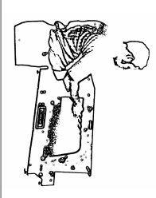
Model 9045
Flow Visualization Table
This item has been developed to meet the increasing importance attached to flow visualization in the study of fluid mechanics. The table is particularly suited for use in conjunction with the Hydrogen Bubble Generator Model 9080. However, the table can also be used to study the flow patterns which occur when water flows around a solid boundary or as an "aerodynalog" to demonstrate the analogy which exists between the flow of a perfect gas and the flow of water in an open channel. "Shock waves" and other phenomena are clearly demonstrated without the necessity to resort to expensive and complicated apparatus. The equipment is designed for use in conjunction with an overhead projector (not included) enabling the flow patterns to be viewed by a large group of students. The flow table is mounted on a steel baseplate provided with leveling screws and carrying handles. It is of unitary construction molded in fiberglass fitted with a clear plexiglas bed in the view section. The working

section is 11 in. long, 8 in. wide and 2 in. deep.
Water is circulated by means of a small electric pump and the flow is regulated by a valve located at the pump discharge. All pipework is of non-corroding material.
Standard Electrical Supply: A. C. Single phase, 115 volts, 60 cycles.

General Specifications of Ordering model 9045
Miniature flow visualization table shall be a self-contained bench-top system incorporating (1) an elevated molded flow channel section of shallow depth in relation to its width in the working area, having a transparent full-width plate in the bed, a stilling reservoir at the inlet end, a discharge sump at the outlet end, and means for mounting gridded plates under transparent plate; (2) a steel base section, upon which the channel proper is mounted, which has leveling lugs and lifting bars at each end and within which is contained a pump with motor, an appropriate fuse, a flow control valve, a drainage fitting, all piping necessary to maintain a constant flow through the flow channel, a three-wire grounded, motor-connection extension cord; (3) a basic set of Plexiglas section models.
Detailed Specifications Construction
Flow Channel Proper
Materials
Body………… Molded fibreglass
Pipe connections (concealed)………copper
Hold-down bolts (concealed)…….steel
Bed plate…………………………….plexiglas
Dimensions, Working Section (in.) Length................................................... 24 Width.................................................... 10 Depth......................................................2
Base Section
Materials
Body & lifting bars…….Heavy-gauge steel
Piping & fittings………Plastic
Pump & valves……….Corrosion-resisting
Electrical
Motor…………….Fractional HP
Power Requirements
EMF (v a/c) ………...110
Frequency (Hz)……….60
Phase…………… Single
Source……….. Grounded, 3-wire
Models………. airfoil, diamond, curved block
Size, Overall (in.)
Height (nominal)……………20
Depth…………. 16
Width…………… 40
Weight (lbs.) Net.................................................... 75
Shipping (est)………………………………… 90

FLOW VISUALIZATION SYSTEMS MODELS 9043, 9045, 9080
Model 9043-P Flow Visualization Table and
Hydrogen Bubble Generator with Overhead Projector
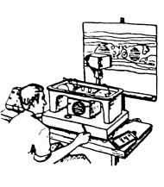
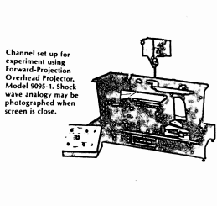
For direct observation of flow patterns by projection. The Forward-Projection Overhead Projector, Model 9095-1, provides certain unique instructional and experimental advantages. At short focal distances, for example, contrast is sufficient for excellent photographs of wave patterns. Secondly, the projector has been specially designed to provide high-intensity illumination with minimum distortion at the edges as well as the center of the image. Thirdly, the image is "right-reading," i.e., left is left, right is right, top is top, and so forth... an immense manipulative advantage. Lastly, by use of the transparent gridded plate, flow rates can be estimates and patterns sketched using the large scale of the screen projection rather than the small scale inherent in direct observation.
Option Models
To obtain obtain value from the Hydrogen Bubble Generator, we recommend the purchase of the following optional accessories

Two pairs of 9 in. flat guides. 93-05-023
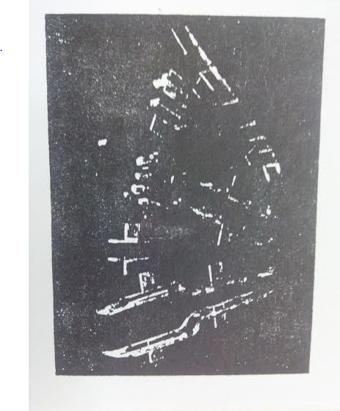
Two guides incorporating an 's' bend. 93-05-18
One curved guide. 93-05-024
One pair of 3 in. Long flat plates. 93-05-012
One pair of plates with radiused ends. 93-05-009
Two special sections, two flat plates with different Shaped ends. 93-05-002, 93-05-004
Four circular cylinders with slip-on-sections from 0.25 in. to 1.00 in. diameter. 93-05-028 to 031
The instruction manual supplied with Model 9080 does deal in depth with the use of these accessories which are all made of clear polished plexiglas.

Technovate reserves the right to make, without prior notice, such changes in this product as will improve its performance or broaden its capabilities.

