September 9, 2013

Ms. Jayne Baran, Associate Professor & Coordinator of CET
State University of New York
Institute of Technology @ Utica/Rome
100 Seymour Road
Donovan Hall 1205
Utica, NY 13502

Dear Ms. Barne:

We are pleased to share with you information on the new streamlined registration process for students that automatically qualify to sit for the computer based format of the NCEES Fundamentals of Engineering examination.

In accordance with New York State Education Law, students who have graduated from a baccalaureate program specifically registered by the Engineering Technology Accreditation Commission (ETAC) of the Accreditation Board for Engineering and Technology (ABET) and the New York State Education Department (NYSED) automatically qualify for direct admission to the NCEES Fundamentals of Engineering examination(FE).

In the past, students were required to obtain approval from NYSED and the State Board for Engineering and Land Surveying to sit for the FE exam. To streamline this process and better coordinate with the implementation of the new computer based FE exam, students may now register, schedule and pay for their FE exam directly with NCEES. This may be accomplished through the NCEES website at www.ncees.org

The new computer based FE exam will be offered in four testing windows throughout the year. The four windows will be two months in duration with one month off between each window starting in January 2014. The NCEES registration for the FE exam will open on November 4, 2013 and remain open year round.

As in the past, examinees and NYSED will continue to receive exam grades directly through the NCEES website. The computer based FE exam administration locations will now be NCEES approved Pearson VUE Testing Centers. For more detailed information on the new computer based FE exam, including revised exam length, specifications, reference material, approved calculators, and location of test centers, please visit the NCEES website at http://cbt.ncees.org/

We hope you and your students find this new streamlined process helpful. If you, your department chairs or staff have any questions or need additional information, please visit our website at http://www.op.nysed.gov/prof/pels/ or contact the State Board Office for Engineering at 518-474-3817 ext. 140; Fax 518-473-6282; email at enginbd@mail.nysed.gov .

Sincerely,
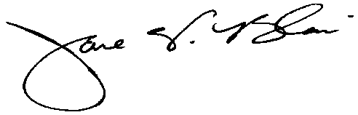
Jane W. Blair, PE
Executive Secretary

