1. Draw the UML diagram for the class defined in Programming Exercise 10.11 at the end of Chapter 10. **Enforce encapsulation!**

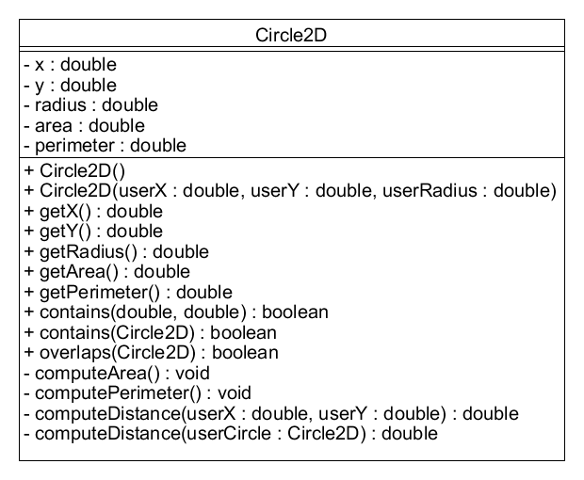

1. Design the following two classes for a top-down 2D game (similar to the NetHack example from before).

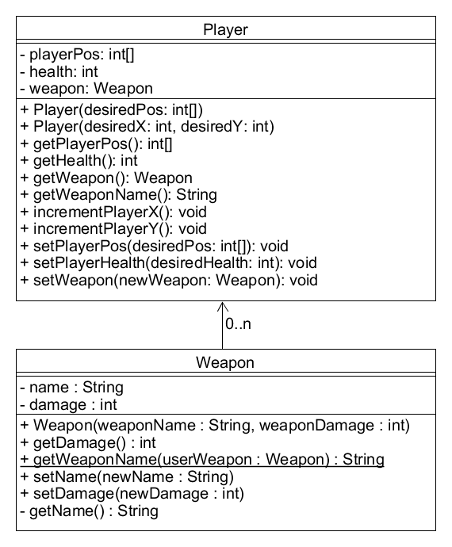

1. Given the Player and Weapon classes (also look at Programming Requirement 2), what do you think most accurately represents the relationship between Player and Weapon?
   1. Association
2. 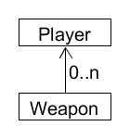Given your answer, draw the UML diagram that shows the relationship between these classes. **Use a simplified form of the UML class diagram that just includes the name.** Also, **be sure to include the correct numbers on either end of the line!**
3. Which of the following is **NOT** part of a **class contract**?
   1. Private methods and fields
4. An **Abstract Data Type (ADT)** is 1) a collection of data and 2) operations that work on that data
   1. True
5. Given the code below, what is this an example of?
   1. Autoboxing