1. Draw the UML diagrams for the following:
2. Draw the UML diagrams for the following:

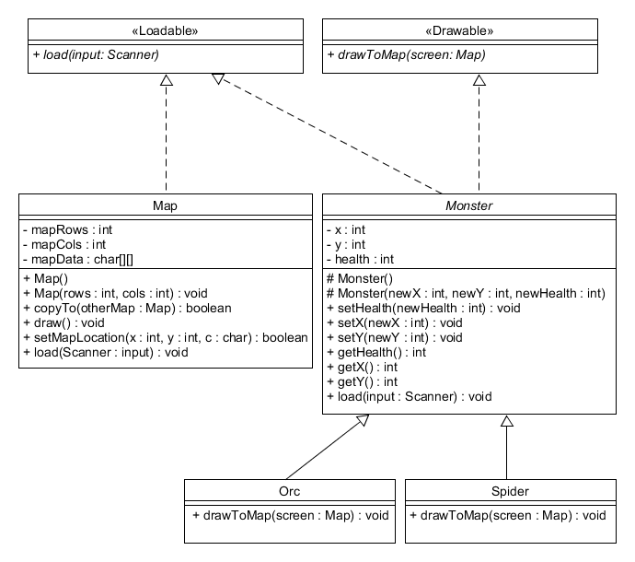

1. Given an **abstract** **class** BakedGood, is the following code legal? If not, why not?
   1. No, you cannot instantiate an abstract class
2. Given an **abstract class** BakedGood and a class Muffin that extends BakedGood, is the following code legal? If not, why not?
   1. Yes you can because Muffin is not an abstract class.
3. Given an **interface** Edible and a class Muffin that implements Edible, is the following code legal? If not, why not?
   1. Yes you can because you can instantiate an interface with a class.
4. A class can implement more than one Java interface
   1. Yes a class can implement more than one interface.
5. A Java interface can have private methods.
   1. False
6. All data fields defined in a Java interface are public, static, and final.
   1. True